Have a try of our home learning for this term. You can do the work online and send it to your teacher or do it in an exercise book and keep it at home until you return to school.
When you have completed your work, please ask your parents to complete the online questions to help us to know how you are doing. They can do this on the website, from the email or by scanning the code:
Looking forward to seeing you all soon and remember we are here to help if you need us!
Mr Newton (michaelnewton@blessedsacrament.lancs.sch.uk)
Mrs Southward (levisouthward@blessedsacrament.lancs.sch.uk) Mr Parry (davidparry@blessedsacrament.lancs.sch.uk)
MUST | You must complete the 3 maths and 3 English lessons that are listed. If you have access to a laptop / tablet / phone, you will be able to see the slides online. If you need a paper copy, one will have been sent to you by your teacher.
 | Maths 1  LO: Using a bar chart. | Maths 2  LO: Using a pictogram. |  |  | Maths 3  LO: Using a range of graphs.
 | English 1  LO: Create and develop character for narrative | English 2  LO: Discuss and record ideas using a range of formats |  |  | English 3  LO: Innovate a story
SHOULD | You should do the 3 additional subjects that are listed here. If you want, you can swap some for your brother / sister’s ‘should’ activities and do them together. You can send photographs of your ‘should’ work to your teacher who will include some of them on the class blog.
 | Geography  Create a mind map of what you know about The United Kingdom.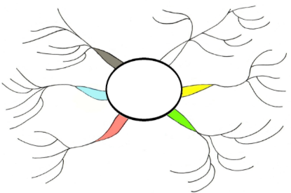  Make it colourful so it is easier to remember.  Write a list of things that you want to know about the UK. |  | Art  Using a pencil and ruler, create a portrait using only straight lines.  Watch the following clip to help you.  https://www.youtube.com/watch?v=XWAFCqMnoqM  Colour your portrait in and bring it into school on your return. |  | RE  Our question for this half term is Why are rules important?  Make a list of the seven sacraments of the Catholic Church.  Why do you think Catholic people follow these sacraments?
COULD | These are some regular activities that you could do more often as they will support your learning and help you to remember what we did together in school.
 | Activity 1: 2Do’s on Purple Mash  Detail: Check your alerts and email on Purple Mashhttps://www.purplemash.com  https://www.prodigygame.com/ is an alternative activity. |  |  | Activity 2: Computing  Use your new school email address and using the lesson we did on attaching documents. Can you send some of your work as an e-mail attachment to your teacher?
 | Activity 3: Multiplication recall  Write out your times tables, practice chanting them or log in to online program e.g. “Times table Rock stars” to practice your recall. |  |  | Activity 4: Physical Activity – 60 minutes a day  Get outside and go for a walk or have a ride on your bike. If you mastered the throwing from last week, try drawing two circles one close to you and the other 2 metres away. Can you bounce the ball in both circles without it touching the ground between them? If that’s too easy, try 3 circles.
Have a look at our Year 3 extras sheet (Home Learning Resources) that has loads of links to different activities and learning opportunities for you to try out.

