Our home learning this week is on the topic of All Around The World-Australia. You can do the work online and send it to your teacher or do it in an exercise book and keep it at home until school reopens.
When you have completed your work, please ask your parents to complete the online questions to help us to know how you are doing. They can do this on the website, from the email or by scanning the code:
MUST | You must complete the 3 maths and 3 English lessons that are listed. If you have access to a laptop / tablet / phone, you will be able to see the slides online. If you need a paper copy, one will have been sent to you by your teacher.
 | Maths –  LO: To recognise numbers up to 10. | Maths –  LO: To develop my measuring skills. |  | Maths –  LO: To begin to understand subtraction.
 | English –  LO: To develop my imagination through storytelling. | English –  LO: To follow a set of instructions. |  | English –  LO: To describe what I have drawn.
SHOULD | You should do the 3 additional subjects that are listed here. If you want, you can swap some for your brother / sister’s ‘should’ activities and do them together. Please send photographs of your ‘should’ work to your class teacher to go onto the Nursery blog on the website
 | Expressive Arts and Design  Can you make a paper plate koala?  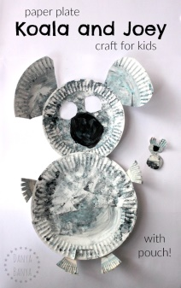 | Understanding The World  Can you go on a nature walk and see what different mini beasts/insects you can find?  Can you ask a grown up if you can use an Ipad, Tablet or phone to take some photographs of all the different creatures you can find? |  | RE  It has been a unique situation these last few months. However, we should be thankful for our health and all the wonderful days with our families.  Please can you think of a prayer to tell God what you are thankful for, what you have enjoyed most during these difficult times and what you are looking forward to once things are back to normal?
COULD | There are some additional activities listed here that will support your learning and help you to remember what we did together in school. You could do these every day.
 | Purple Mash  Complete some of the ‘to dos’ on your account. | Literacy  Can you sing different nursery rhymes and listen for the rhyming words? |  | Shape  Can you practise recognising the simple 2D shapes: Circle, Square, Oval, Rectangle and Triangle?
 | PE  Can you practise your bat and ball skills? You could use a tennis racket and see if you can balance the ball on the racket. | PSED  Can you play some ring games with your family such as duck duck goose, and the farmers in his den. | Physical development  Can you practise tying your laces?  Can you practise fastening your buttons?
Mrs Hilton (jodiehilton@blessedsacrament.lancs.sch.uk)

