You can select any activities from the list below or come up with your own ideas to suggest to your teacher.
Please record any home learning on Tapestry and, feel free to email in any photos or relevant learning.
English | Phonics  Listen to the Jolly Phonics Phase 2 song:  https://www.youtube.com/watch?v=1Qpn2839Kro  Can you begin to recognise and say the initial sounds in your name? | Reading  Enjoy a story, either share a book or watch an online story.  Can you name the characters, settings and events that happen in the story?  https://www.bbc.co.uk/cbeebies/stories | Writing  Can you practise writing your name?  Can you practise writing numbers 0-5?
Maths | Number  Can you add to groups of objects and see how many altogether?  Can you match the amount of objects to the correct number? | Measure  Can you use a piece of string, ruler or measuring tape to measure a selection of objects?  Which is the longest? Which is the shortest? Can you put them in order starting with the longest first? | Shape  Can you go on a shape hunt?  Can you recognise simple 2D shapes?  (circle, square, oval, rectangle, triangle, star, heart, diamond)
Topic | PSED/ C&L  Can you create an imaginative role play activity with the people in your house?  Can you act out a narrative to your role play game? | Understanding of the World  Can you help do some cooking with your family?  Can you help to make lunch or dinner? | Creative  Can you create a nature collage using lots of natural resources?  Can you create some spring crafts?
Topic | Growing  Can you plant some seeds and help to look after them?  Can you think about what you might need to do to help them grow? | The Hungry Caterpillar  Share the story of The Hungry Caterpillar.  Can you recall what happened in the story?  Draw a picture of your favourite part of the story and your favourite food the caterpillar eats? | Malleable  Can you make some cloud dough? What does it feel like?  Can you mould something with the dough?  Can you make patterns with the dough?
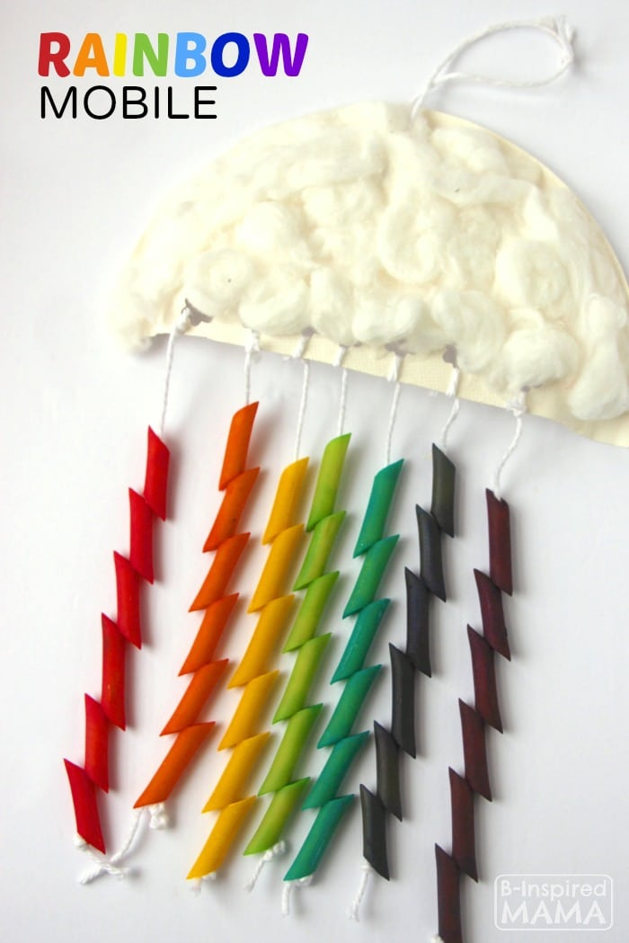
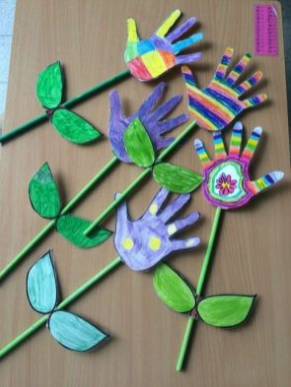
Spring craft ideas
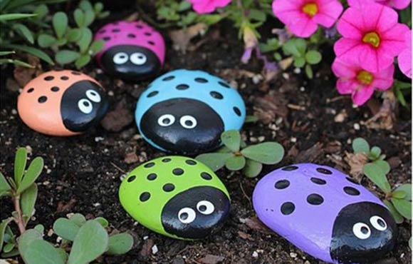
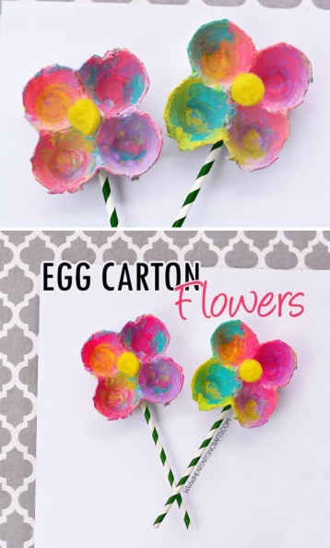
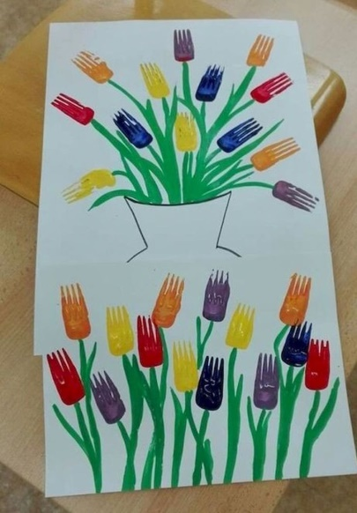
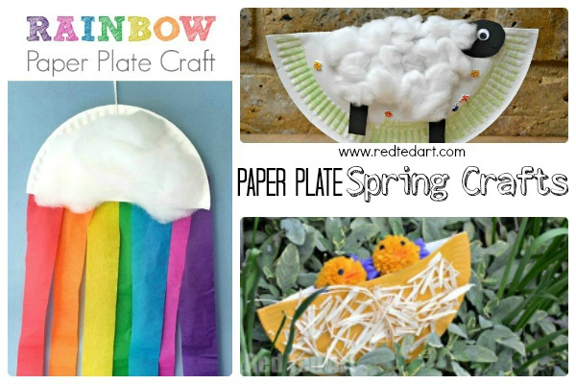
Websites
https://www.topmarks.co.uk/maths-games/3-5-years/counting This is a brilliant website for lots of Maths games.
https://www.bbc.co.uk/cbeebies/games A great collection of fun and exciting games.
https://www.getepic.com/?fbclid=IwAR1it4kzUNFsnAFl4OVf3c9nokeSYe7pA4lr1mg7nVlNV58LRredL3nzbiA This link is for a free 30 day trial for 1000s of online books.
https://www.youtube.com/user/oxbridgebaby Lots of lovely traditional tales to watch and listen.
https://pagingfunmums.com/2013/07/20/cloud-dough/ Lots of ideas for messy and creative play.
https://www.teachyourmonstertoread.com/ A free app with lots of reading activities.
https://fiveminutemum.com/ a website with lots of easy to set up activities for Maths, writing and social skills.
http://www.crickweb.co.uk/Early-Years.html Brilliant website that provide stimulating games to make learning fun!
https://www.bbc.co.uk/iplayer/episodes/p06tmmvz/andys-wild-workouts Great physical workouts perfect for little ones!
Outdoor Learning
- Spring hunt – What signs of Spring can you find in the garden?
- Can you collect a selection of natural resources to create a picture or a face?
- Can you create a crown using natural resources?
- Can you create a fairies’ garden?
- Can you go on a Spring colour hunt, marking down the different colours you can see?
- Can you create a construction area using different materials found in your shed?
- Can you create an obstacle course and see how fast you can do it? Can you beat your time?
- Can you create a small garden for you to look after and take care of?

How to make cloud dough

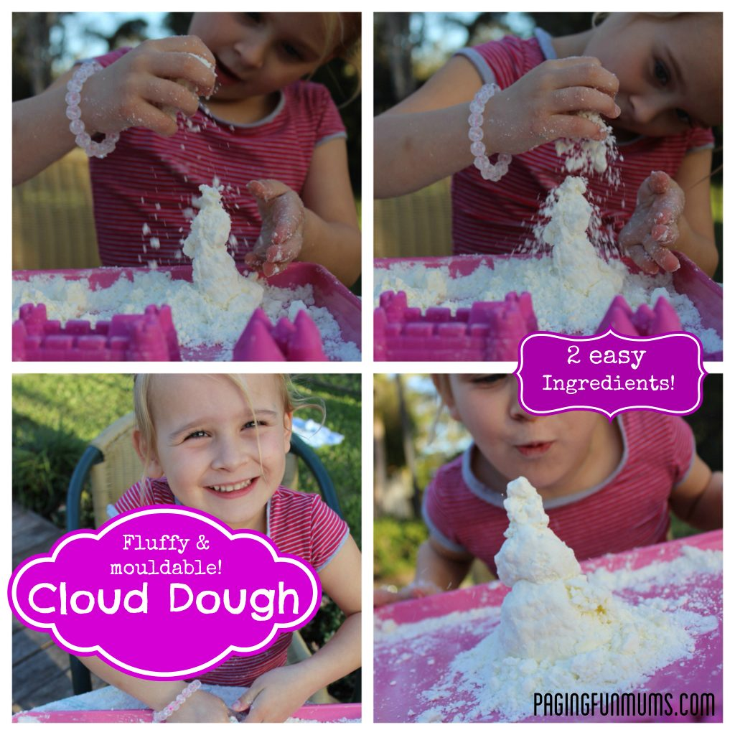
This is a cool sensory dough that is light, fluffy, crumbly & yet mouldable and you only need two ingredients to make it!
You need:
- 300g packet of Cornflour or Cornstarch
- 1/4 cup of bath oil
Note: you can use baby oil, coconut oil or vegetable oil too– I think the lighter the oil the better the results.
Method:
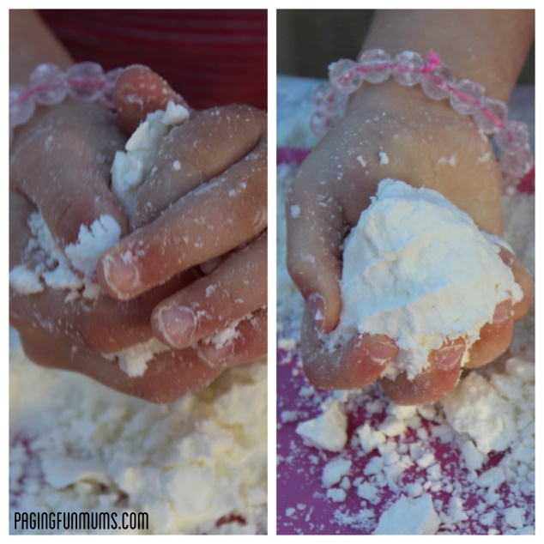
Just combine the two ingredients and mix well using your fingers – it takes a little while to get the flour and oil evenly mixed. You may need to add a little more oil if it’s still not moulding when you compact it in your hands.
It has such a lovely light and fluffy feel to it. Enjoy!

