History | Staff |  | RE
Aztecs  Who were the Aztecs? Where did they come from? What did they do? How did they live? | Miss Bonsor – Monday and Tuesday  Mrs Southward – Wednesday, Thursday and Friday.  Miss Straker will be supporting in class every day.  Mrs Whittell will be in class as well. |  | How does God speak to us?  How can we use it to deepen our relationship with Him?  Which ways are helpful to our prayer?
Science | In Year 6 we will be looking at how wonderful we are and sharing our gifts and individuality!  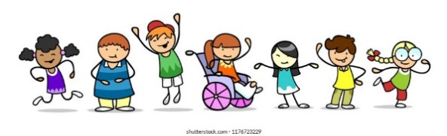 |  | Art
EARTH AND SPACE – From Year 5. Describe the movement of the Earth, and other planets, relative to the Sun in the solar system. Explain day and night and the apparent movement of the sun across the sky.  LIGHT. Recognise that light appears to travel in straight lines and to explain that objects are seen because they give out or reflect light into the eye. To explain why shadows have the same shape as the objects that cast them. |  |  | Textiles - Tie Dying  Awareness of the potential of the uses of material.  Use different techniques, colours and textures etc when designing and making pieces of work.  To be expressive and analytical to adapt, extend and justify their work.
 |  |  | STRIVE Focus/PSED
Valued Collaboration.
Well-being Fridays focused on physical, emotional and social development.

Computing |  |  | Spanish
Coding  Understanding why programming and coding is important. |  |  | Regular and irregular verbs
Maths | P.E. | Music | English
Place Value – Negative numbers  Place value - Decimals/fractions  Mental and written calculation  Calculating fractions  Algebra and sequences  Measurement, ratio and proportion  Statistics, line graphs and pie charts | Striking, fielding, catching and throwing skills playing Kwik cricket. | Music and Me  Using music to explore and express our identity.  Inspirational women in music.  Creating music. | All lessons will be based around the book ‘Wonder.’ (Please don’t watch the film unless you have seen it already!)  Poetry – creating poetry about how people look and feel.  Narrative – writing parts of a story.  Biography – about people with facial deformities

