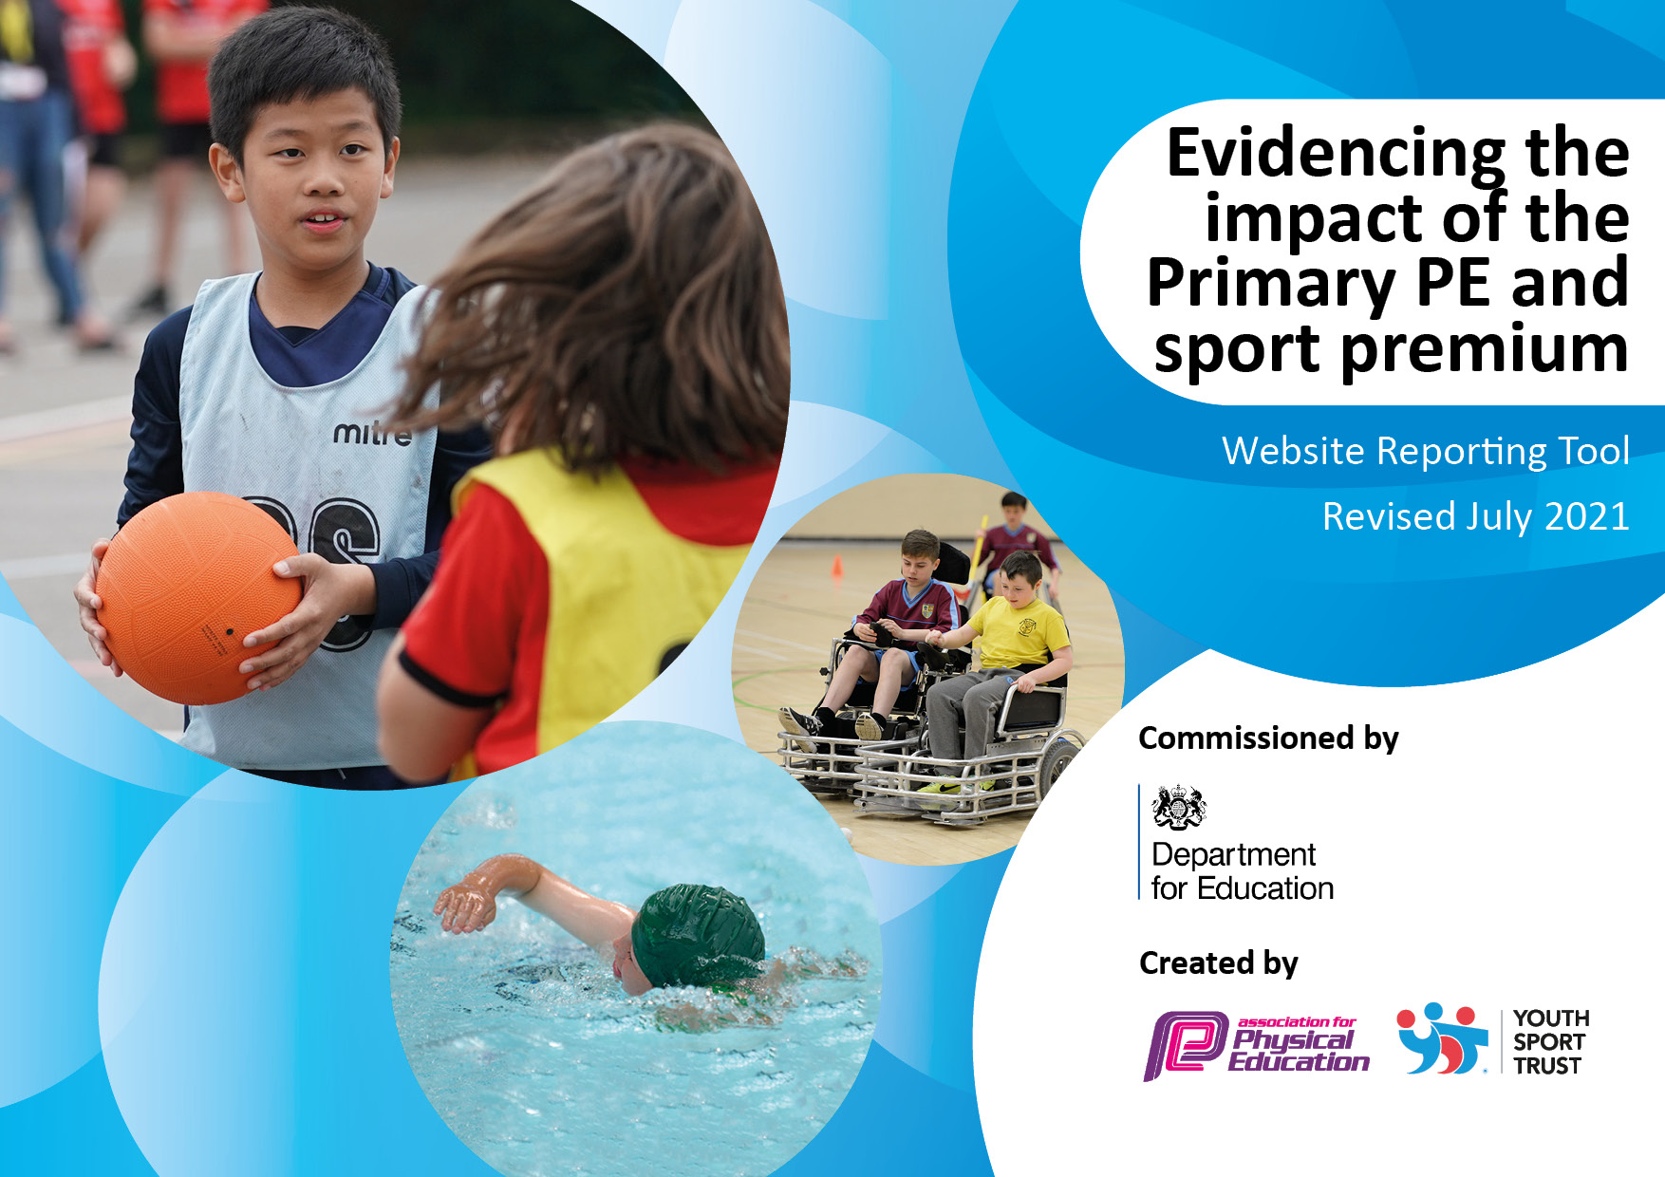
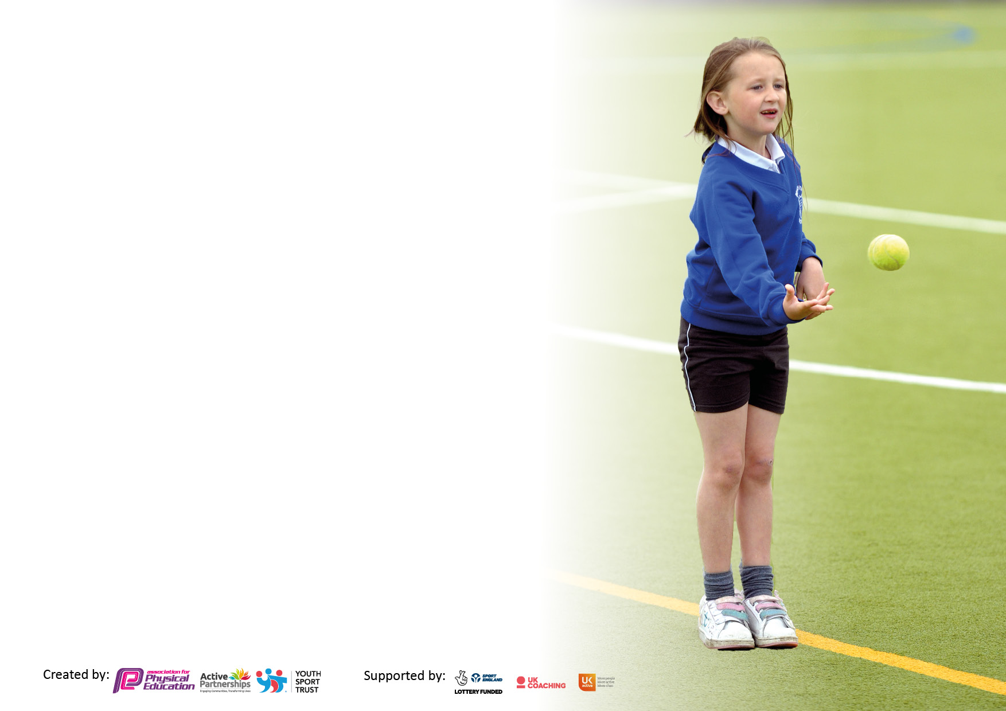

It is important that your grant is used effectively and based on school need. The Education Inspection Framework makes clear there will be a focus on ‘whether leaders and those responsible for governors all understand their respective roles and perform these in a way that enhances the effectiveness of the school’.

Under the Quality of Education Ofsted inspectors consider:
Intent - Curriculum design, coverage and appropriateness
Implementation - Curriculum delivery, Teaching (pedagogy) and Assessment
Impact - Attainment and progress

To assist schools with common transferable language this template has been developed to utilise the same three headings which should make your plans easily transferable between working documents.

Schools must use the funding to make additional and sustainable improvements to the quality of Physical Education, School Sport and Physical Activity (PESSPA) they offer. This means that you should use the Primary PE and sport premium to:

- Develop or add to the PESSPA activities that your school already offer
- Build capacity and capability within the school to ensure that improvements made now will benefit pupils joining the school in future years
- The Primary PE and sport premium should not be used to fund capital spend projects; the school’s budget should fund these.

Pleasevisitgov.ukfortherevisedDfEguidanceincludingthe5keyindicatorsacrosswhichschoolsshoulddemonstrate animprovement.Thisdocumentwillhelpyoutoreviewyourprovisionandtoreportyourspend.DfEencouragesschools to use this template as an effective way of meeting the reporting requirements of the Primary PE and sport premium.

We recommend you start by reflecting on the impact of current provision and reviewing the previous spend.

Schools are required to publish details of how they spend this funding, including any under-spend from 2019/2020, as well as on the impact it has on pupils’ PE and sport participation and attainment. All funding must be spent by 31st July 2022.

We recommend regularly updating the table and publishing it on your website throughout the year. This evidences your ongoing self-evaluation of how you are using the funding to secure maximum, sustainable impact. Final copy must be posted on your website by the end of the academic year and no later than the 31st July 2021. To see an example of how to complete the table please click HERE.
Created by: Supported by:

Details with regard to funding
Please complete the table below.

Total amount carried over from 2020/21? | £
Total amount allocated for 2021/22? | £14573
How much (if any) do you intend to carry over from this total fund into 2022/23? | £0
Total amount allocated for 2021/22 | £14573
Total amount of funding for 2021/22. To be spent and reported on by 31st July 2022. | £14573
Swimming Data
Please report on your Swimming Data below.

Meeting national curriculum requirements for swimming and water safety.

N.B. Complete this section to your best ability. For example you might have practised safe self-rescue techniques on dry land which you can then transfer to the pool when school swimming restarts.
Due to exceptional circumstances priority should be given to ensuring that pupils can perform safe self rescue even if they do not fully meet the first two requirements of the NC programme of study
What percentage of your current Year 6 cohort swim competently, confidently and proficiently over a distance of at least 25 metres?  N.B. Even though your pupils may swim in another year please report on their attainment on leaving primary school at the end of the summer term 2021.  Please see note above | 48%
What percentage of your current Year 6 cohort use a range of strokes effectively [for example, front crawl, backstroke and breaststroke]?  Please see note above | 48%
What percentage of your current Year 6 cohort perform safe self-rescue in different water-based situations? | 91%
Schools can choose to use the Primary PE and sport premium to provide additional provision for swimming but this must be for activity over and above the national curriculum requirements. Have you used it in this way? | Yes/No

Action Plan and Budget Tracking
Capture your intended annual spend against the 5 key indicators. Clarify the success criteria and evidence of impact that you intend to measure to evaluate for pupils today and for the future.

Academic Year: 2022/23 | Total fund allocated: | Date Updated:
Key indicator 1: The engagement of all pupils in regular physical activity – Chief Medical Officers guidelines recommend that primary school pupils undertake at least 30 minutes of physical activity a day in school |  |  |  | Percentage of total allocation:
 |  |  |  | %
Intent | Implementation |  | Impact
Your school focus should be clear what you want the pupils to know and be able to do and about  what they need to learn and to  consolidate through practice: | Make sure your actions to achieve are linked to your intentions: | Funding allocated: | Evidence of impact: what do pupils now know and what can they now do? What has changed?: | Sustainability and suggested next steps:
- Increased participation and physical activity on playground  - Increase participation in physical activity through ‘Daily Mile’. | - Development of the environment to provide a MUGA to ensure that space is available for physical activity in all conditions.  - Current PE resources organised and redistributed to provide a range of resources for use at playtimes  - Competitive intra school competitions organised and run across each playtime involving a range of sports/games.  - Training provided to lunchtime welfare staff to increase confidence and skills in supporting physical activity at lunch playtime.  - Sports TA to support and organise a range of games/activities on the MUGA during lunch playtimes.  - Each class to timetable a ten minute slot to complete a daily mile on the days which they do not participate in a PE lesson. | £13150  £0  £0  £0  £1423  £0 | - A high number of children have ‘signed up’ to join in with the organised activities and participate in the events. This has been particularly successful within UKS2.  - The majority of children now participate in lunchtime activities organised by the sports TA and now are becoming more adept at organising their own activities.  - Most classes regularly complete their allotted daily mile including those children with mobility issues. | - Further development of the resources available to the children to extend opportunities.  - Train and appoint ‘sports leaders’ to lead activities and promote participation in physical activity during playtimes  - Further celebrate the outcomes and participation in organised intra school competitions.  - Further develop the understanding of children of the health benefits of regular physical activity.
Key indicator 2: The profile of PESSPA being raised across the school as a tool for whole school improvement |  |  |  | Percentage of total allocation:
 |  |  |  | %
Intent | Implementation |  | Impact
Your school focus should be clear what you want the pupils to know and be able to do and about  what they need to learn and to  consolidate through practice: | Make sure your actions to achieve are linked to your intentions: | Funding allocated: | Evidence of impact: what do pupils now know and what can they now do? What has changed?: | Sustainability and suggested next steps:
- Increase the profile of PESSPA in school | - Organise and run Intra School sports events on the newly built MUGA.  - Hold an opening ceremony for the MUGA with the mayor of Preston invited  - Create a display within school to celebrate the participation and achievements of children participating in PESSPA  - Regular reports to be given in assemblies on the performance of children in PESSPA | £13150  £0  £0  £0 | - Children are excited by the prospect of activities being held on the MUGA and far more children are now participating in activities when they are held on the MUGA rather than on the playground. | - Continue to develop the opportunities for children to participate in organised activities within school

Key indicator 3: Increased confidence, knowledge and skills of all staff in teaching PE and sport |  |  |  | Percentage of total allocation:
 |  |  |  | %
Intent | Implementation |  | Impact
Your school focus should be clear | Make sure your actions to | Funding | Evidence of impact: what do | Sustainability and suggested
what you want the pupils to know | achieve are linked to your | allocated: | pupils now know and what | next steps:
and be able to do and about | intentions: |  | can they now do? What has
what they need to learn and to |  |  | changed?:
consolidate through practice:
- To deliver consistently good PE lessons throughout the curriculum. | - Purchase the Primary PE Passport app created by Lancashire County Council.  - Provide staff with comprehensive training on how to use the app to support the planning and delivery of curriculum PE.  - Develop the use of the PE passport app to conduct, track and use assessments to increase the quality of PE lessons  - Employ a Sports TA to support the delivery of high quality PE across the curriculum.  - Improve the environment for the delivery of high quality PE by building a multi-use games area (MUGA) | £0  £0  £0  £1423  £13150 | - Children are now consistently receiving two timetabled PE lessons a week ensuring coverage of the whole NC.  - The quality of PE lessons has improved. The structure of PE across lessons and the curriculum has improved.  - Children are now more able to recall the learning they have achieved and make links across the curriculum.  - Teachers have identified the improvement of having the sports TA available in terms of both the gathering of correct equipment and their ability to differentiate lessons appropriately. | - Provide opportunities to staff to identify areas of the curriculum where they feel least secure in their knowledge and skills and then provide the relevant CPD.
Key indicator 4: Broader experience of a range of sports and activities offered to all pupils |  |  |  | Percentage of total allocation:
Intent | Implementation |  | Impact
Your school focus should be clear | Make sure your actions to | Funding | Evidence of impact: what do | Sustainability and suggested
what you want the pupils to know | achieve are linked to your | allocated: | pupils now know and what | next steps:
and be able to do and about | intentions: |  | can they now do? What has
what they need to learn and to |  |  | changed?:
consolidate through practice:
- Increase the opportunity for a broader range of sports and activities to be accessed by all pupils | - Build MUGA and provide markings and permanent equipment for teachers and children to access  - Develop the role of sports TA to organise and support the running of a range of activities across school | £13150  £1423 | - The level of participation in activities has increased across school and the range of activities and sports has also risen. | - Complete an audit of the resources available and purchase further resources needed particularly in sports and activities not usually prevalent within school  - Provide markings on the playground to further the opportunities to participate in different activities within a range of settings across school.

Key indicator 5: Increased participation in competitive sport |  |  |  | Percentage of total allocation:
 |  |  |  | %
Intent | Implementation |  | Impact
Your school focus should be clear | Make sure your actions to | Funding | Evidence of impact: what do | Sustainability and suggested
what you want the pupils to know | achieve are linked to your | allocated: | pupils now know and what | next steps:
and be able to do and about | intentions: |  | can they now do? What has
what they need to learn and to |  |  | changed?:
consolidate through practice:
- To increase participation in inter school competitive sporting events  - To provide a wider range of children opportunity to participate in inter school competitive sporting events | - Enter organised competitive leagues (boys football, girls football, netball, tag rugby, kwik cricket, rounders)  - After school clubs run to support the development of skills and understanding of the games for which teams are entered into leagues  - Enter inter school activities organised by School Games Organiser organised by Sports TA  - Enter events organised by DB Sports to provide opportunities to a greater range of children (range of year groups, male/female, SEN) by Sports TA | £0  £0  £1423 | - More competitive leagues have been entered and participation completed than in previous years resulting in a larger number of children accessing competitive sport.  - Participation in extra activities outside the leagues has also improved including participation in events such as triathlon, gymnastics and SEN multi skills. This has meant a range of children with differing abilities and backgrounds have been able to participate. | - Continue to develop the number of sports available for children to participate in  - Identify ways to improve the skills of children participating to help future successes within competitive sport.

Signed off by
Head Teacher:
Date:
Subject Leader:
Date:
Governor:
Date:

