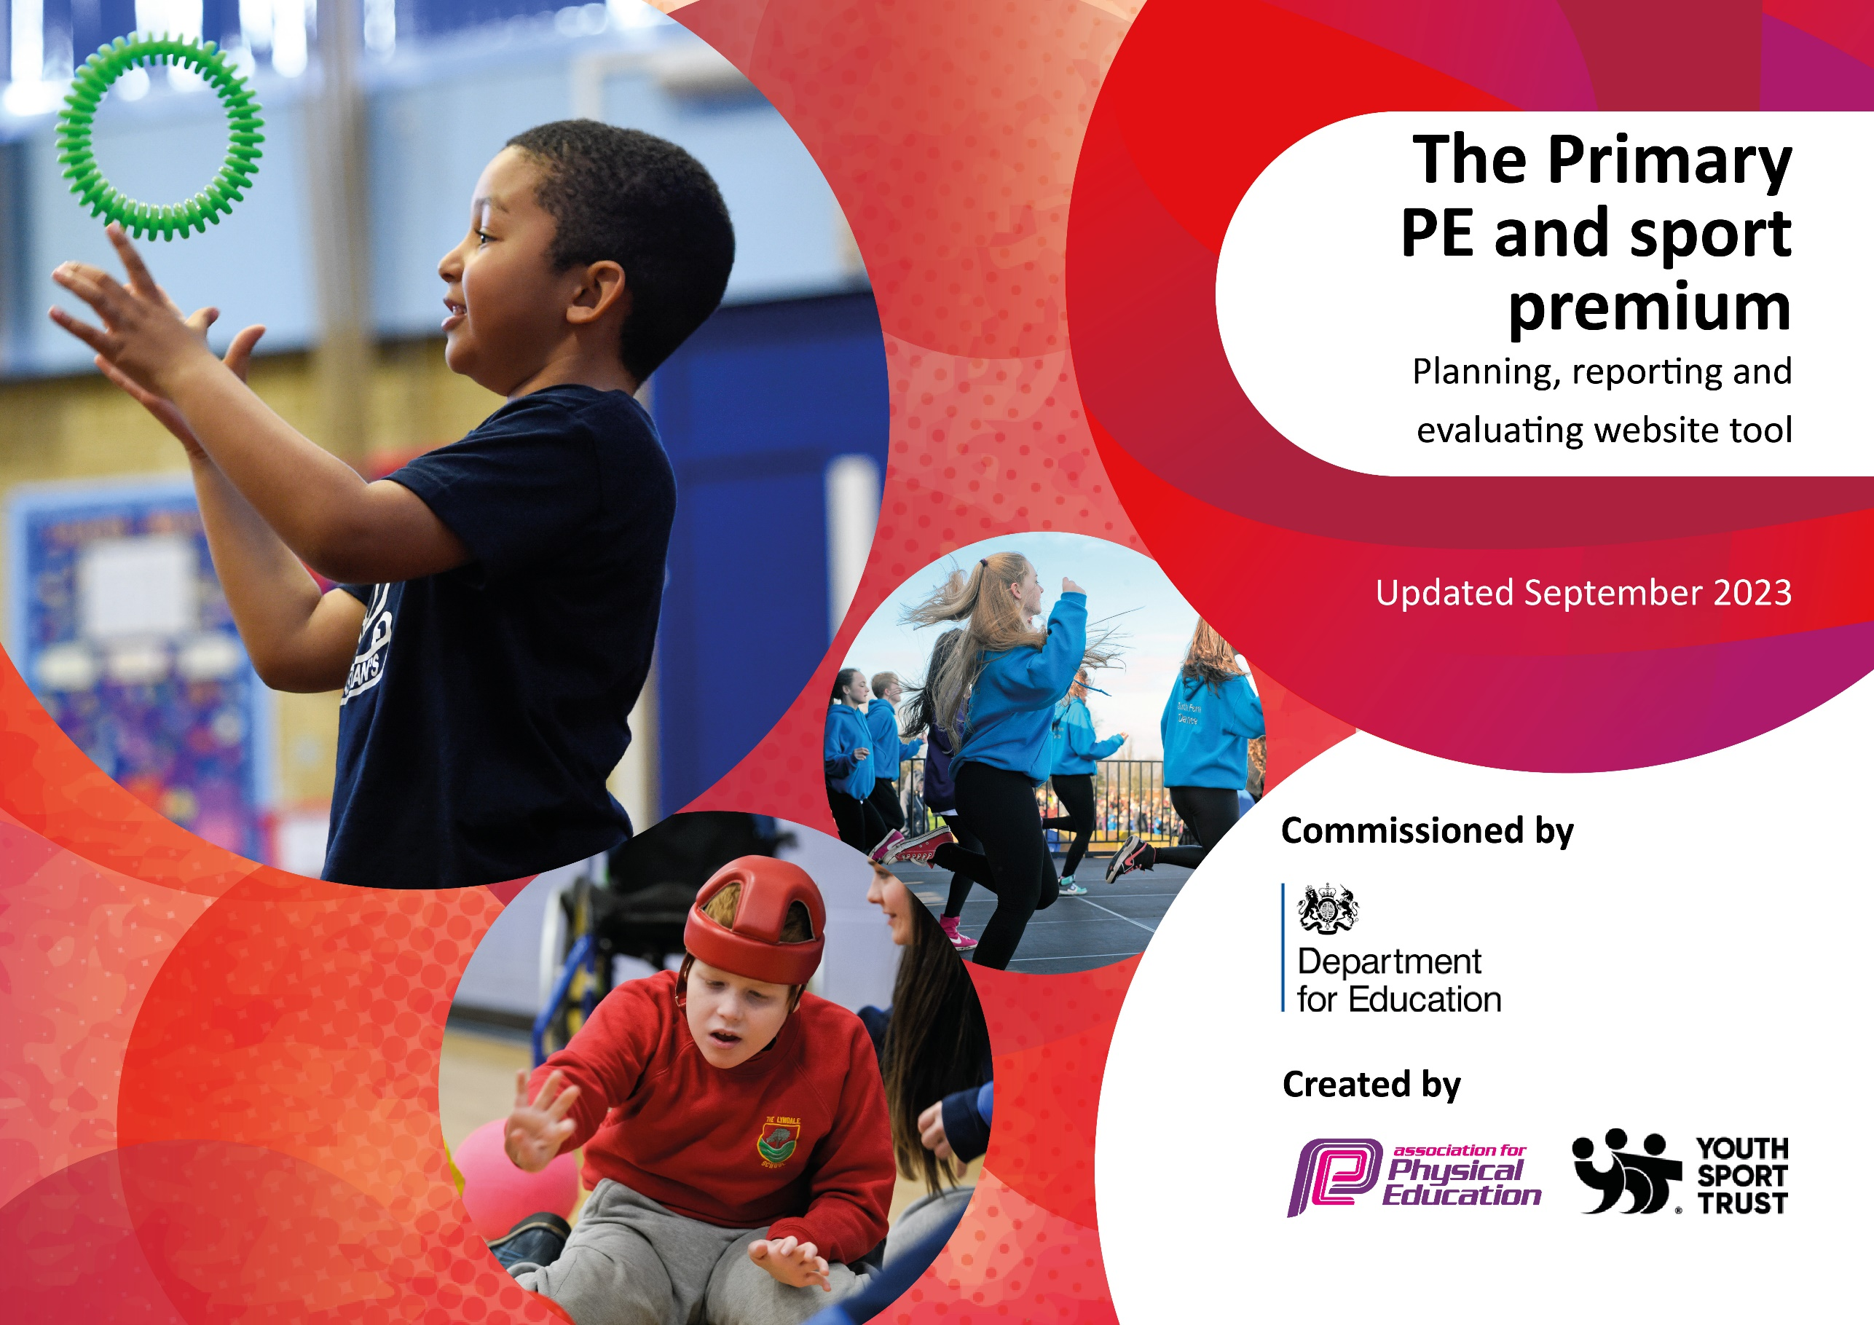

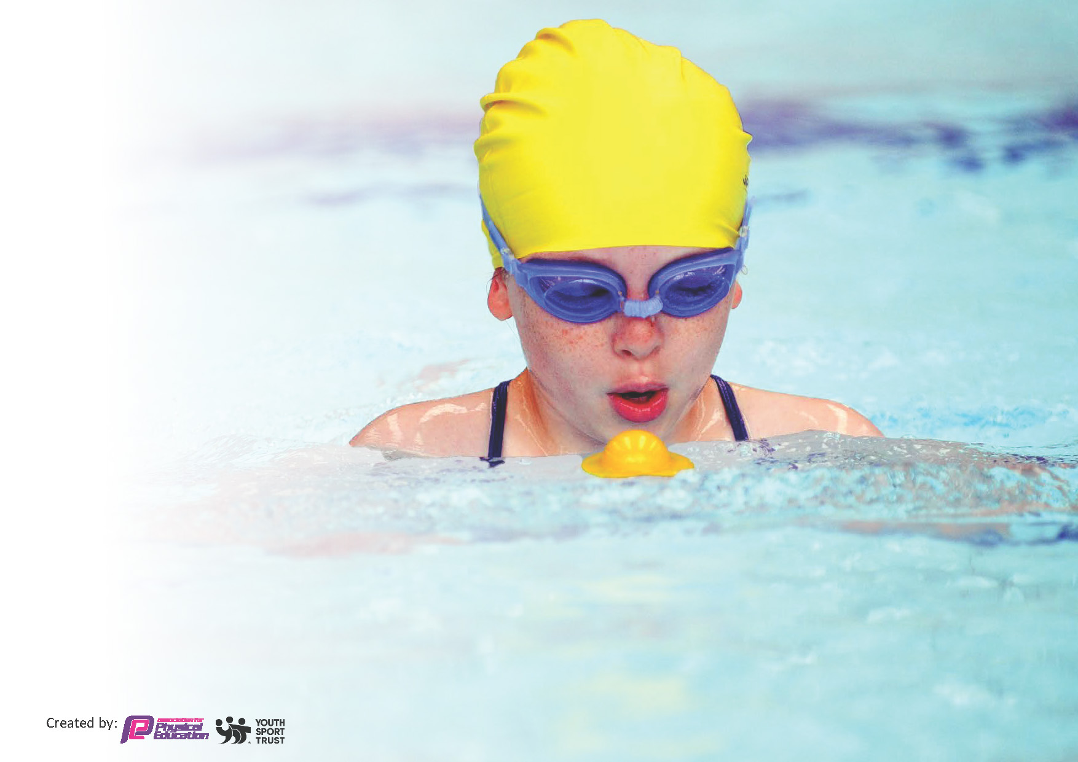
This template can be used for multiple purposes:
by:
- It enables schools to effectively plan their use of the Primary PE and sport premium
- It helps schools to meet the requirements (as set out in guidance) to publish information on their Primary PE and sport premium
- It will be an effective document to support Ofsted inspections enabling schools to evidence progress in Physical Education (PE) and evidence swimming attainment, which forms part of the PE National Curriculum. We would recommend schools consider
the Intent, Implementation and Impact of any spend, as examined within the Education Inspection Framework.

It is important that your grant is used effectively and based on school need.

Schools must use the funding to make additional and sustainable
improvements to the quality of the PE, School Sport and Physical Activity (PESSPA)
they offer. This means that you should use the Primary PE and sport premium to:

- Build capacity and capability within the school to ensure that improvements made now will benefit pupils joining the school in future years
- Develop or add to the PESSPA activities that your school already offers.

The Primary PE and sport premium should not be used to fund capital spend projects; the school’s core budget should fund these. Further detail on capital expenditure can be found in the updated Primary PE and sport premium guidance.

The Primary PE and sport premium guidance, outlines 5 key priorities that funding should be used towards. It is not

necessary that spending has to meet all the key priorities, you should select the priorities that you aim to use any funding towards.

Although completing this template is not a requirement for schools, schools are required to publish details of how they spend this funding. Schools must also outline what the impact this funding has had on pupils’ PE and sport participation and attainment and how any spending will be sustainable in the future. All funding must be spent by 31st July 2024.

The Department for Education has worked closely with the Association for Physical Education (afPE) and the Youth Sport Trust (YST) to develop this template and encourages schools to use it. This template is an effective way of meeting the reporting requirements of the Primary PE and sport premium.
Review of last year’s spend and key achievements (2022/2023)

We recommend you start by reflecting on the impact of current provision and reviewing your previous spend.

Activity/Action | Impact | Comments
- Increased participation and physical activity on playground  - To deliver consistently good PE lessons throughout the curriculum.  - Increase the opportunity for a broader range of sports and activities to be accessed by all pupils  - To increase participation in inter school competitive sporting events  - To provide a wider range of children opportunity to participate in inter school competitive sporting events | - Development of the environment to provide a MUGA to ensure that space is available for physical activity in all conditions.  - Sports TA to support and organise a range of games/activities on the MUGA during lunch playtimes.  - Children are now consistently receiving two timetabled PE lessons a week ensuring coverage of the whole NC.  - The quality of PE lessons has improved. The structure of PE across lessons and the curriculum has improved.  - Children are now more able to recall the learning they have achieved and make links across the curriculum.  - Teachers have identified the improvement of having the sports TA available in terms of both the gathering of correct equipment and their ability to differentiate lessons appropriately.  - Build MUGA and provide markings and permanent equipment for teachers and children to access  - Develop the role of sports TA to organise and support the running of a range of activities across school  - Participation in extra activities outside the leagues has also improved including participation in events such as triathlon, gymnastics and SEN multi skills. This has meant a range of children with differing abilities and backgrounds have been able to participate. | - Further development of the resources available to the children to extend opportunities.  - Train and appoint ‘sports leaders’ to lead activities and promote participation in physical activity during playtimes  - Further celebrate the outcomes and participation in organised intra school competitions.  - Provide opportunities to staff to identify areas of the curriculum where they feel least secure in their knowledge and skills and then provide the relevant CPD.  - Complete an audit of the resources available and purchase further resources needed particularly in sports and activities not usually prevalent within school  - Provide markings on the playground to further the opportunities to participate in different activities within a range of settings across school.  - Continue to develop the number of sports available for children to participate in  - Identify ways to improve the skills of children participating to help future successes within competitive sport.

Key priorities and Planning
This planning template will allow schools to accurately plan their spending.

Action – what are you planning to do | Who does this action impact? | Key indicator to meet | Impacts and how sustainability will be achieved? | Cost linked to the action
- Provide children further opportunities to participate in regular physical activity  - To provide CPD to members of staff to improve the skills of teachers delivering PE and Sport in school  - Introduce a range of sports that children may not have had access to previously  - Sports TA to run a wide range of extra curricular sports clubs to widen the range of activities on offer | - Pupils – more children will be able to access swimming aiming to ensure a greater number of children leave being able to meet end of curriculum requirements  - Staff (ECTs and non PE specialists) – will be required to attend organised CPD and feedback their learning to the subject leader and school  - Pupils – children should see the benefit of receiving higher quality PE lessons based on a better trained staff  - Purchase resources to facilitate the delivery of sports not already provided within school (e.g. Tri Golf, Ultimate Frisbee)  - Miss Straker to run a range of sports/activities after school clubs. | - Key Indicator 2 - Engagement of all pupils in regular physical activity  - Key Indicator 1 - Increased confidence, knowledge and skills of all staff in teaching PE and sport  - Key Indicator 4 - Broader experience of a range of sports and activities offered to all pupils  - Key Indicator 4 - Broader experience of a range of sports and activities offered to all pupils | - More children participating in regular physical activity and also more children able to swim competently.  - Staff will develop skills and confidence in delivering PE resulting in higher quality PE being produced across the school. This will result in a greater % of children achieving working at / above the expected standard.  - Increase participation by a higher % of children in a wider range of sporting activities | £5000  £5000  £10880

Key achievements 2023-2024
This template will be completed at the end of the academic year and will showcase the key achievements schools have made with their Primary PE and sport premium spending.

Activity/Action | Impact | Comments

Swimming Data
Meeting National Curriculum requirements for swimming and water safety.
Priority should always be given to ensuring that pupils can perform safe self-rescue even if they do not fully meet the first two requirements of the National Curriculum programme of study

Question | Stats: | Further context  Relative to local challenges
What percentage of your current Year 6 cohort can swim competently, confidently and proficiently over a distance of at least 25 metres? | 50% | Use this text box to give further context behind the percentage.  e.g., 30% - we are struggling to get pool space due to our local pool closing so we have had to use a much smaller local school pool. We have had to limit the number of pupils attending swimming lessons during one term which means some pupils have attended fewer swimming lessons than others.
What percentage of your current Year 6 cohort can use a range of strokes effectively [for example, front crawl, backstroke, and breaststroke]? | 50% | Use this text box to give further context behind the percentage.  e.g., Even though your pupils may swim in another year please report on their attainment on leaving primary school at the end of the summer term 2024

What percentage of your current Year 6 cohort are able to perform safe self-rescue in different water-based situations? | 88% | Use this text box to give further context behind the percentage.
If your schools swimming data is below national expectation, you can choose to use the Primary PE and sport premium to provide additional top-up sessions for those pupils that did not meet National Curriculum  requirements after the completion of core lessons. Have you done this? | Yes/No
Have you provided CPD to improve the knowledge and confidence of staff to be able to teach swimming and water safety? | Yes/No

Signed off by:

Head Teacher: | Kelly Hannah
Subject Leader or the individual responsible for the Primary PE and sport premium: | Dan Thompson
Governor: | Ged McKevitt
Date: | 16.9.23

