UW | Questions? | RE
Learning about Celebrations  Customs and Traditions  Remembrance Sunday  Bonfire Night  Diwali  Birthdays  Christmas | Please send any emails to  RB: louisethompson@blessedsacrament.lancs.sch.uk  angelamorris@blessedsacrament.lancs.sch.uk  RS:meerachauhan@blessedsacrament.lancs.sch.uk | Learn about celebrations in other faiths and how they are similar and different to ours.  To listen to, act out and retell the story of The Nativity.
English | 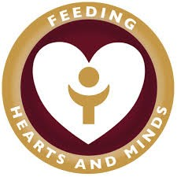 | Maths
Listening to longer stories, talking about their content and making links to other stories,  Learning letter sounds  Phonic blending and segmenting  Using initial sounds to write simple words and captions. |  | Number – Understanding, counting, recognising and writing the numbers to 10  Beginning to investigate number bonds to 10 ( 6 and 4, 2 and 8)  Investigate and name 2D shapes
PD | EA and D | PSED AND STRIVE Focus
Practise team games  Listening and following instructions of movement  Gross Motor skills | Using a range of materials to create  cards, decorations, and items linked to customs and traditions.  Selecting their own resources and discussing reasons for their choices. | Thinking – We are trying to sequence three thoughts or ideas using visual prompts.  Know what a question is and ask a relevant one.  Form an opinion which is supported by an adult.  Identify what has happened and say why  Why are Rules Important?  Keeping safe and helping us to learn.

