UW | Questions?  How Can I Share What I Have ? | RE
Learning about people who help us and keep us safe.  Medical – Florence Nightingale (comparing the past and the present)  Police and Emergency Services  The dentist and dental health | Please send any emails to  RB: louisethompson@blessedsacrament.lancs.sch.uk  angelamorris@blessedsacrament.lancs.sch.uk  RS:meerachauhan@blessedsacrament.lancs.sch.uk | The stories of Easter – Doubting Thomas, Pentecost, The Ascension.  Understanding what it is to be a disciple and how this is also shown in other faiths.
English | 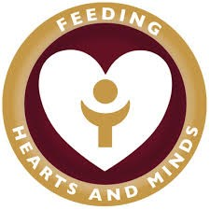 | Maths
Listening to longer fiction and non-fiction texts, talking about their content and making links to other texts and answering questions about what we have read.,  Consolidating Phase 3 and introducing Phase 4 phonemes.  Phonic blending and segmenting  Using phonic knowledge to write words and captions and sentences. |  | Number – Understanding the process of addition and subtraction.  Counting on and back from a given number.  Doubling numbers up to 10, seeing the pattern and using this knowledge to solve problems.
PD | EA and D | PSED AND STRIVE Focus
Practise team games  Listening and following instructions of movement  Gross Motor skills | Music – Charanga – Everyone. Learning about pulse and rhythm. Creating sounds, listening and discussing pieces of music.  Using a variety of media inside and outside to create collaborative works of art.  Studying the work of the artist Kandinsky and producing a piece of art work in a similar style | Valued Collaboration- working together.  Understanding the benefits of working as a group in PE, in outdoor adventures and knowing that some goals are difficult to achieve alone.

