Accessing Reading Bug from Home

- Email Mr T (3S) using danthompson@blessedsacrament.lancs.sch.uk or Mrs McCaul (3B) using clairemccaul@blessedsacrament.lancs.sch.uk to request your username, password and school code.

- Use a search engine to search for ‘active learn primary’
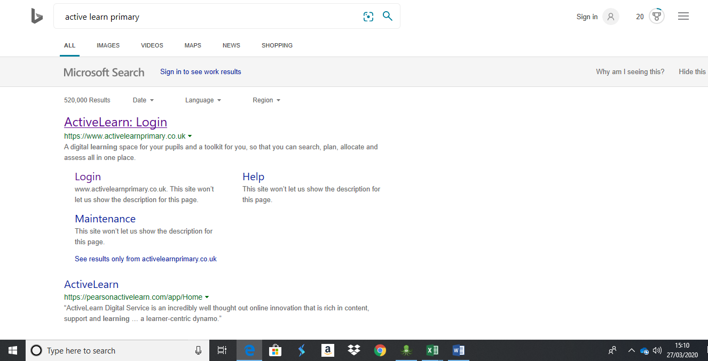

Click this link

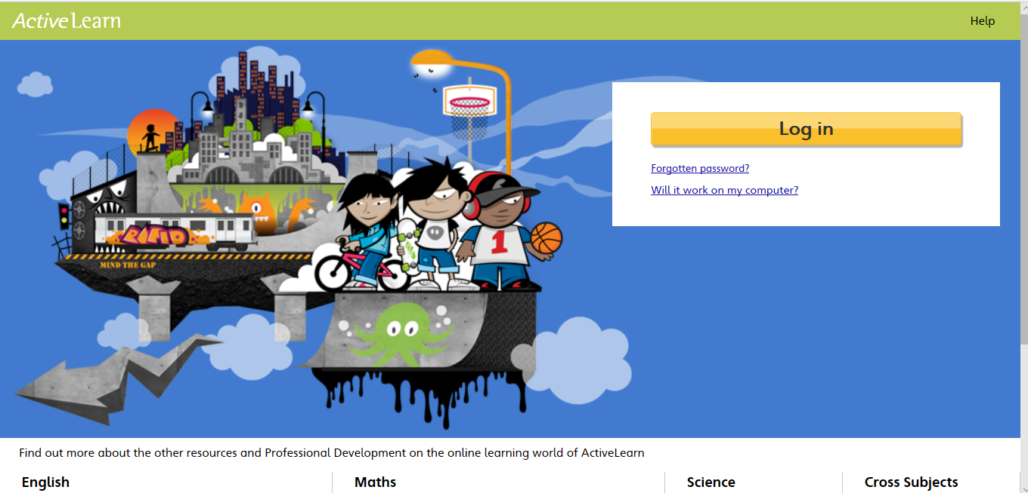
- Should bring you to this page.
Click here

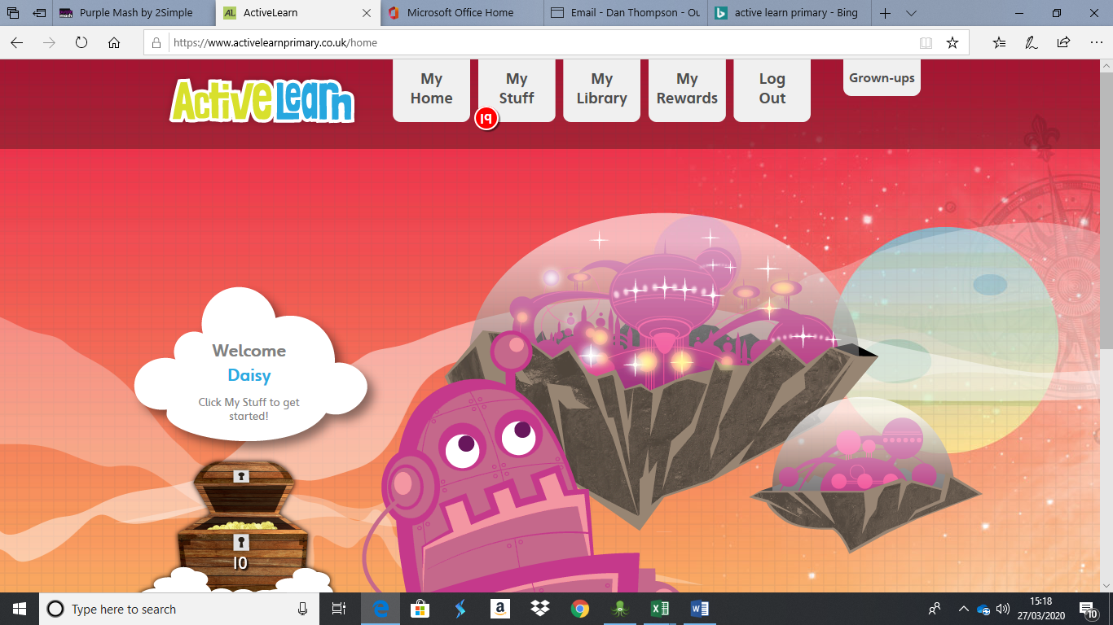
- Complete the fields with the given username, password and school code. This will then take you to this page.

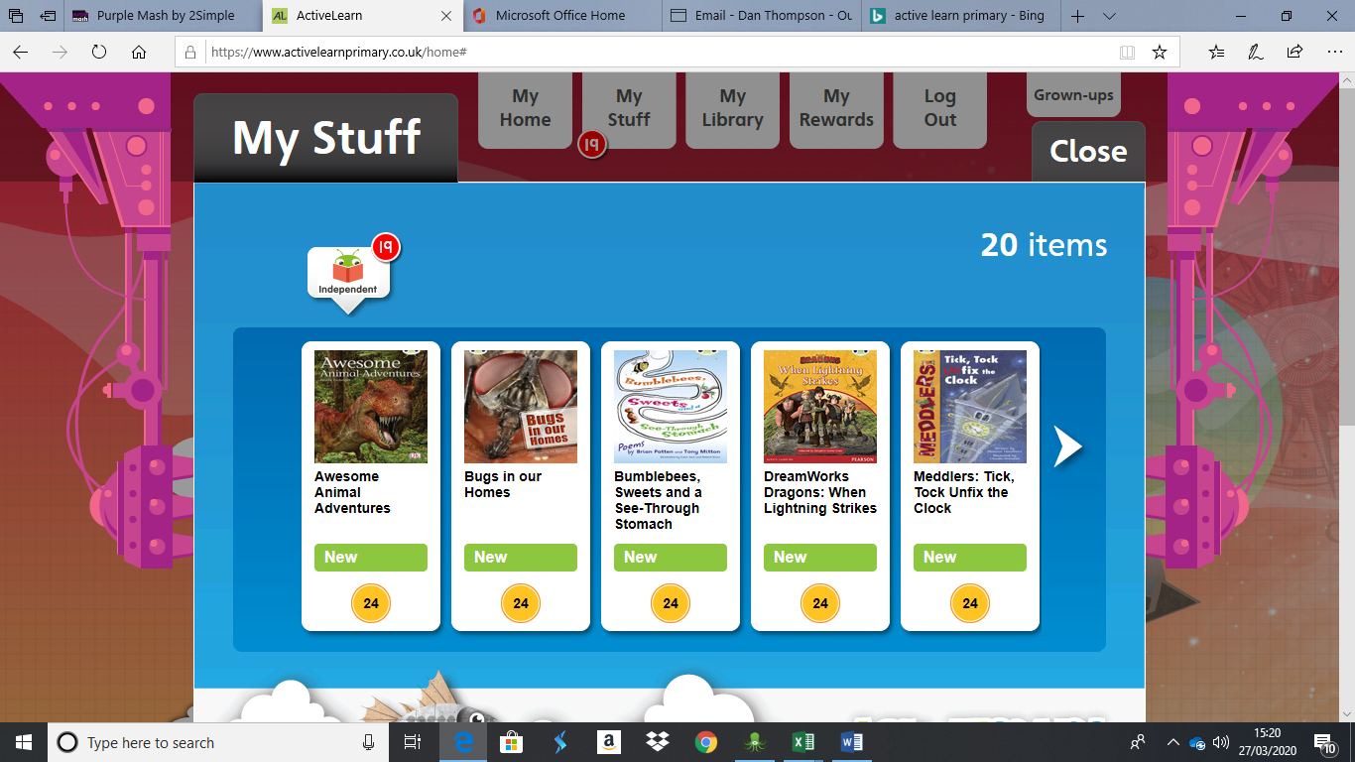
- Click on the My Stuff tab at the top of the page. This will open a selection of books which can be read online. Children to choose a book and begin reading.

- You will need to make sure that you allow all pop ups for the children to access the book. When you open a book it will look like this.
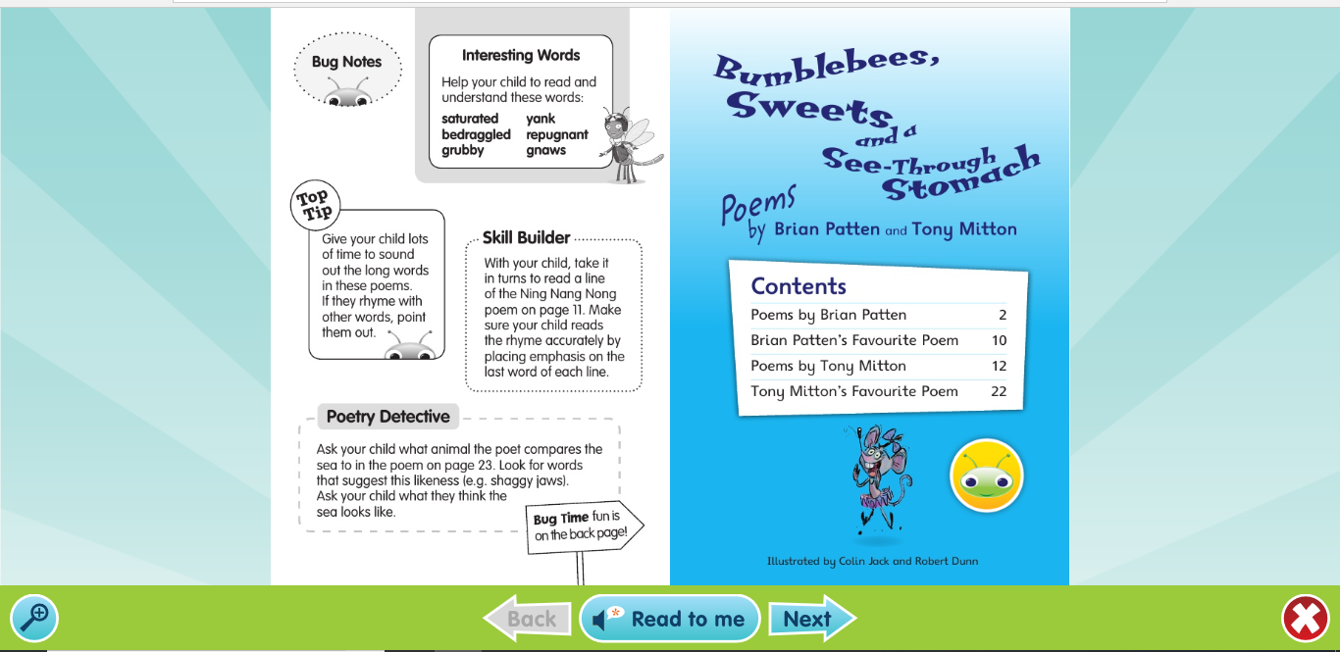
If there is a button like this whilst reading, it will ask the reader a question about what they have read.
Press this to move to the next page
If you press this the book will be read out loud

Example
