Lead Subjects | Additional Subjects | Getting Started | RE
Geography this term will compare the human and physical geography of 2 places – the UK and South America. We will explore the vast array of contrasting biomes and vegetation belts, further research using ICT and Digimaps, and interpret data about the locations.  In Science, we will be learning about Space. Children will understand that the Sun is a star at the centre of our solar system with the planets orbiting around it. | PE this term will focus on net and wall games. Children will develop a range and quality of skills using rackets, develop effective serving techniques and tactics and learn specific tactics and skills for net/wall games.  5S PE day is a Tuesday.  5B PE day is a Monday. | clairemccaul@blessedsacrament.lancs.sch.uk  kdelaney@blessedsacrament.lancs.sch.uk  Any questions? Please get in touch.  We expect the children to be reading for at least 15 minutes each day at home. Please sign their reading record daily and return to school. Your children can change their book as often as they need to. Please ask your child questions about what they are reading. | Gospel value - Humility and Gentleness - “Blessed are the meek, for they shall inherit the earth.”  During Eastertide, children will learn about the significance of Jesus’ appearances to His friends before returning to His Father in Heaven.  Children will gain a deeper understanding of Jesus’ resurrection and Pentecost knowing that this is the time the disciples were gifted the Holy Spirit to spread the Good News.
English | 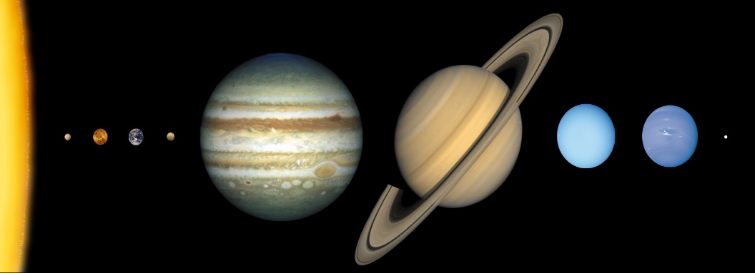 |  | Maths
Our class novel will be Aquila.  Children will write their own science fiction narrative based on our class novel.  We will then move on to report writing.  Can they write a report about a UFO sighting? |  |  | Our focus areas for Maths will be place value with decimals, fractions, Measures (time and statistics), geometry, addition and subtraction along with multiplication and division.
Art | DT/Computing | Spanish | STRIVE Focus
Children will create 3D Space art looking at different textures and patterns which will help them to create their outer space art. | Children will get their game heads on and create their own programmes with a quest. They will develop settings, characters, and create different levels with different levels of challenge.  In DT, we will be making our own Viking bread after researching and adapting our own recipes. | La ropa – Children will learn about the different types of clothing they wear and will learn about the verb ‘ponerse’ – to wear! | Our STRIVE focus this term will be focussing on Valued collaboration.  Children will understand how to work co-operatively with any group member, reach agreements by talking and will learn to take on roles within a group and contribute to an end product.

