Date: 13th February 2020

To: Parent/Carers of children in Y4B

Dear Parents/Carers,

Swimming lessons start for your child on Tuesday 25th February 2020 (First Tuesday back after half term.)

Please note lessons are from 2:00 pm – 3:00 pm so can you arrange to collect your child at 3:30 pm on swimming days.

On swimming days children need to bring a bag to school containing:-

- A towel
- Boys - a pair of swimming trunks (not shorts)
- Girls – a one piece swimming costume
- Boys and girls – a swimming hat

Please note the following:

- Earrings must not be worn.
- Drinks, sweets or other foods are not allowed.
- The wearing of swimming goggles is discouraged. (Medical reasons only with a note from the doctor.)
- Swimming hats are available for sale at the Leisure Centre at a cost of £1.30 each which is cheaper than the sports shops.

Kind Regards
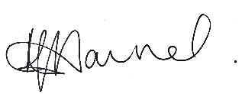
Miss K Hannah
Headteacher

