RE | Science | Questions? | Art
In RE we are focusing mainly on the Christmas story. We will look at the struggles Mary and Joseph faced and their journey to Bethlehem. | Human growth, hygiene and survival  Pupils will be learning about how we humans change as we get older. We will also look at the benefit of exercise and the effect on our bodies. | Please send any emails to  nancybillingsley@blessedsacrament.lancs.sch.uk  enotman@blessedsacrament.lancs.sch.uk | In Art, we will be looking at drawing with a variety of different materials. We will start by drawing firework pictures and then move onto focusing on artwork by Giuseppe Arcimboldo.
English | 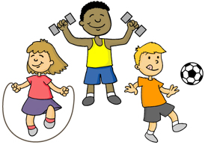  Year 2  Why Are Rules Important?  Personal health + hygiene |  | Maths
Instructions  This unit will be based around the book ‘Neil Gaiman – Instructions’ and will write their own instructions based on the book.  Stories with a familiar setting  In this unit we will write stories linking to our theme of important rules.  Classic poetry  In this unit we will look at poetry around the theme of Christmas. |  |  | Geometry  Counting, Multiplication and Sorting  Statistics  Fractions
PE | Computing | PSHE | STRIVE Focus
We will be focusing on fundamental movement skills this half term but specifically teaching throwing and catching. | In Computing, we will be looking at online safety. We will focusing on where to go for help and support if we see something inappropriate or worrying. | In PSHE, we will be looking at keeping ourselves safe, what to do when feeling unsafe and bullying. | Our STRIVE focus for this half term encourages the children to think for themselves and make positive choices.

