RE | Science | History | Questions
In RE this half term, we are going to be focusing on The Lord’s Prayer. We are going to be exploring what it means and how we live this out in our daily lives as Catholics. | Our focus in science this half term is on Forces and Magnets. We will be using scientific investigative skills to explore how magnets work. We will also be devising conducting research and asking questions about magnets and forces. | This half term we will be learning more about the Romans. More specifically, we will be looking at the Roman way of life including how they lived, what they wore, what they did for enjoyment, what Roman children did. We will find out how Romans have influenced our lives today. | Please send any emails to:  michaelnewton@blessedsacrament.lancs.sch.uk  trudiwindsor@blessedsacrament.lancs.sch.uk
English | 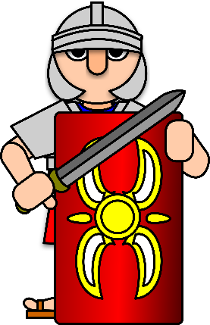  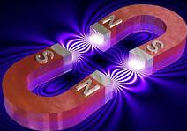 |  | Maths
This half term we are enjoying classic poetry. We are exploring lots of poems and using our literacy skills to write poems to perform to the class.  We are also learning about biographies as chronological non-fiction texts. We are learning about some famous and influential people before writing our own biographies about famous individuals. |  |  | Maths Mastery Units covered:  - Fractions  - Position and Direction  - Time  - Multiplication and Division  - 2D shape  - Decimal Place Value
PE | Geography | DT | PSHE
Year 3 will be developing their games skills this half term. They will be improving their ball skills – both throwing and batting while playing games such as cricket, tennis and rounders. | In geography, we are going to be using mapping skills using maps, both digital and in an atlas to locate places on a grid. | In DT, out topic is Levers and Links. We are going to be designing and making mechanisms to create an effect or for a purpose. | We are learning how to be a good listener in PSHE. Our Strive focus this half term is Valued Collaboration  Our Well-being sessions will continue to focus on developing our social, emotional and physical wellbeing.

