English | Lead Subjects | Maths | Additional Subjects
Information booklet:  Key Text: The Mayan Civilisation  Play scripts:  Key Texts:  Dangle  The Switch  Non-chronological reports:  Key texts: A variety of chosen texts | Science -  Living things and their habitats  States of matter  Geography -  Map skills and fieldwork of the UK  DT -  Making an electrical system | Counting and sequences with statistics.  Fractions and decimals with measures.  Fractions and division.  Measures - volume/capacity and mass.  Shape and area.  Multiplication facts  Time | Computing - Shell structures and using CAD nets to create structures.  History - The Ancient Greeks  PSHE/Wellbeing - Online relationships  PE - Gymnastics and dance  Music - Pop music (Blackbird by the Beatles)  Spanish - La familia
RE | 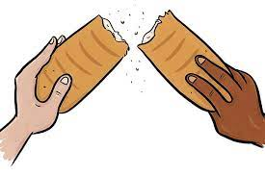  STRIVE -Valued collaboration |  | Questions
The Resurrection  The Universal Church |  |  | If you have any questions please email:  Year 4 Blessed - Mr Whalley  stevenwhalley@blessedsacrament.lancs.sch.uk  Year 4 Sacrament -Mr Readey  chrisreadey@blessedsacrament.lancs.sch.uk
Visits / Visitors | Key Dates to Remember | STRIVE Focus | Useful Information
To be confirmed | PE - Thursday  Home Reading Books - Mon, Wed & Fridays  Holy Days  Pentecost Sun 23rd May | Valued collaboration  Building relationships, communication, being positive, taking turns, sharing, negotiation and understanding others views. | School website -  https://blessedsacrament.lancs.sch.uk/

