English | Watch Handa’s surprise on you tube (type in Handa’s surprise on you tube). https://www.youtube.com/watch?v=XyIV_xYi0as  Question your family what they know about the continent of Africa. Find the map draw a picture and write some sentences about Africa. | Draw a basket of fruit like Handa’s surprise with your favourite fruits.  Write sentences to describe what is in your fruit bowl at home. Can you use describe the colour, shape, taste? | How many fruits can you name against the letters of the alphabet? A is for apple B is for banana ……  Write sentences about your favourite African animal and say why. Use because in your answer.  Imagine you are lost in Africa. Write a short passage about what creatures and plants you would meet.
Maths | Multiplication  Practise counting in twos, fives and tens  Watch have fun teaching counting rap songs.  Money:  set up a shop at home. Children to come to the shop and buy items.  Children to recognise all the coins.  How many different ways can they make 2p, 5p, 10p, 20p, 50p, £1 and £2.  Type in on google ICT money games.  Top marks- money, telling the time.  Websites:  http://www.ictgames.com/mobilePage/money.html  http://www.topmarks.co.uk/maths-games/5-7-years/multiplication-and-division  http://www.bbc.co.uk/bitesize/ks1/maths/multiplication/play/  https://www.everyschool.co.uk/maths-key-stage-1-multiplication.html | Shape  Shape finder- go on a walk around your house and find all the shapes. Draw a picture of the item found and write what it is and the shape.  Clock- circle  Cereal box – cuboid.  Remember 2D shapes are flat.  3D shapes are solid.  Time:  Write a diary of a day in a life of ……… Complete what you do a each time of the day with pictures and sentences.  Number Jack https://www.youtube.com/watch?v=inGDsk7V1sw  Learn to tell the time to o’clock and half past.  Time website to support you.  http://www.primaryhomeworkhelp.co.uk/maths/measures.htm  https://www.ictgames.com/mobilePage/hickoryDickory/  https://www.youtube.com/watch?v=NS-2dUpkoHA | Important year 1 learning.  Number Bonds  Practise Number bonds to numbers 1-20  One more and one less for numbers to 100  Write numbers 1-100 with the correct number formation.  Practice all doubles and halves of numbers to 20.  Websites:  http://www.topmarks.co.uk/Search.aspx?q=number%20bonds%20to%2020  http://www.ictgames.com/moreless.htm  http://www.topmarks.co.uk/Search.aspx?q=ONE%20MORE%20OR%20LESS
Topic | Draw a picture of an African animal. Write sentences or label the animal. | Make a collage of different fruits. Design a new front cover for Handa’s Surprise. 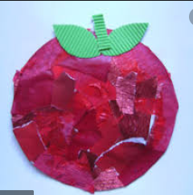 | Create a colourful African setting using a resources of your choice.
Science | Choose a plant and write 10 interesting facts about it. Present your work in an interesting way. | Plant something of your choice. Keep a plant/flower diary. Record what you have planted and when. Keep note of how much water you give it, measure its height. Take pictures. Present your work in a booklet. | Draw a labelled picture to show the differences between the different parts of a plant.  Write a set of instructions on how to grow a plant.
Working Together | Make a jungle box out of junk modelling.  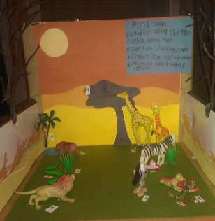  Listen to some African music. Do you like the music? Can you copy the beat? Create an African musical instrument using household materials. | Draw a map of Africa. Label the oceans and at least two countries.  Draw a picture of what you see in the garden and trees, use paint, chalk, felt pens, pencils or crayons.  Create a fruit salad then write out the recipe. A set of instructions on how to make a fruit salad. Remember to use time words. First, next, after that. | Create a textured picture/poster of your favourite plant/flower.  Create an African animal out of junk modelling.  Try a new fruit. Write a few sentences to describe what it tastes like? Do you like it? Does it taste like a fruit you know

