EYFS Policy

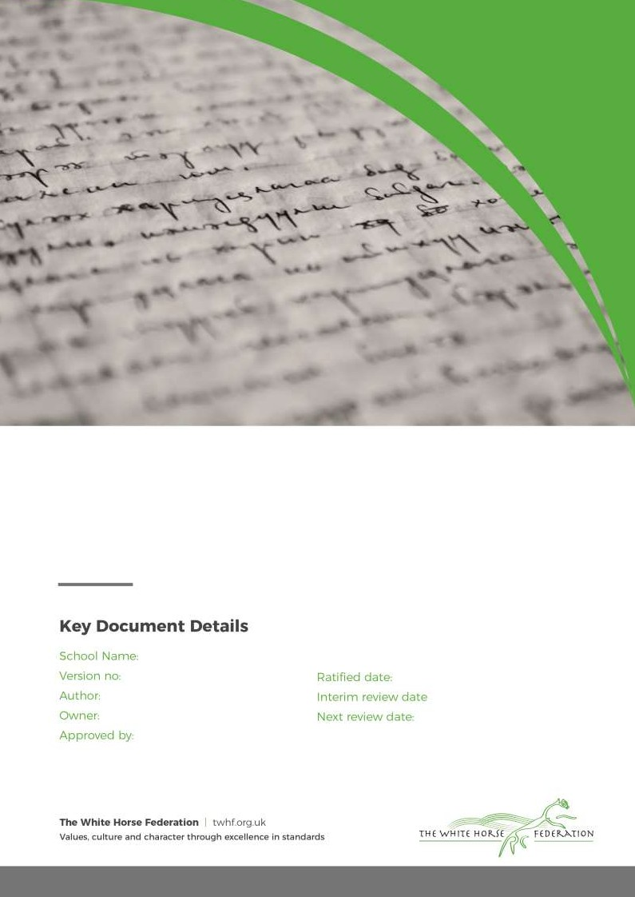
The Croft Primary School
1
E Murphy E Murphy
Simon Cowley

Sept 2022
October 2024

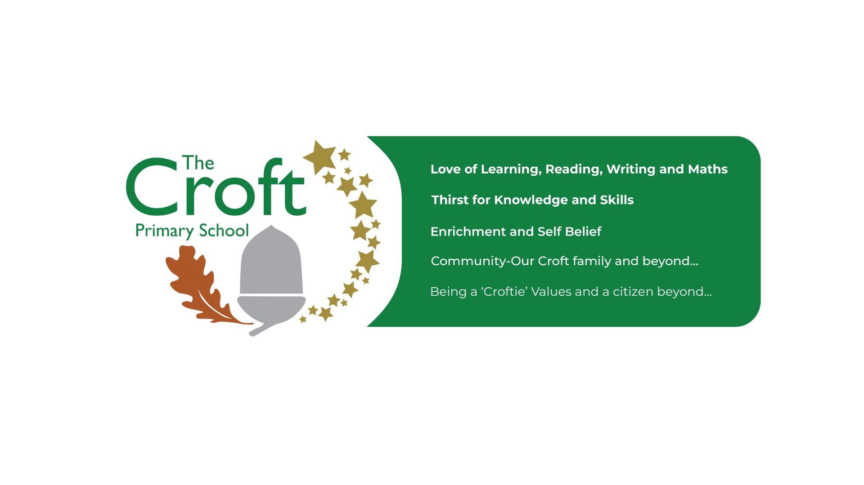

It is our intent that children who start in in Reception at The Croft Primary School develop a love a learning. We will support children in beginning their lifelong learning journey to make progress in all areas of learning from their individual starting points. At The Croft Primary School our aim is to create high quality learning environments that support, enhance and invite every child’s curiosity, confidence and development. Every child has access to a broad, balanced and differentiated curriculum that reflects our community; this prepares them for now and for the future in terms of opportunities and experiences. Through a language rich environment all children are supported and given opportunities to become skillful communicators who connect with others through language and play. We work collaboratively with parents and carers to encourage independent and enthusiastic learners who thrive and reach their full potential. The curriculum offer supports children to achieve a ‘Good Level of Development’ at the end of Reception.

Statutory Framework for EYFS
- It is to provide a secure foundation for all children through planning for the learning and development.
- It ensures quality and consistency across all Early Years settings.
- 7 areas of learning
- At the end of the Reception Year children are assessed against 17 Early Learning Goals (ELGs). This is what all children are aiming to achieve by the end of their Reception year (the knowledge, skills and understanding of the curriculum) and indicates whether they have achieved a Good Level of Development (GLD).
- the curriculum) and indicates whether they have achieved a Good Level of Development (GLD).
- The EYFS Statutory Framework
- Characteristics of Effective Learning
- Playing & Exploring: Children investigate and experience things, and
- ‘have a go’
- Active Learning: Children concentrate and keep on trying if they encounter difficulties and enjoy achieving
- Creating & Thinking Critically: Children have and develop their own ideas, make links between ideas, and develop strategies for doing things

These are the Prime Areas
Personal, Social and Emotional Development
- Self-regulation
- Managing Self
- Building relationships

Physical Development
- Gross motor skills
- Fine motor skills

Communication & Language
- Listening, attention & understanding
- Speaking

Specific Areas of Learning
Literacy
- Comprehension
- Word Reading
- Writing
Understanding The World
- Past & Present
- People, culture & communities
- The natural World
Mathematics
- Number
- Numerical Patterns
Expressive Art & Design
- Creating with materials
- Being imaginative & expressive

Child - Initiated Learning and Play

At The Croft Primary School, we believe play and child initiated learning to be the means through which young children learn. It is through child initiated learning that children have the opportunity to explore, develop and act out experiences, helping them make sense of the world. Play helps children build up ideas and develop self-control and understand the need for rules. Children investigate and solve problems through collaborative and individual play; children can work at their highest cognitive level in self-chosen play.
We provide the children with a safe and secure environment. We aim to develop good relationships with all children by interacting positively with them and taking time to listen. We also model and support children in forming positive relationships and friendships with one another. It is the role of all adults within the environments to engage in high quality interactions with all children and scaffold children’s learning to support them to make progress.

At The Croft Primary School we recognise the learning environment plays a key role in supporting and extending the children’s development. The reception classroom, both the indoor and outdoor area, are well organised to allow children to explore and learn securely and safely. There are areas where the children can be active and can be quiet.

The environments are set up into learning areas to enable the children to find and locate resources and equipment independently. Within the learning environment, children can choose which area of the environment they would like to learn in. Child initiated learning opportunities are accessible both indoors and outdoors, where the three prime areas and four specific areas of learning are offered with equal importance. High quality active learning occurs when children are motivated and interested.

Throughout the school day, there will be a variety of whole class learning, small adult-led group sessions, 1:1 learning and learning in the environment (“choose your own learning”).
What does Reception look like at The Croft?
- A Continuation of the Early Years Curriculum
- A Play based framework
- Child initiated and adult initiated learning
- 10-15 minute teacher led sessions: 1:1 learning, whole class and small groups with a focused area of learning
- Carpet sessions and circle times to support with speaking and listening and social skills
- Daily phonics – whole class (Little Wandle)
- Choose your own learning with carefully planned learning opportunities in the environment
- Indoor and outdoor learning
Planning

Our curriculum coverage is based upon the Educational Programmes outlined in the Early Years Foundation Stage framework (2021). The educational programmes are the areas of learning and development that shape the activities and experiences that the children will experience in Reception.
Skills progression and knowledge of child development informs planning in all areas of the curriculum. Staff have a secure knowledge of individual children’s starting points and have a clear understanding of how to ensure children reach their full potential at the end of the EYFS.

Assessment and Observation

Before children begin reception, a member of the Early Years team discusses the ‘Moving on document’ with the child’s key worker in their current setting. This information and discussion supports their transition to school.

Within the first six weeks of starting school, all children in Reception will complete the Reception Baseline Assessment (RBA); it is a statutory assessment. It is a short task-based assessment that assesses children’s starting points in language, communication and literacy and in mathematics. It provides a starting point to measure the progress schools make with their pupils between reception and the end of primary school. In addition to the RBA, the staff in Reception will carry out internal, observational based, assessments to create a secure judgement of all children’s starting points.

Throughout the year reception teachers and teaching assistants will engage and interact with children within child-initiated learning. Some of this learning will be recorded as an observation on Tapestry (online learning journal). Parents have access to their child’s online learning journey, can respond to observations of learning in school and are encouraged to add information about their child’s learning at home.

The planned, adult led activities offer insight into children’s attainment however it is mostly evidence through observing and engaging with children in their child-initiated learning that are used as judgements for the EYFS profile.

The ongoing assessments of the children are collected and recorded into the children’s Learning Journeys. Assessments are collated through high quality interactions and observations that our practitioners have with the children. These assessments are then used to create a judgement of ‘on track’ or ‘not on track’ for the end of year expectations. These judgements are recorded onto our tracking system on Pupil Asset three times a year. For those children judged as not being on track to meet the end of year expectations, next steps will be planned for based on their gaps in learning.

Internal moderation take place within The Croft Primary School, across the White Horse Federation and schools within the local area to secure and validate our judgments of children’s attainment.

Behaviour and Values Based Education
- Focus on learning behaviours - resilience/resourcefulness
- Positive affirmations of appropriate behaviour - thank you for listening, well done for sticking at that tricky task, I am looking for someone who is showing me they are listening
- Home School Agreement & Behaviour Policy – All school policies can be found on our website
- CROFTIE values and Show Me 5
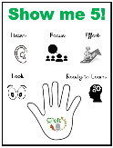
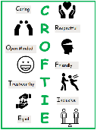

Working in partnership with Parents and Carers

We recognise that parents and carers are children’s first and enduring educators and we value the contribution that they make. We appreciate the role that parents have played and their future role in educating the children.

We achieve this by:
- Talking to parents about their child before they start school and holding an induction workshop for parents with key information.
- Visits to all children in their home setting prior to starting school.
- Giving the children an opportunity to come into school to spend time in the environment and get to know their teacher. They are invited to a stay and play session before starting school.
- Parents evening in Term 1 to discuss how children have settled into Reception
- Parents evening and reports throughout the year
- Open evenings
- Encouraging engagement with Tapestry
- Parent workshops for all areas of learning

