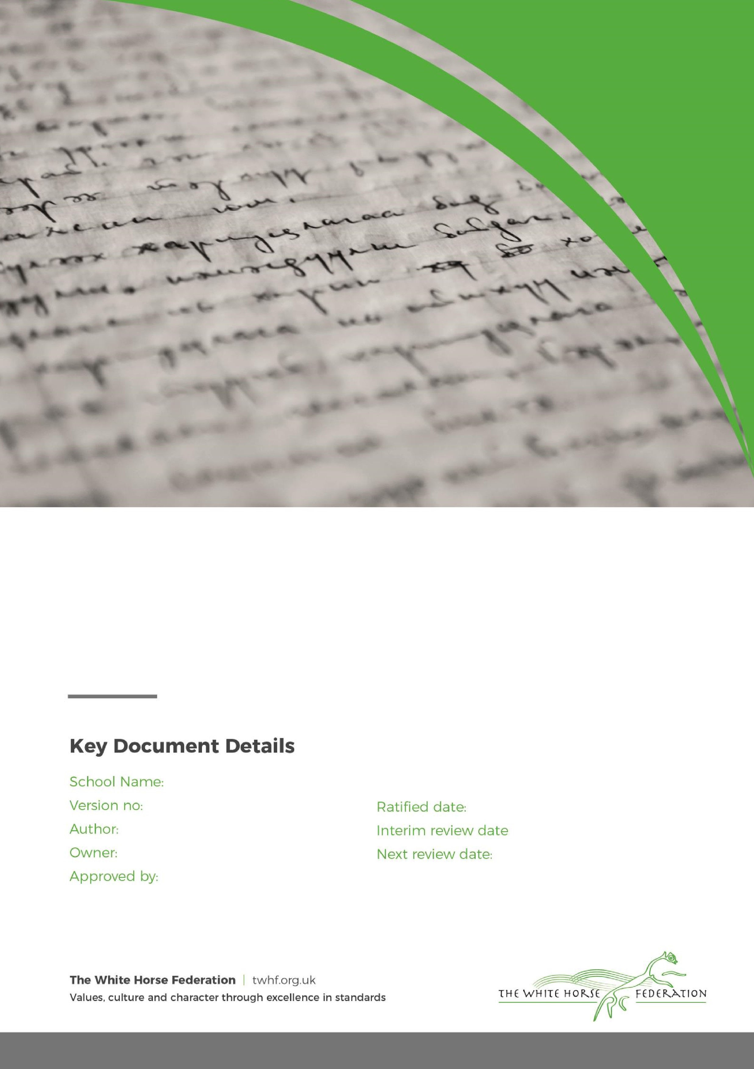

The Croft Primary
School

Homework Policy

1

Elaine
Murphy

Elaine Murphy

Simon Cowley

September 2023

n/a

September 2024

The Croft Primary School

Intent
Homework is to enable children to practise skills that they have been taught within that week or Term, we give children tasks that enable them to improve their fluency, confidence as well as support deeper and more fluent recall. Homework also enables children to develop a sense of responsibility for their own learning. We provide a diet of homework that blends these different purposes. We provide routine questions (fluency,challenge)-like those we practise in class as well as knowledge retrieval (spellings, factual recall).

Homework Expectations
- Term 1 - Term 6
- Worksheets to be stuck into homework book
- Homework to be closely linked to the skills covered in school that week
- Homework and Reading Books to be given out on Friday and collected in on Wednesday
- Homework Champion to be chosen and celebrated termly from each year group
- Additional half term projects can be set as appropriate

Year Group | Homework
Reception | Reading  Phonics flashcards (graphemes/tricky words)  Literacy/Maths (alternate weeks – from T2)
Year 1 | Reading  Phonics flashcards (graphemes/tricky words)  English/Maths (alternate weeks)  Spellings (from T2)
Year 2 | Reading  Phonics flashcards (as appropriate)  English/Maths (alternate weeks)  Spellings
Year 3 | Reading  Spellings  English/Maths (alternate weeks)  Times tables
Year 4 | Reading  Spellings  English/Maths (alternate weeks)  Times tables
Year 5 | Reading  Spellings  Maths CGP (weekly)  Grammar CGP (weekly)
Year 6 | Reading  Spellings  Maths CGP (weekly)  Grammar CGP (weekly)

Marking
Children can self-mark where appropriate but there must also be acknowledgement from an adult that it has been looked at (stamps will be provided).
Parental engagement
- We ask that the parents support children when and if appropriate
- We ask that they email or talk to the class teacher if they are not able to complete homework

Impact

Homework enables children to rehearse/practise in school learning to support their in class learning and support progress.

Page
3

of
3

Pupils with special educational needs

We set homework for all children as a normal part of school life. We ensure that all

tasks set are appropriate to the ability of the child. If a child has special needs, we

endeavour to adapt any task set so that all children can contribute in a
positive way. When setting
homework to pupils who are named on the register of special needs, we refer to the Individual Education
Plans (IEPs). More able children are given weekly homework which is aimed at expanding creativity and
thinking skills. This i
s published to parents at the start of each term.

Marking

Children can self
-
mark where appropriate but there must also be acknowledgement from an adult that it
has been looked at (stamps will be provided).

Parental engagement

•

We ask that the parents su
pport children when and if appropriate

•

We ask that they email or talk to the class teacher if they are not able to complete homework

•

We ask parents to check the home/school diary at least once a week and to sign it as requested.

Impact

Homework enables c
hildren to rehearse/practise in school learning to support their in class learning and
support progress.

T
o promote a partnership between home and school in supporting each child’s learning

Monitoring and review

It is the responsibility of our governing

body to agree and then monitor the school homework policy. This
is done by the committee of the governing body that deals with curriculum issues. Parents complete a
questionnaire during the school’s OFSTED inspection, and our governing body pays careful c
onsideration
to any concern that is raised at that time, or in between OFSTED inspections, by any parent. Our
governing body may, at any time, request from our Headteacher a report on the way homework is
organised in our school.

