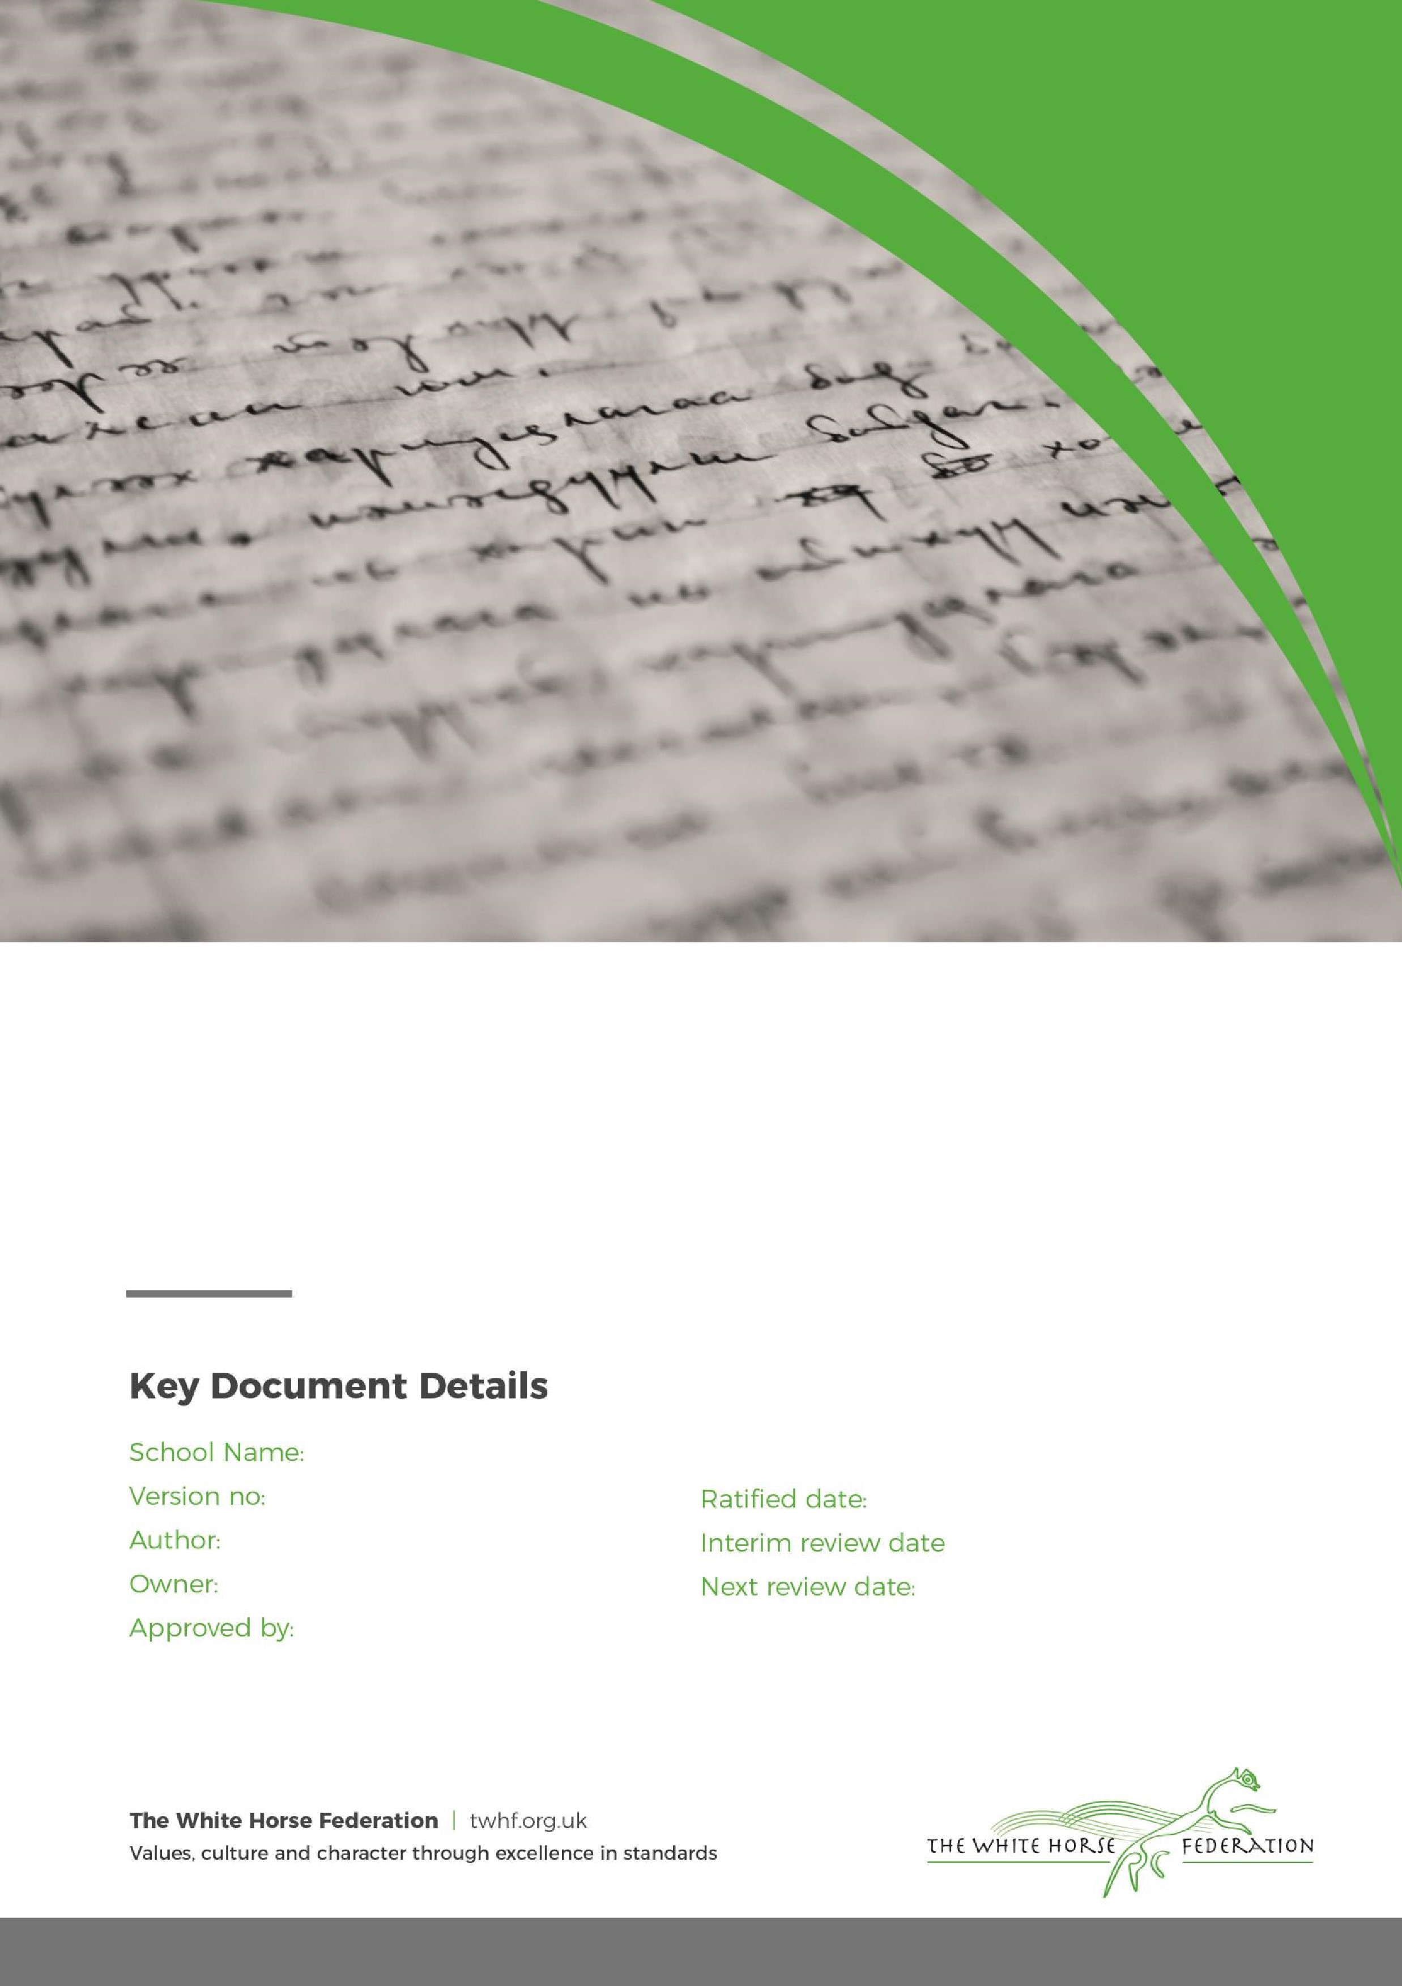

Special Education Needs (SEN)

Information Report

1

Tim James

Tim James

September / 2024

Month / Year

The Croft Primary School

Month / Year

# **Dear Parents and Carers,**

The aim of this information report is to explain how we implement our SEND policy. In other words, we want to show you how SEND support works in our school.

If you want to know more about our arrangements for SEND, read our SEND policy.

You can find it on our website [Special Educational Needs and Disabilities Information | The Croft Primary School](https://thecroft.swindon.sch.uk/about-us/school-information/special-educational-needs-and-disabilities-information)

**Note:** If there are any terms we’ve used in this information report that you’re unsure of, you can look them up in the Glossary at the end of the report.

# **1. What types of SEN does the school provide for?**

Our school provides for pupils with the following needs:

|  |  |
| --- | --- |
| **Area of need** | **Condition** |
| **Communication and interaction** | Autism spectrum disorder |
| Speech and language difficulties |
| **Cognition and learning** | Specific learning difficulties, including dyslexia, dyspraxia, dyscalculia |
|
|
| Moderate learning difficulties |
| Severe learning difficulties |
| **Social, emotional and mental health** | Attention deficit hyperactive disorder (ADHD) |
| Attention deficit disorder (ADD) |
| **Sensory and/or physical** | Hearing impairments |
| Visual impairment |
| Multi-sensory impairment |
| Physical impairment |

# **2. Which staff will support my child, and what training have they had?**

Our special educational needs co-ordinator, or SENCO

The SENCO, Miss Karen Myler, is a fully qualified and highly experienced teacher. She has 12 years teaching experience. She gained her National Award for Special Educational Needs Coordinator in 2014. Miss Karen Myler gained Senior Mental Health Lead qualification in May 2023.

All teachers are responsible for teaching SEND children in their class, with the support of the SENCO, to ensure the best possible progress and attainment for all children. Teachers have regular training on SEND related issues throughout the school year.

Teaching Assistants are employed to support the learning needs of all the children with the exception of targeted support for children with high needs to enable them to access a mainstream curriculum. We also have pastoral support for all pupils when appropriate, this includes Teaching Assistants that have been trained in emotional coaching. We also have a highly experienced family support worker (Emma Rant) who supports some of our families.

Karen Myler is allocated 3 days a week to manage SEN provision.

Contact details: [kmyler@thecroft.swindon.sch.uk](mailto:kmyler@thecroft.swindon.sch.uk)

**Class Teachers**

All of our teachers receive in-house SEN training, and are supported by the SENCO to meet the needs of pupils who have SEN.

All teachers are responsible for teaching SEND children in their class, with the support of the SENCO, to ensure the best possible progress and attainment for all children. Teachers have regular training on SEND related issues throughout the school year.

Teaching assistants (TAs)

Teaching Assistants are employed to support the learning needs of all the children with the exception of targeted support for children with high needs to enable them to access a mainstream curriculum. We also have pastoral support for all pupils when appropriate, this includes Teaching Assistants that have been trained in emotional coaching. We also have a highly experienced family support worker (Emma Rant) who supports some of our families.

External agencies and experts

Sometimes we need extra help to offer our pupils the support that they need. Whenever necessary we will work with external support services to meet the needs of our pupils with SEN and to support their families. These include:

* Speech and language therapists
* Educational psychologists
* Occupational therapists
* GPs or paediatricians
* School nurses
* Child and adolescent mental health services (CAMHS)
* Education welfare officers
* Social services and other LA-provided support services
* Voluntary sector organisations
* Advisory teacher for Physical needs
* Social, Emotional & Mental Health team
* SIAS
* SEND Family Voice
* TAMHS/ CAMHS/ Be U Swindon – supporting mental well being
* Mosaics of life therapies
* Swindon Virtual School (for children looked after)
* Special Educational Needs Assessment Team (SENAT)
* Education welfare officer
* Young Carers

# **3. What should I do if I think my child has SEN?**

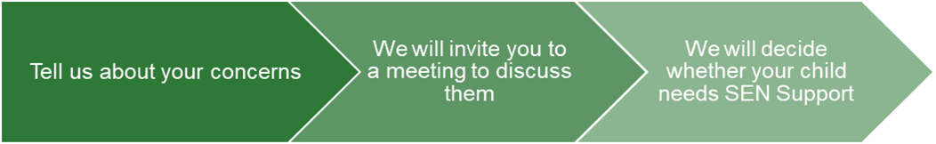

|  |  |  |
| --- | --- | --- |
| If you think your child might have SEN, the first person you should tell is your child’s teacher. If you wish to discuss your child’s learning progress, please contact the  Class Teacher- please see termly letters  For list of email addresses.  They will pass the message on to our SENCO, Karen Myler who will be in touch to discuss your concerns.  You can also contact the SENCO directly  [kmyler@thecroft.swindon.sch.uk](mailto:kmyler@thecroft.swindon.sch.uk) | We will meet with you to discuss your concerns and try to get a better understanding of what your child’s strengths and difficulties are.  Together we will decide what outcomes to seek for your child and agree on next steps.  We will make a note of what’s been discussed and add this to your child’s record. You will also be given a copy of this. | If we decide that your child needs SEN support, we will formally notify you in writing and your child will be added to the school’s SEND register.  Our SEND register is fully fluid and is reviewed by the SENCo and teaching staff on a termly basis. If it is felt that a child no longer requires the additional support and can continue to make good progress with Quality First Teaching, they will be removed, with parental consent, from the SEND register |

# **4. How will the school know if my child needs SEN support?**

All our class teachers are aware of SEN and are on the lookout for any pupils who aren’t making the expected level of progress in their schoolwork or socially. This might include progress through core subjects- in particular looking at children’s independent learning in books, particularly English & Maths, teacher assessments & progress against National Curriculum expectations.

If the teacher notices that a pupil is falling behind, they try to find out if the pupil has any gaps in their learning. If they can find a gap, they will give the pupil extra tuition to try to fill it. Pupils who don’t have SEN usually make progress quickly once the gap in their learning has been filled.

If the pupil is still struggling to make the expected progress, the teacher will talk to the SENCO, and will contact you to discuss the possibility that your child has SEN.

The SENCO will observe the pupil in the classroom and in the playground to see what their strengths and difficulties are. They will have discussions with your child’s teacher/s, to see if there have been any issues with, or changes in, their progress, attainment or behaviour. They will also compare your child's progress and development with their peers and available national data.

The SENCO will ask for your opinion and speak to your child to get their input as well. They may also, where appropriate, ask for the opinion of external experts such as a speech and language therapist, an educational psychologist, or a paediatrician.

Based on all of this information, the SENCO will decide whether your child needs SEN support. You will be told the outcome of the decision in writing.

If your child does need SEN support, their name will be added to the school’s SEN register, and the SENCO will work with you to create a SEN support plan for them.

# **5. How will the school measure my child’s progress?**

We will follow the ‘graduated approach’ to meeting your child’s SEN needs.

The graduated approach is a 4-part cycle of **assess, plan, do, review**.

**Assess**

**If your child is not making the expected level of progress, we will make an assessment to find out what strengths and difficulties your child has.** **We will ask for you and your child’s input, as well as getting help from external professionals where necessary.**

**Review**

**We will assess how well the support we put in place helped the pupil to meet the outcomes we set. We will use our improved understanding of   
your child’s needs to improve the support we offer.**

**Plan**

**In discussion with you and your child, we will decide what outcomes we are hoping to achieve. We will make a plan of the support we will offer your child to help them meet those outcomes. We will make a record of this and share it with you and all relevant school staff.**

**Do**

**We will put our plan into practice.**

**The class teacher, with the support of the SENCO, will be responsible for working with your child on a daily basis, and making sure the support we put in place is having the impact we intended.**

As a part of the planning stage of the graduated approach, we will set outcomes that we want to see your child achieve.

Whenever we run an intervention with your child, we will assess them before the intervention begins. This is known as a ‘baseline assessment’. We do this so we can see how much impact the intervention has on your child’s progress.

We will track your child’s progress towards the outcomes we set over time and improve our offer as we learn what your child responds to best.

This process will be continual. If the review shows a pupil has made progress, they may no longer need the additional provision made through SEN support. For others, the cycle will continue and the school's targets, strategies and provisions will be revisited and refined.

Children on SEN register will have personalised targets for their learning gaps. They will be monitored and assessed through the assess, plan, do , review , process, with full reviews completed at least 3 times a year by Class Teachers with support of SENCo. SEN Targets will be shared with Parents during parent meetings.

# **6. How will I be involved in decisions made about my child’s education?**

We will provide annual reports on your child's progress

Your child’s class teacher will meet you for parent meetings to:

* Set clear outcomes for your child’s progress
* Review progress towards those outcomes
* Discuss the support we will put in place to help your child make that progress
* Identify what we will do, what we will ask you to do, and what we will ask your child to do

The SENCO may also attend these meetings to provide extra support.

We know that you’re the expert when it comes to your child’s needs and aspirations. So we want to make sure you have a full understanding of how we’re trying to meet your child’s needs, so that you can provide insight into what you think would work best for your child.

We also want to hear from you as much as possible so that we can build a better picture of how the SEN support we are providing is impacting your child outside of school.

If your child’s needs or aspirations change at any time, please let us know right away so we can keep our provision as relevant as possible.

After any discussion we will make a record of any outcomes, actions and support that have been agreed. This record will be shared with all relevant staff, and you will be given a copy.

If you have concerns that arise between these meetings, please contact your child’s class teacher.

# 

# **7. How will my child be involved in decisions made about their education?**

The level of involvement will depend on your child’s age, and level of competence. We recognise that no 2 children are the same, so we will decide on a case-by-case basis, with your input.

We may seek your child’s views by asking them to:

* Attend meetings to discuss their progress and outcomes
* Prepare a presentation, written statement, video, drawing, etc.
* Discuss their views with a member of staff who can act as a representative during the meeting
* Complete a survey

**8. How will the school adapt its teaching for my child?**

At The Croft, we understand that children learn and develop in different ways. Teachers and teaching assistants recognise this and use different teaching styles, resources and plan different levels of work in the classroom to cater for the various ways children learn.

Support is planned for and implemented using a graduated approach which includes Assess, Plan, Do, Review. The school SENDCo, Miss Myler, will support staff and parents throughout this process and seek advice from other professionals, such as health professionals, specialist teachers and/or educational psychologists as necessary. Some children may experience significant learning differences and have a range of professionals working with them to help them to meet their agreed outcomes. In some instances, further assessments may be necessary, and it may be deemed appropriate to prepare and submit and Educational and Health Care Plan (EHCP) application to the appropriate Local Authority. This is a very detailed assessment of each child’s needs. Parents or Carers, the school and a range of professionals will all be asked to provide written reports. At the end of the assessment phase the Local Authority will consider these reports to help decide whether to issue an Education, Health and Care Plan for the child. Parents/Carers can complete a parental request for Educational and Health Care Plan (EHCP) Education, Health and Care Assessment is only appropriate for a small number of children

Your child’s teacher is responsible and accountable for the progress and development of all the pupils in their class.

High-quality teaching is our first step in responding to your child’s needs. We will make sure that your child has access to a broad and balanced curriculum in every year they are at our school.

We will adapt how we teach to suit the way the pupil works best. There is no '1 size fits all’ approach to adapting the curriculum, we work on a case-by case basis to make sure the adaptations we make are meaningful to your child.

These adaptations include:

* Adapting our curriculum to make sure all pupils are able to access it, for example, by grouping, 1-to-1 work, adapting the teaching style or content of the lesson, etc.
* Adapting our teaching, for example, giving longer processing times, pre-teaching of key vocabulary, reading instructions aloud, etc.
* Adapting our resources and staffing
* Using recommended aids, such as laptops, coloured overlays, visual timetables, larger font, etc.
* Teaching assistants may support pupils on a 1-to-1 basis for some periods of the school day, if specified in an Educational, Health & care plan
* Teaching assistants may support pupils in small groups when required

We may also provide the following interventions:

|  |  |
| --- | --- |
| **Area of need** | **How we support these pupils** |
| **Communication and interaction** | Visual timetables/ checklists  Social stories  Now and Next boards  Speech and language therapy  Wellcomm  Language for thinking  Attention bucket  Intensive interactions  Colourful semantics  Communication boards  Adapted curriculum and timetable to meet specific needs |
| **Cognition and learning** | Writing slope  Coloured overlays  Talking in devices  Post it notes to jot ideas/ key words  Highlighters for key words  Phoneme frames  Phonics mats  Lollipop sticks to support finger spaces  Numicon  Number lines  Multipulatives such as counters, dienes etc  Little Wandle phonics intervention  Adapted curriculum and timetable to meet specific needs |
|
|
| **Social, emotional and mental health** | Work station screens  Movement / sensory breaks to help regulate  Mindfulness time  Well-being check ins  Mindfulness  Relaxation techniques  Drawing & talking  Timetable adaptations |
| **Sensory and/or physical** | Seating plan  Clearly labelled classroom resources  Seating plans  School will contact hearing impairment team to ensure school have correct support in place.  Larger print font on resources  Sensory exercises  Access to sensory aids such as ear defenders  Fine motor interventions  SPARKS and SPARK-EY |

These interventions are part of our contribution to Swindon’s local offer.

# **9. How will the school evaluate whether the support in place is helping my child?**

We will evaluate the effectiveness of provision for your child by:

* Reviewing their progress towards their goals each term
* Reviewing the impact of interventions after 6- weeks.
* Using pupil questionnaires
* Class observations – how well are children accessing the learning
* Looking through children’s learning books to evaluate if support in place is helping
* Monitoring by the SENCO and subject leaders
* Using SEND Targets & provision mapping to measure progress
* Holding an annual review (if they have an education, health and care (EHC) plan)

# **10. How will the school resources be secured for my child?**

When needed, and through consultation and support from the appropriate outside agency professional service, additional equipment and/or facilities will be sourced for children. These resources will be dependent on the need of the child, and the school will work hard to remove any physical barrier to learning and gather equipment necessary to support access to the school and education. These resources could include noise cancelling headphones, writing slopes, pencil grip adaptions, use of ICT, reading frames etc. It may be that If additional funding that exceeds the SEND allocated budget for an individual child, the school will meet with you to discuss the need for an application to the Local Authority to request additional funding.

# **11. How will the school make sure my child is included in activities alongside pupils who don’t have SEND?**

All of our extra-curricular activities and school visits are available to all our pupils, including our before and after-school clubs.

All pupils are encouraged to go on our school trips, including our residential trips.

All pupils are encouraged to take part in sports day/ schools plays / special workshops.

No pupil is ever excluded from taking part in these activities because of their SEN or disability and we will make whatever reasonable adjustments are needed to make sure that they can be included.

# **12. How does the school make sure the admissions process is fair for pupils with SEN or a disability?**

In accordance with the Code of Practice, our school admissions policy requires children and young people with SEND to be treated fairly. No pupil will be refused admission to school on the basis of his or her special educational need. In line with the SEN and Disability Act we will not discriminate against disabled children and we will take all reasonable steps to provide effective educational provision in line with The White Horse Federation admissions arrangements and policy. Further information on the policy can be found here [Admissions | The Croft Primary School](https://thecroft.swindon.sch.uk/about-us/admissions)

If your child has an EHCP, the Local Authority manage the admissions process and any changes in school placement.

Please email SENDService@swindon.gov.uk to ask any questions regarding your child’s school placement if they have an EHCP.

# **13. How does the school support pupils with disabilities?**

At Croft Primary School we ensure that pupils with disabilities are able to access the curriculum and school building and environment alongside their peers. We will ensure that steps are taken to prevent disabled pupils from being treated less favourably than other pupils. This will include us working alongside both parents and outside agencies professionals to identified the reasonable adjustments that we can put into place to meet your child’s specific needs.

Necessary additional resources and equipment such as auxiliary aids and services will be sought. This is further referred to in our Accessibility plan.

# 

# **14. How will the school support my child’s mental health and emotional and social development?**

At Croft Primary School, we are committed to supporting the mental health and emotional wellbeing of our

children and staff. We know that everyone experiences life challenges that can make us vulnerable and that at times we could all need additional support. We believe good mental health is everyone’s concern and all of us have a role to play in supporting this. Our mental health and wellbeing policy sets out how we do this.

The school has a trained Senior Mental Health Lead (Karen Myler) and another suitably qualified member of staff who focus on intervention for pupils who require support with their social, emotional and mental health. They work closely with class teachers and the Leadership Team to offer additional support for children in class and in intervention.

We provide support for pupils to progress in their emotional and social development in the following ways:

* Pupils with SEN are encouraged to be part of the school council
* Pupils with SEN are also encouraged to be part of clubs to promote teamwork/building friendships
* We provide extra pastoral support for listening to the views of pupils with SEN with staff having emotional coaching training.
* We run a nurture breakfast for pupils who need extra support with social or emotional development and a smoother transition into school.
* We have a ‘zero tolerance’ approach to bullying. Our School’s behaviour policy outlines the measure that we put into place to prevent bullying.

# **15. What support will be available for my child as they transition between classes or settings, or in preparing for adulthood?**

At The Croft Primary School we recognise how important a successful transition is to our pupils with additional needs. It is incredibly important to us that our school provides a positive learning environment for all children and particularly for children with SEND who may find certain aspects of school difficult or daunting. One area that can be particularly difficult for children with SEND is transition. Transition occurs at many stages throughout school and transition procedures are put in place to support the children, not only on entry and exit, but also within the school.

**Transition to Reception**

New starters for Reception children are provided with the following opportunities:

* Parent Open Information Event
* Home visits with Croft staff
* Stay and play sessions- getting familiar with the Reception environment

Change can be daunting for any child but more so for a child with SEND. Transition

books will be provided for children with SEND over the summer holidays to remind

children of their new teacher and classroom. Additional trips to the classroom can be

arranged to increase familiarity, confidence in the new environment and to reduce any

anxiety. Once children begin Reception, they will gradually build up to full days to

prepare them for longer times at school.

Between years

To help pupils with SEND be prepared for a new school year we:

* Ask both the current teacher and next year’s teacher to attend hand over meeting to discuss support in place and progress against SEN targets.
* Hand up day – where children spend 1 day with their next years’ teacher before September start.
* Some SEN children benefit from transition social stories about what their new classroom and teacher look like etc
* Some SEN children benefit from additional sessions with next year such as – story time / social game to build up relationships and reduce any anxieties.

Between schools

When your child is moving on from our school, we will ask you and your child what information you want us to share with the new setting.

**Between phases**

The SENCO of the secondary school will come into our school for a meeting with our SENCO. They will discuss the needs of all the children who are receiving SEN support.

Pupils will be prepared for the transition by:

* Personal development lessons supporting talking about any worries/concerns that they may have regarding secondary school. During these sessions, children learn about the importance of getting organised independently and practising with a secondary school timetable.
* Secondary school staff are invited into school to meet and greet the Year 6 children.
* Children complete transition days at their secondary schools in readiness for September start.
* Additional support is given to plug any gaps in knowledge.

# **16. What support is in place for looked-after and previously looked-after children with SEN?**

Elaine Murphy (Head Teacher) will work with our SENCO, to make sure that all teachers understand how a looked-after or previously looked-after pupil’s circumstances and their SEN might interact, and what the implications are for teaching and learning.

Children who are looked-after or previously looked-after will be supported much in the same way as any other child who has SEND. However, looked-after pupils will also have a personal education plan (PEP). We will make sure that the PEP and any SEN support plans or EHC plans are consistent and complement one another.

# **17. What should I do if I have a complaint about my child’s SEN support?**

Complaints about SEN provision in our school should be made, SENCo and or Head Teacher in the first instance. They will then be referred to the school’s complaints policy ([Policies & Procedures | The Croft Primary School](https://thecroft.swindon.sch.uk/about-us/school-information/policies-procedures))

If you are not satisfied with the school’s response, you can escalate the complaint. In some circumstances, this right also applies to the pupil themselves.

To see a full explanation of suitable avenues for complaint, see pages 246 and 247 of the [SEN Code of Practice](https://www.gov.uk/government/publications/send-code-of-practice-0-to-25).

If you feel that our school discriminated against your child because of their SEND, you have the right to make a discrimination claim to the first-tier SEND tribunal. To find out how to make such a claim, you should visit: <https://www.gov.uk/complain-about-school/disability-discrimination>

You can make a claim about alleged discrimination regarding:

* Admission
* Exclusion
* Provision of education and associated services
* Making reasonable adjustments, including the provision of auxiliary aids and services

Before going to a SEND tribunal, you can go through processes called disagreement resolution or mediation, where you try to resolve your disagreement before it reaches the tribunal.

([Disagreement resolution, mediation and tribunal | Swindon Borough Council](https://www.swindon.gov.uk/info/20198/information_advice_and_advocacy/1412/disagreement_resolution_mediation_and_tribunal))

# **18. What support is available for me and my family?**

If you have questions about SEND, or are struggling to cope, please get in touch to let us know. We want to support you, your child and your family.

To see what support is available to you locally, have a look at The Swindon Local Offer.

Swindon Borough publishes information about the local offer on their website:

[SEND Local Offer | Swindon Borough Council](https://www.swindon.gov.uk/sendlocaloffer)

Our local special educational needs and disabilities information advice and support services organisations are:

* SIAS- [Swindon SEND Information, Advice & Support (swindonsias.org.uk)](https://www.swindonsias.org.uk/)

Local charities that offer information and support to families of children with SEND are:

* SEND Families Voice [swindonsendfamiliesvoice.org.uk](https://swindonsendfamiliesvoice.org.uk/)

National charities that offer information and support to families of children with SEND are:

* [IPSEA](https://www.ipsea.org.uk/)
* [SEND family support](https://sendfs.co.uk/)
* [NSPCC](https://www.nspcc.org.uk/keeping-children-safe/support-for-parents/)
* [Family Action](https://www.family-action.org.uk/what-we-do/children-families/send/)
* [Special Needs Jungle](https://www.specialneedsjungle.com/)

# **19. Glossary**

* **Access arrangements** – special arrangements to allow pupils with SEND to access assessments or exams
* **Annual review** –an annual meeting to review the provision in a pupil’s EHC plan
* **Area of need** – the 4 areas of need describe different types of needs a pupil with SEND can have. The 4 areas are communication and interaction; cognition and learning; physical and/or sensory; and social, emotional and mental health needs.
* **CAMHS** – child and adolescent mental health services
* **Adapt** – when teachers adapt how they teach in response to a pupil’s needs
* **EHC needs assessment** – the needs assessment is the first step on the way to securing an EHC plan. The local authority will do an assessment to decide whether a child needs an EHC plan.
* **EHC plan** –an education, health and care plan is a legally-binding document that sets out a child’s needs and the provision that will be put in place to meet their needs.
* **First-tier tribunal/SEND tribunal** – a court where you can appeal against the local authority’s decisions about EHC needs assessments or plans and against discrimination by a school or local authority due to SEND
* **Graduated approach** – an approach to providing SEN support in which the school provides support in successive cycles of assessing the pupil’s needs, planning the provision, implementing the plan, and reviewing the impact of the action on the pupil
* **Intervention** – a short-term, targeted approach to teaching a pupil with a specific outcome in mind
* **Local offer** – information provided by the local authority which explains what services and support are on offer for pupils with SEN in the local area
* **Outcome** – target for improvement for pupils with SEND. These targets don't necessarily have to be related to academic attainment
* **Reasonable adjustments** – changes that the school must make to remove or reduce any disadvantages caused by a child’s disability
* **SENCO** – the special educational needs co-ordinator
* **SEN** – special educational needs
* **SEND** – special educational needs and disabilities
* **SEND Code of Practice** – the statutory guidance that schools must follow to support children with SEND
* **SEN information report** – a report that schools must publish on their website, that explains how the school supports pupils with SEN
* **SEN support** – special educational provision which meets the needs of pupils with SEN
* **Transition** – when a pupil moves between years, phases, schools or institutions or life stages