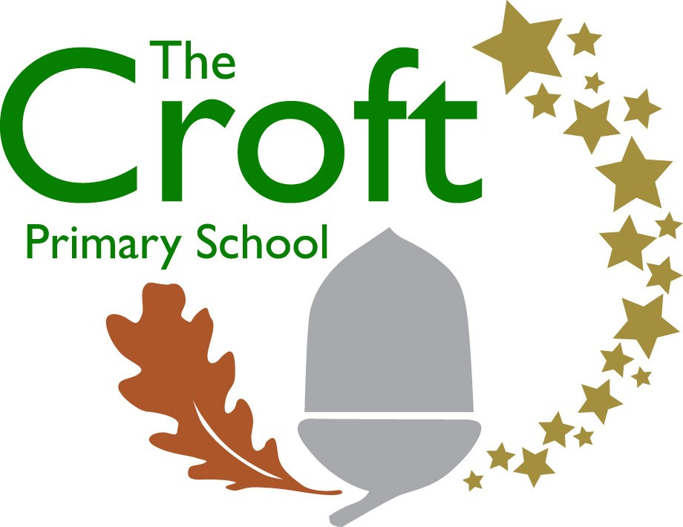
Music Development Plan:summary
Overview
Detail | Information
Academic year that this summary covers | 2024-2025
Date this summary was published | September 2024
Date this summary will be reviewed | August 2025
Name of the school music lead | Hazel Matthews
Name of school leadership team member with responsibility for music (if different) | Headteacher
Name of local music hub | Swindon Music Service
Name of other music education organisation(s) (if partnership in place) | 1:1 Music Services

This is a summary of how our school delivers music education to all our pupils across three areas – curriculum music, co-curricular provision and musical experiences – and what changes we are planning in future years. This information is to help pupils and parents or carers understand what our school offers and who we work with to support our pupils’ music education.
Part A: Curriculum music
This is about what we teach in lesson time, how much time is spent teaching music and any music qualifications or awards that pupils can achieve.
- Love of Learning: We believe and want to create an environment that encourages children learn. We do this by providing them with access to a broad and balanced curriculum using a variety of resources, We believe that every child has the potential to excel and make progress in the learning and be the best they can be and we are committed to helping them achieve their full potential.
- Thirst for Knowledge and skills -wanting to learn more and know more: Through our design of music, we ensure it builds progressively on knowledge and skills
- Community- Through our Music Intent, we ensure our music is taken in to the community and the community music is bought into us.
- Values: These thread through our music intent, of inclusivity
- Enrichment: Our Music intent provides children with a wealth of experiences beyond the classroom that ensure that they are ready and prepared for the next phase of education through music and the skills and knowledge that the curriculum provide
Our Intent for our Music Curriculum:
- To be curious about different music genres and how they are composed and performed
- To learn how to play a range of instruments
- Use our school values to work cooperatively and persevere when activities challenge them
- To make connections in their learning and to know more, remember more and do more each year leading to academic success and enjoyment in music
- Develop skills in order to acquire, apply and transfer their knowledge ​

We intend our music curriculum to be a way of celebrating our diverse school community. We aspire to offer a range of opportunities to sing a variety of multicultural songs, listen to inspirational composers, participate in music sessions delivered by Swindon Music Service. We are committed to ensuring that children understand the value and importance of music and can transfer their musical skills knowledge and experiences into their wider community. As a school we intend to develop every child’s self-confidence and social development that will support them in their future, and as such we believe that Music offers all children an opportunity to express their creativity and inspire self-confidence through practical experiences leading to various musical performances and activities.
Implementation:
The National Curriculum is the starting point of our curriculum design. It has been used to drive our curriculum design, in order to ensure the aims of the National Curriculum are met, and it has been used to inform the choices we have made about the content that we teach.
The implementation of the Music Curriculum is a through a combination of class teachers and music specialists from Swindon Music Service delivering sessions. Specialists from the Music Service are utilised as they provide vital subject knowledge, musical experiences, road shows and teaching of specialised musical instruments. We teach the National Curriculum through the Charanga scheme of work which offers a range of differentiated activities to allow every child an opportunity to access the music curriculum and celebrate the diversity and inclusivity of our school community. Musical vocabulary is built upon from Nursery through to Year 6 through movement, pictorial representations and written / oral language of musical terminology and notations. This helps to develop the skills to be able to read and understand how to perform a basic musical composition. In addition to their classroom music sessions, and experiences, children are exposed to a range of music through singing lessons and activities where children procure the rewards of singing in unison and harmony and are taught to consider the elements of music required for performances such as tone, tempo, pitch, along with enhancing their ability to listen, respect and cooperate with each other.
Impact:
Our intended impact is that by the time our pupils leave our school, they will have developed:
- Their own opinions of different music genres and how they are composed and performed by listening and analysing different music types
- To have challenged themselves to create and perform different genres of music
- Develop skills in order to acquire, apply and transfer their knowledge ​across different musical instruments and genres
- An appreciation for music and how it makes us feel and how it represents different cultures and other parts of the world

Our music curriculum is published on our school website and can be accessed here:
Music is timetabled weekly across the school so that all children have regular access to music lessons as part of a broad and balanced curriculum offer. Assemblies are also used as additional time where children learn songs and practise singing.

Part B: Co-curricular music
This is about opportunities for pupils to sing and play music, outside of lesson time, including choirs, ensembles and bands, and how pupils can make progress in music beyond the core curriculum.
Our school works in partnership with the Swindon Music Service to provide pupils with additional group tuition, alongside the music curriculum.
- Year Reception -12 weeks of Singing
- Year 1 -16 weeks of Drumming
- Year 2 -16 weeks of Ukelele
- Year 3 and Year 4 - 32 Weeks of Recorders
- Year 5 -16 Weeks of Ukelele

Tuition available: (*We always share, if we have more than 10 children interested in a particular musical instrument, we will endeavour to find a tutor)

- 1:1 Drumming tuition KS1 and KS2
- 1:1 Piano tuition KS1 and KS2
- 1:1 Guitar tuition KS1 and KS2
- 1:1 Trumpet tuition KS1 and KS2
- 1:1 Violin tuition KS1 and KS2
.
Assembly time is also set aside on a weekly basis for singing. Children are introduced to new songs and enjoying practising, rehearsing and performing together.

Part C: Musical experiences
This is about all the other musical events and opportunities that we organise, such as singing in assembly, concerts and shows, and trips to professional concerts.
- Assembly time for singing
- Christmas Choir led by SMS and held at Wyvern Theatre Swindon
- Choir at BandstanD, Old Town Gardens, Enchanted Light Trail
- Choir at School Events
- Choir at The Ridgeway School-Out KS2 Christmas Choir event
- YR and KS1 Christmas Nativity and Christmas Productions support and enable singing to an audience
- Year 3, Year 4, Year 5, Production Performance enables Singing to an audience
- Instrument performances to Parents (Recorders and Ukulele)
- Guitar Performance *private1:1 Tuition in school
- Pantomime Experiences
- Church Christingle
- Y6 End of Year Performance

In the future
This is about what the school is planning for subsequent years.
It is the intention of the leadership team to:
- Plan additional opportunities for children to engage in musical events (e.g. school choir, House team performances and attendance at events such as ‘Young Voices’).

Further information (optional)
Swindon Music Services: https://smscio.org/
Swindon Music Cooperative: https://swindonmusiccoop.co.uk/apply-for-music-lessons/
Ultimate Tuition: www.ultimatebrand.org
L Bateman Music: https://www.batemanmusic.co.uk/

