The Croft Primary Anti-Bullying-Child Friendly

Simon Cowley

Elaine Murphy

Elaine Murphy

The Croft Primary School

1

September 2025

n/a

September 2026

As we are a Rights Respecting school we work together to ensure the children at

The Croft Primary school have their rights met. EVERY CHILD HAS RIGHTS.

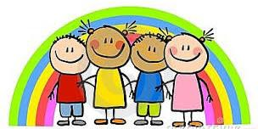
Produced by Rights Respecting Group 2018-19

Our School: What we want it to be like:

Our school is special to us and we want it to be a place where everyone feels happy and is friendly towards each other. We all want to follow our motto ‘Working together…playing together.’ To do this, we need to co-
operate with each other and treat each other with patience, kindness, and respect. Our 22 values, our children’s rights and our British values are important to remember and to show towards each other.

1. I will always use kind words, kind hands and kind feet to myself and to all others
2. I will show tolerance, understanding, respect and patience to ALL
3. I will show resilience even when things get tough in learning or social times!
4. I can be trusted to always make the sensible/right/good choices in all areas of the school
5. I will show good listening at all times with all grown ups
6. I will always be honest in all that I say and do
7. I will always model our Values and show what being a Croftie means!


How we should behave and why:
We should behave in a respectful way that makes all children and adults in our school feel safe. This means we should be kind and friendly to everyone. We should listen carefully to each other and follow instructions.


What happens if we behave appropriately?

In Friday assembly, we celebrate hard work, achievements and those who have shown the value of the month. Golden stars are awarded for good behaviour and Each class has their own reward system that means if we behave well there is an end of term treat.

What happens if we do not behave appropriately?
We are given a warning, which gives us a chance to make the right choice. If we make a wrong choice, a member of staff will talk to us about our choices and we will be reminded that we need to respect other people’s rights. If we continue to make the wrong choices, we may need to leave the classroom, miss playtimes or see Mrs Knight, Mrs Bowers or Mrs Murphy. If our choices continue to be wrong, our parents will be informed. If it is serious inappropriate behaviour, we might be sent home.
We will always have a chance to discuss our behaviour and make steps to put it right.

What we promise to do:
We will try our hardest to follow the values and school charters and be positive towards others. We promise to follow our class charter, making sure everyone has their rights met. We will also follow our playground charter, which explains how to respect other people’s rights at playtime. We are aware of our Computing charter, which explains how to use technology responsibly.

Are our behaviour rules for everyone?
We expect everyone at The Croft Primary School to respect our rules and values. Some children find it hard to follow the rules and values and we help those children in different ways so they can earn rewards too.

Are our behaviours for all times?
We should behave well at all times when we are wearing our school uniform: class times, assemblies, playtimes, walking to and from school, on school trips, after school clubs, and with visitors so that people outside and inside school can see we make the right choices and do our best.

What is Bullying?
In our school, a bully is someone who hurts someone more than once, by using behaviour which is meant to hurt, frighten or upset another person.

Bullying can be…

- Emotional: Hurting people’s feelings, leaving you out.
- Physical: Punching, kicking, spitting hitting, pushing.
- Verbal: Being teased, name-calling.
- Racist: Graffiti, calling you racist names.
- Cyber: saying unkind things by text, e-mail and/or social media.

When is it bullying?

Several Times
On Purpose
We promise to always treat bullying seriously.

What should I do if I see someone else is being bullied?
- Don’t walk away and ignore the bullying, don’t be a bystander.
- Let someone know what is happening; tell a trusted friend or adult.
- Tell the bully to stop if it is safe to do so.
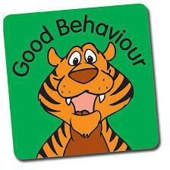
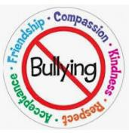
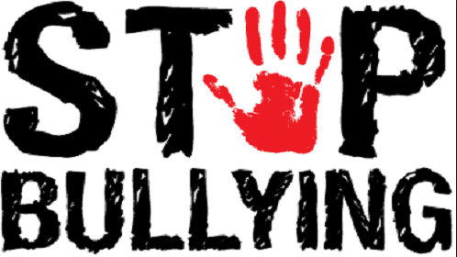
- Don’t stay silent – tell someone to help stop the bullying behaviour.

The Head Teacher, Mrs Murphy, the Governors, the staff, School Parliament will work

together to:

- Make our school a place where everyone can feel safe and happy. We will not tolerate bullying.
- We will help everyone to get on with each other and we believe that everyone has the right to be who they are.

Who can I tell?

A friend, Mum/Dad, Teachers, School Council, lunch time Staff, any Teachers, Teaching Assistant or other adult in school even Mrs Mrs Murphy, another trusted family member

If you are being bullied:
TELL SOMEONE!

You can talk to someone outside of school by calling Child Line on 0800 1111. It’s free and confidential.

If you are bullied- DO:-
- Ask them to STOP if you can.
- Use eye contact and tell them to go away.
- Ignore them.
- Walk away.
- Use the worry box if you are too scared to speak openly about it.
- Talk to a School council/ Rights Respecting group member.
- TELL SOMEONE, you trust.

DON’T:-
- Do what they say.
- Get angry or look upset. Hurt them or retaliate in any other way.
- Think it is your fault.
- Hide it.
BE YOU. BE BRAVE. BE HEARD.

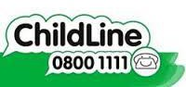
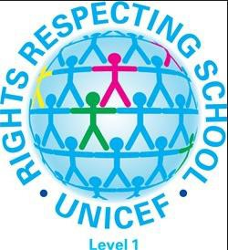
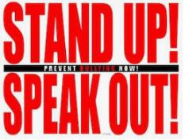
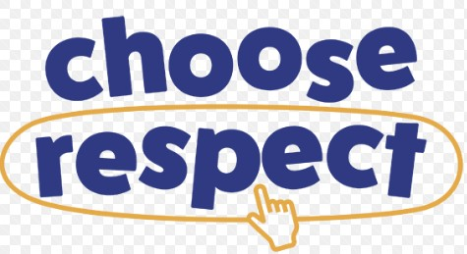

We can stop bullying together

