

Year 1 - Long Term Planning: Curriculum Overview

 | Term 1 |  | Term 2 | Term 3 | Term 4 | Term 5 | Term 6
Writing | Leaf  Purpose: writing to entertain  Outcome: setting description  Stuck  Purpose: writing to inform  Outcome: recount  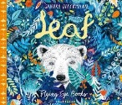  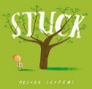 |  | Bog Baby  Purpose: writing to entertain  Outcome: character description  Zog  Purpose: writing to inform  Outcome: recount  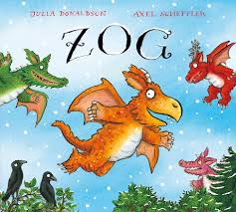  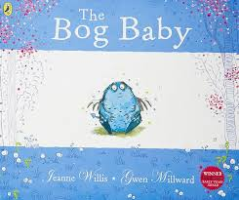 | Poles Apart  Purpose: writing to entertain  Outcome: retell of story  Dear Greenpeace  Purpose: writing to inform  Outcome: non-chronological report  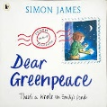  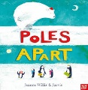 | Beegu  Purpose: writing to entertain  Outcome: story  Paddington  Purpose: writing to inform  Outcome: diary entry  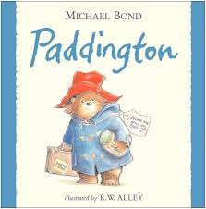  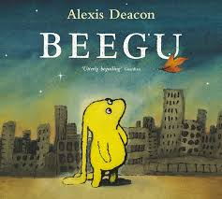 | Lost in the Toy Museum  Purpose: writing to Entertain  Outcome: retell of story  Tidy  Purpose: writing to inform  Outcome: instructions  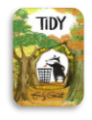  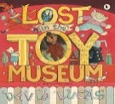 | Look Up  Purpose: writing to entertain  Outcome: story  Dragon Post  Purpose: writing to inform  Outcome: letter  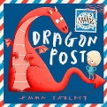  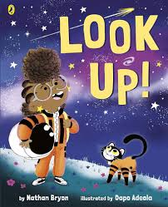
Reading | Book Talk around a planned range of High-Quality Texts
Maths | Number and Place Value  Addition and Subtraction  Place Value to 50  Problem Solving  Space for Pace |  | Addition and Subtraction: Facts of 7-10  Property of Shapes (2D and 3D)  Measurement and Length  Problem Solving  Space for Pace | Addition and Subtraction: Facts of 11-16  Place Value to 100  Problem Solving  Space for Pace | Addition and Subtraction: Facts of 17-20  Fractions  Position and Direction  Days and Months  Problem Solving  Space for Pace | Addition and Subtraction  Multiplication and Division  Problem Solving  Space for Pace | Time  Money  Mass and Capacity  Problem Solving  Space for Pace
Art and Design | Painting - Concentric Circles  Artist: Wassily Kadinsky |  |  | Textiles: Seaside Collage  Artist: Megan Coyal |  |  | Drawing – Observational drawing (fruit)  Artist: Claude Monet
Design and Technology (DT) |  |  | Materials and structures - Jam Jar Snow Globes |  | Cooking and nutrition - Marmalade Sandwich | Textiles – hand puppets
Physical Education (PE) | Fundamentals |  | Sending and Receiving | Gymnastics | Net and Wall Games | Dance | Team Building
Science | Animals including humans – Animals |  | Everyday Materials: Part 1 | Animals including humans – Humans | Everyday Materials: Part 2 | Plants: Part 1 | Plants: Part 2
 | 1 lesson on seasonal changes - Autumn |  |  | 1 lesson on seasonal changes- Winter | 1 lesson on seasonal changes – Spring |  | 1 lesson on seasonal changes - Summer
Religious Education (RE) | Religion: Christianity  Theme: Creation Story  Key Question: Does God want Christians to look after the world? |  | Religion: Christianity  Theme: Christmas  Key Question: What gifts might Christians in my town have given Jesus if he had been born here rather than Bethlehem? | Religion: Christianity  Theme: Jesus as a friend  Key Question: Does God want Christians to look after the world? | Religion: Christianity  Theme: Easter - Palm Sunday  Key Question: Why was Jesus welcomed like a king or celebrity by the crowds on Palm Sunday? | Religion: Judaism  Theme: Shabbat  Key Question: Is Shabbat important to Jewish children? | Religion: Judaism  Theme: Rosh Hashanah and Yom Kippur  Key Question: Are Rosh Hashanah and Yom Kippur important to Jewish children?
History |  |  | My History  How am I making history? |  | Toys  How have toys changed? |  | Significant Individuals: Explorers  How have explorers changed the world?
Geography | Local Study  What is it like here? |  |  | Weather in the UK  What is the weather like in the UK? |  | Shanghai  What is it like to live in Shanghai?
Computing | Digital Literacy  Computing systems and networks: Technology around us |  | Computer Science  NCCE Programming Unit A Moving a robot (Y1 unit) | Information Technology  Purple Mash Pictograms | Computer Science  NCCE Programming B – Moving a robot (currently a Y2 unit) | Information Technology  Animated Story Books on 2Createastory | Digital Literacy  Use searching to create a postcard on 2Publish
Online Safety | Self Image and Identity | Privacy and Security | Online Bullying | Online Reputation | Health, wellbeing and lifestyle | Online Relationships | Managing Online Information | Copyright and Ownership
Personal Development | Being Me in My World |  | Celebrating Difference | Dreams and Goals | Healthy Me | Relationships | Changing Me
Music | African drumming |  | African drumming | African drumming | Unit 1 - Charanga  ‘Hey You’ | Unit 2: Charanga  ‘Rhythm In The Way We Walk’ | Unit 3 - Charanga
Visits, visitors and experiences |  |  | Pantomime | Drumming performance to parents | Parent/grandparent to talk about the toys they played with when they were younger. | The Story Museum - Oxford

