
Sc

Year 2 - Long Term Planning: Curriculum Overview

 | Term 1 |  | Term 2 | Term 3 | Term 4 | Term 5 | Term 6
Writing | Little Red and the Very Hungry Lion  Purpose: writing to entertain  Outcome: setting description  Man on the Moon  Purpose: writing to inform  Outcome: diary entry  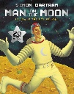  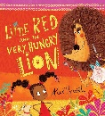 |  | The Dragon Machine  Purpose: writing to entertain  Outcome: character description  The Day the Crayons Quit  Purpose: writing to inform  Outcome: a letter  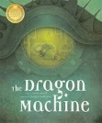  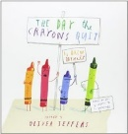 | The Three Little Wolves and The Big Bad Pig  Purpose: writing to entertain  Outcome: retell  There’s a Rang-Tan in My Bedroom  Purpose: writing to inform  Outcome: non-chronological report  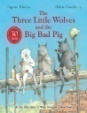  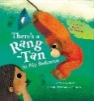 | The Light House Keeper’s Lunch  Purpose: writing to entertain  Outcome: a sequel  George’s Marvellous Medicine  Purpose: writing to inform  Outcome: instructions  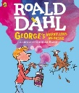  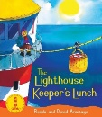 | The Pirate Cruncher  Purpose: writing to entertain  Outcome: character description  Clean Up!  Purpose: writing to inform  Outcome: leaflet  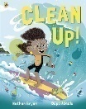  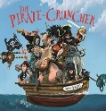 | The Bear and the Piano  Purpose: writing to entertain  Outcome: alternative ending  The Wonder!  Purpose: writing to inform  Outcome: recount  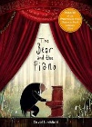  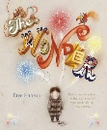
Reading | Book Talk around a range of High Quality Texts  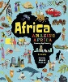  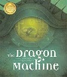  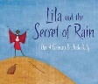  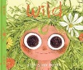  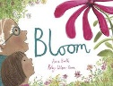 |  | The Day the Crayons Quit, The Robot and the Blue Bird and The Big Book of Birds  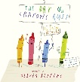  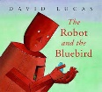  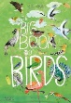 | 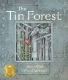  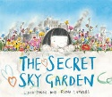  The Tin Forest, The Secret Sky Garden and A Planet Full of Plastic | 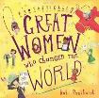  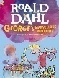  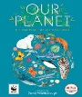  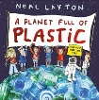  Our Planet, George’s Marvellous Medicine, Great Women who changed the World | 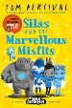  Silas and the Marvellous Misfits | The Dancing Bear and A Book of Bears  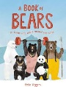  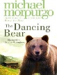
Maths | Number and Place Value  Addition  Properties of Shapes  Problem Solving  Space for Pace |  | Subtraction  Multiplication and Division  Properties of Shapes  Problem Solving  Space for Pace | Multiplication and Division  Length and Mass  Problem Solving  Space for Pace | Fractions  Tie  Money  Problem Solving  Space for Pace | Money  Statistics  Temperature and Capacity  Problem Solving  Space for Pace | Position and Direction  Place Value  Addition and Subtraction  Multiplication and Division  Problem Solving
Art and Design | Printing – patterns from nature  Artist: Andy Goldsworthy |  |  | Sculpting - Coil Clay Art  Artist: The Romans | Drawing (chalk) - Sketching animals  Artist: Beatrix Potter | Painting – Underwater Scene  Artist: Olga Nikitina
Design and Technology (DT) |  |  | Mechanisms - Moving fairy tale book using sliders and levers |  |  |  | Materials and Structures: Car Port Toy
Physical Education (PE) | Fundamentals |  | Swimming | Invasion Games | Gymnastics | Striking and Fielding Games | Athletics
Science | Everyday Materials |  | Animals (including humans) | Living Things and their Habitats | Living Things and their Habitats | Plants | Plants
Religious Education (RE) | Religion: Christianity  Theme: What did Jesus teach?  Key Question: Is it possible to be kind to everyone all of the time? |  | Religion: Christianity  Theme: Christmas - Jesus as gift from God  Key Question: Why do Christians believe God gave Jesus to the world? | Religion: Islam  Theme: Prayer at home  Key Question: Does praying at regular intervals help a Muslim in his/ her everyday life? | Religion: Christianity  Theme: Easter – Resurrection  Key Question: How important is it to Christians that Jesus came back to life after his crucifixion? | Religion: Islam  Theme: Community and Belonging  Key Question: Does going to a mosque give Muslims a sense of belonging? | Religion: Islam  Theme: Hajj  Key Question: Does completing Hajj make a person a better Muslim?
History | Schools in the past  How was school different in the past? |  |  | Significant Individuals – Flight  How did we learn to fly? |  | Monarchs  What is a monarch?
Geography |  |  | Hot and Cold Places  Would you prefer to live in a hot or cold place? |  | Our World Around Us  Why is our world wonderful? |  | Coasts  What is it like to live by the coast?
Computing | Information Technology  Creating Media - Purple Mash Creating Pictures (Unit 2.6) |  | Computer Science Programming A  NCCE - Programming animations | Digital Literacy  Computing Systems and Networks - IT around us | Information Technology  Creating media - Digital Photography | Computer Science  Programming B – NCCE An introduction to quizzes | Digital Literacy  Purple Mash Effective Searching to create a poster
Online Safety | Self Image and Identity | Privacy and Security | Online Bullying | Online Reputation | Health, wellbeing and lifestyle | Online Relationships | Managing Online Information | Copyright and Ownership
Personal Development | Being Me in My World |  | Celebrating Difference | Dreams and Goals | Healthy Me | Relationships | Changing Me
Music | Ukuleles |  | Ukuleles | Ukuleles and Ukulele performance | Unit 1: Charanga - ‘Hands, Feet, Heart’ | Unit 2: Charanga - ‘Friendship Song’ | Unit 3: Charanga
Visits, visitors and experiences | - Trip to Sevington Victorian school  - Visit from a parent and grandparent to interview about their school life |  | - Visit from the local vicar  - Fieldwork: weather on local grounds | - Visit from a local practising Muslim to talk about prayer  - Ukulele performance | - Visit from a local doctor  - Fieldwork to investigate local habitats |  | - Visit from a Muslim who has completed the Hajj  - Beach trip

