
Cor

Year 3 - Long Term Planning: Curriculum Overview

 | Term 1 |  | Term 2 | Term 3 | Term 4 | Term 5 | Term 6
Writing | The Iron Man  Purpose: writing to entertain  Outcome: setting description  The Iron Man  Purpose: writing to inform  Outcome: diary entry  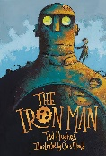 |  | Winter’s Child  Purpose: writing to entertain  Outcome: character description  Winter’s Child  Purpose: writing to inform  Outcome: a letter  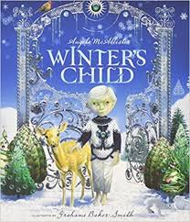 | Mrs Noah’s Pockets  Purpose: writing to entertain  Outcome: retell of story  Mrs Noah’s Pockets  Purpose: writing to inform  Outcome: non-chronological report  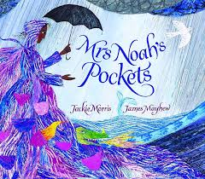 | Fly Eagle Fly  Purpose: writing to entertain  Outcome: short story  Fly Eagle Fly  Purpose: writing to persuade  Outcome: persuasive speech  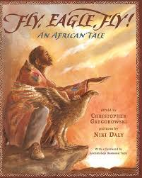 | BFG  Purpose: writing to entertain  Outcome: setting description  George’s Marvellous Medicine/Half Blood Prince Potions Scene  Purpose: writing to inform  Outcome: instructions    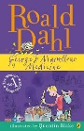  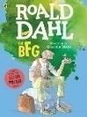 | Egyptian Cinderella  Purpose: writing to entertain  Outcome: story writing  The Wonder!  Purpose: writing to inform  Outcome: recount  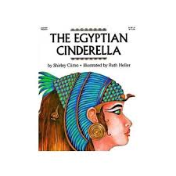
Reading | The Iron Man  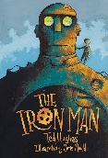 |  | The Winter’s Child | The Miraculous Journey of Edward Tulane  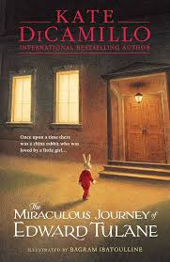 | 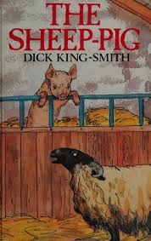  The Sheep Pig | 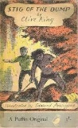  Stig of the Dump | 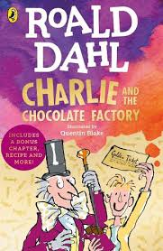  Charlie and the Chocolate Factory
Maths | Number and Place Value  Addition and Subtraction (mental methods: addition)  Problem Solving  Space for Pace |  | Addition and Subtraction (mental methods: subtraction)  Multiplication tables  Properties of Shape  Problem Solving  Space for Pace | Fractions  Addition and Subtraction (written methods: addition)  Addition and Subtraction (written methods: subtraction)  Problem Solving  Space for Pace | Multiplication and Division  Money  Problem Solving  Space for Pace | Fractions: Calculating  Time  Problem Solving  Space for Pace | Length, mass and capacity  Properties of shapes  Statistics Problem Solving  Space for Pace
Art and Design | Drawing – Extreme Nature  Artist: Pierre-Jacques Volaire |  | Painting - Egg box animal paintings  Artist: Darrell Wakelam |  | Sculpting - Roman Mosaic coasters  Artist: Sonia King
Design and Technology (DT) |  |  |  | Materials and Structures - Totem Pole in mod roc |  | Cooking and nutrition - Wrap Pizza | Textiles – sweet bag for Willy Wonka
Physical Education (PE) | Fundamentals |  | Gymnastics | Basketball | Dance | Cricket | Athletics
Science | Rocks |  | Animals (including humans) | Light | Light | Forces and Magnets | Plants
Religious Education (RE) | Religion: Hinduism  Theme: Diwali  Key Question: Would celebrating Diwali at home and in the community bring a feeling of belonging to a Hindu child? |  | Religion: Christianity  Theme: Christmas  Key Question: Has Christmas lost its true meaning? | Religion: Christianity  Theme: Jesus’ miracles  Key Question: Could Jesus heal people? Were these miracles or is there some other explanation? | Religion: Christianity  Theme: Easter - forgiveness  Key Question: What is really ‘good’ about Good Friday? | Religion: Hinduism  Theme: Hindu Beliefs  Key Question: How can Brahman be everywhere and in everything? | Religion: Hinduism  Theme: Pilgrimage to the River Ganges  Key Question: Would visiting the River Ganges feel special to a non-Hindu?
History |  |  | Stone Age to Iron Age  Would you prefer to live in the Stone Age, Iron Age or Bronze Age? |  | Romans  Why did the Romans settle in Britain? |  | Egyptians  What did the ancient Egyptians believe?
Geography | Volcanoes  Why do people live near volcanoes? |  |  | Settlements  Are all settlements the same? |  | Rainforests  Why are rainforests important to us?
Computing | Digital Literacy  Computing Systems and Networks - Connecting computers |  | Computer Science  Programming A – NCCE Sequence in music | Information Technology Creating Media -  Microsoft PowerPoint | Digital Literacy  2Email on Purple Mash | Information Technology  Data and Information – Branching databases | Computer Science  Programming B - Events and actions in programs
Online Safety | Self Image and Identity | Privacy and Security | Online Bullying | Online Reputation | Health, wellbeing and lifestyle | Online Relationships | Managing Online Information | Copyright and Ownership
PSHE/Jigsaw | Being Me in My World |  | Celebrating Difference | Dreams and Goals | Healthy Me | Relationships | Changing Me
Music | Recorders |  | Recorders | Recorders | Unit 1 - Charanga  ‘What stories does music tell us about the past? | Unit 2: Charanga  ‘Bringing us Together’
Modern Foreign Languages – French | French Greetings with puppets |  | French adjectives of colour, size and shape | French playground games – number and age | In a French Classroom | French transport | A circle of life in French
Visits, visitors and experiences | Local Hindu to talk about the celebration of Diwali |  | Experience day – Stone Age | Fieldwork: features in local area | Corinium Museum Trip | Old Town Pizza Express Visit | Local visitor who has been to the Ganges  Experience day - Egyptians

