

Year 4 - Long Term Planning: Curriculum Overview

 | Term 1 |  | Term 2 | Term 3 | Term 4 | Term 5 | Term 6
Writing | The Great Kapok Tree  Purpose: writing to entertain  Outcome: story setting  Taking Flight  Purpose: writing to inform  Outcome: recount  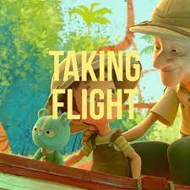  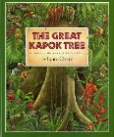 |  | The Barnabus Project  Purpose: writing to entertain  Outcome: character description  The Gift  Purpose: writing to persuade  Outcome: a letter    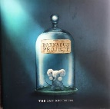 | Wolves in the Walls  Purpose: writing to entertain  Outcome: retell story  What a Waste  Purpose: writing to inform  Outcome: non-chronological report  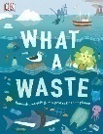  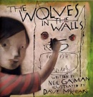 | Journey  Purpose: writing to entertain  Outcome: retell story  After the Fall  Purpose: writing to inform  Outcome: eyewitness report  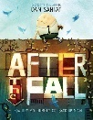  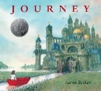 | Wisp  Purpose: writing to entertain  Outcome: story setting/description  Mia’s Story  Purpose: writing to inform  Outcome: instructions  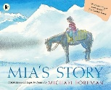  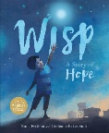 | Little Red  Purpose: writing to entertain  Outcome: story  Leon and the Place Between  Purpose: writing to inform  Outcome: recount  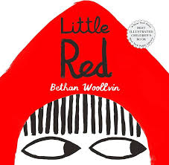  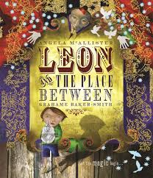
Reading | Varjak Paw  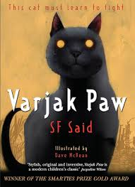 |  | 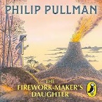  The Firework Maker’s Daughter | 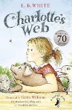  Charlotte’s Web | 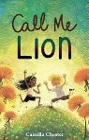  Call me Lion | 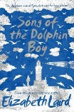  Song of the Dolphin Boy | 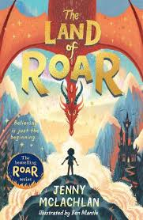  The Land of Roar
Maths | Number and Place Value  Multiplication Tables (6,7,9)  Problem Solving  Space for Pace |  | Properties of shape  Addition and Subtraction: mental methods  Number and Place Value  Problem Solving  Space for Pace | Multiplication Tables (11,12)  Addition and Subtraction: written methods  Problem Solving  Space for Pace | Mutiplication and Division  Properties of shapes (angles)  Problem Solving  Space for Pace | Decimals  Fractions  Problem Solving  Space for Pace | Decimals  Addition and Subtraction  Time and converting units  Perimeter and Area  Position and Direction  Statistics  Problem Solving  Space for Pace
Art and Design |  |  | Textiles: Batik  Artist: William Morris and Iwan Tirta |  |  | Drawing – Fur Patterns  Artist: George Stubbs | Sculpting – Cauldron in clay  Artist: Grayson Perry
Design and Technology (DT) | Mechanisms – Animal themed mechanisms using levers and linkages |  |  | Cooking and Nutrition – Anglo Saxon Meal (bread and stew) | Electronics – light up card
Physical Education (PE) | Fundamentals |  | Netball | Tennis | Gymnastics | Dance | Athletics
Science | Electricity |  | States of Matter | Sound- How sound is made and how we hear sound. | Sound – 2. How sounds can be changed. | Animals including humans | Living Things
Religious Education (RE) | Religion: Judaism  Theme: Beliefs and Practices  Key Question: How special is the relationship Jews have with God? |  | Religion: Christianity  Theme: Christmas  Key Question: What is the most significant part of the nativity story for Christians today? | Religion: Judaism  Theme: Passover  Key Question: How important is it for Jewish people to do what God asks them to do? | Religion: Christianity  Theme: Easter  Key Question: Is forgiveness always possible for Christians? | Religion: Judaism  Theme: Rites of Passage and Good Works  Key Question: What is the best way for a Jew to show commitment to God? | Religion: Christianity  Theme: Prayer and Worship  Key Question: Do people need to go to church to show they are Christians?
History | Children’s Changing Lives  How have children’s lives changed? |  |  | Anglo-Saxons  How hard was it to invade and settle in Britain? |  | Mayans  How did the achievements of the Maya civilization influence their society and beyond?
Geography |  |  | Rivers  What are rivers and how are they used? |  | Antarctica  Who lives in Antarctica? |  | Food Sources  Where does our food come from?
Computing | Computer Science  Programming A – Repetition in shapes A |  | Information Technology  Creating media – Audio production | Digital Literacy Computing systems and networks – The Internet | Information Technology Data and information – | Digital Literacy/ Recap IT  Collaborative poster on MS word (PM Unit 5.8) | Computer Science  Programming B – Repetition in games
Online Safety | Self Image and Identity | Privacy and Security | Online Bullying | Online Reputation | Health, wellbeing and lifestyle | Online Relationships | Managing Online Information | Copyright and Ownership
Personal Development | Being Me in My World |  | Celebrating Difference | Dreams and Goals | Healthy Me | Relationships | Changing Me
Music | Recorders |  | Recorders | Recorders | Recorders | Unit 1: Charanga  ‘Mamma Mia’ | Unit 2: Charanga  ‘Stop!’
Modern Foreign Languages – French | Portraits – describing in French |  | Clothes – getting dressed in France | French numbers, calendars and birthdays | French weather and the water cycle | French food | Eurovision Song Contest
Visits, visitors and experiences | Audiology Specialist Science – Sound.  Library visit |  | Christchurch - RE | Anglo Saxon Experience day - History |  | Old Town Heritage Day | 3 day residential – Grittleton House

