

Year 5 - Long Term Planning: Curriculum Overview

 | Term 1 |  | Term 2 | Term 3 | Term 4 | Term 5 | Term 6
Writing | The Lion, the Witch and The Wardrobe  Purpose: writing to entertain  Outcome: story setting  Last  Purpose: writing to inform  Outcome: recount - diary entry  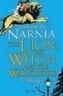  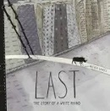 |  | The Promise  Purpose: writing to entertain  Outcome: character description  The Promise  Purpose: writing to persuade  Outcome: a letter  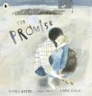 | Boy 87  Purpose: writing to entertain  Outcome: retell part of the story  The Land of Never Believe  Purpose: writing to inform  Outcome: non-chronological report  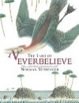  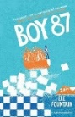 | Wonder  Purpose: writing to entertain  Outcome: short story  Wonder  Purpose: writing to persuade  Outcome: persuasive letter  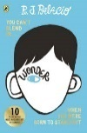 | Letters from the Lighthouse  Purpose: writing to entertain  Outcome: contrasting setting description  Letters from the Lighthouse  Purpose: writing to inform  Outcome: instructions  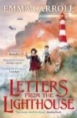 | 23 degrees 5 minutes  Purpose: writing to entertain  Outcome: story  Everest  Purpose: writing to inform  Outcome: recount  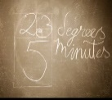  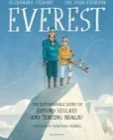
Reading | The Lion, the Witch and The Wardrobe  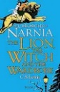 |  | 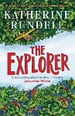  The Explorer | 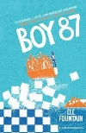  Boy 87 | 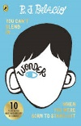  Wonder | Letters from the Lighthouse  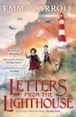 | Everest
Maths | Number and Place Value  Decimals  Properties of Shape  Problem Solving  Space for Pace |  | Addition and Subtraction  Multiplication and Division: powers of 10  Multiplication and Division: properties of number  Problem Solving  Space for Pace | Multiplication and Division: written methods  Position and Direction  Fractions, Decimals and Percentages  Problem Solving  Space for Pace | Fractions, Decimals and Percentages  Length, Mass and Capacity  Roman Numerals  Problem Solving  Space for Pace | Fractions: calculating  Problem Solving  Space for Pace | Area and Volume  Properties of Shape  Time  Statistics  Problem Solving  Space for Pace
Art and Design | Drawing – Self portraits  Artist: Pablo Picasso |  |  |  | Printing – Lino printing  Artist: Andy Warhol | Painting – Cityscape  Artist: Van Gogh
Design and Technology (DT) |  |  | Materials and structures - Viking Shields | Cooking and nutrition – Apple crumble |  |  | Mechanisms – cam toys
Physical Education (PE) | Fitness |  | Gymnastics | Handball | Dance | Rounders | Athletics
Science | Forces |  | Properties and Change of Material | Living Things and their Habitats | Earth and Space | Properties and Change of Material Part 2 | Living Things and their Habitats  Animals (including Humans)
Religious Education (RE) | Religion: Sikhism  Theme: Belief into Action  Key Question: How far would a Sikh go for his/her religion? |  | Religion: Christianity  Theme: Christmas  Key Question: Is the Christmas Story true? | Religion: Sikhism  Theme: Beliefs and Moral Values  Key Question: Are Sikh stories important today? | Religion: Christianity  Theme: Easter  Key Question: How significant is it for Christians to believe God intended Jesus to die? | Religion: Sikhism  Theme: Prayer and Worship  Key Question: What is the best way for a Sikh to show commitment to God? | Religion: Christianity  Theme: Beliefs and Practices  Key Question: What is the best way for a Christian to show commitment to God?
History |  |  | Vikings  Were the Vikings raiders, traders or something else? |  | Tudors  What was life like in Tudor England? | Greeks  What is the legacy of the ancient Greek civilisation?
Geography | Sources of Energy  Where does energy come from? |  |  | The Alps  What is life like in the Alps? |  |  | Oceans  Why do oceans matter?
Computing | Computer Science  Programming A – NCCE Selection in physical computing |  | Information Technology  Creating media – Video production using iMovie | Digital Literacy  Computing Systems and Networks – Sharing Information | Digital Literacy –  Space themed blogs on 2Blog on Purple Mash | Information Technology –  Data and information - Flat-file databases | Computer Science  Programming B – NCCE Selection in quizzes
Online Safety | Self Image and Identity | Privacy and Security | Online Bullying | Online Reputation | Health, wellbeing and lifestyle | Online Relationships | Managing Online Information | Copyright and Ownership
PSHE/Jigsaw | Being Me in My World |  | Celebrating Difference | Dreams and Goals | Healthy Me | Relationships | Changing Me
Music | Ukulele |  | Ukulele | Ukulele | Ukulele | Unit 1: Charanga  ‘Livin’ On A Prayer’ | Unit 2: Charanga  ‘Blackbird’
Modern Foreign Languages - French | French monster pets |  | Space exploration | Shopping in France | French speaking world | Verbs in a French week | Meet my French family
Visits, visitors and experiences |  |  |  |  |  |  | Beach Trip with Year 2

