

Year 6 - Long Term Planning: Curriculum Overview

 | Term 1 |  | Term 2 | Term 3 | Term 4 | Term 5 | Term 6
Writing | Skellig  Purpose: writing to entertain  Outcome: story setting  The Viewer  Purpose: writing to inform  Outcome: diary entry  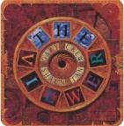  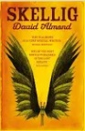 |  | Road’s End  Purpose: writing to entertain  Outcome: character description  A Christmas Carol  Purpose: writing to inform  Outcome: persuasive letter  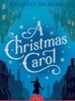  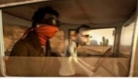 | Alma  Purpose: writing to entertain  Outcome: short story  Alma  Purpose: writing to inform  Outcome: non-chronological report  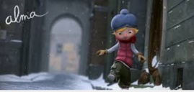 | The Lighthouse  Purpose: writing to entertain  Outcome: retell  The Lighthouse  Purpose: writing to inform and persuade  Outcome: biography and persuasive letter  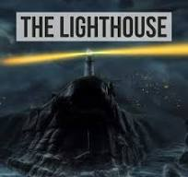 | Francis  Purpose: writing to entertain  Outcome: retell with invented ending  Francis  Purpose: writing to inform and explain  Outcome: instructions   | Texts TBC  Purpose: writing to entertain  Outcome: TBC  Purpose: writing to inform  Outcome: presentation
Reading | Skellig  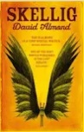 |  | 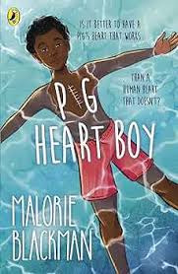  Pig Heart Boy | 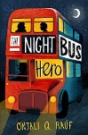  The Night Bus Hero | 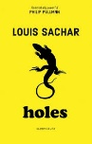  Holes | High Quality Extracts | The Sleeper and the Spindle  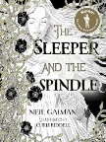
Maths | Number and Place Value  Decimals  Multiplication and Division  Addition, Subtraction, Multiplication and Division  Problem Solving  Space for Pace |  | Fractions, Decimals and Percentages  Fractions calculating (additive)  Properties of shapes (angles)  Problem Solving  Space for Pace | Fractions calculating (multiplicative)  Ratio and Proportion  Measurement converting  Area and Volume  Problem Solving  Space for Pace | Statistics  Algebra  Position and Direction  Propeties of Shapes  Problem Solving  Space for Pace | Targeted Revision and Problem Solving | Secure:  Fractions, Decimals and Percentages  Algebra  Ratio and Proportion  Geometry
Art and Design | Drawing – One point perspective drawing  Artist: Leonardo da Vinci / Masaccio |  | Sculpting - Dragon eyes in clay  Artist: Clay throughout history | Drawing – cartoon family  Artist: Matt Groening | Painting: Desert Landscapes  Artist: Georgia O’Keefe
Design and Technology (DT) |  |  |  |  |  | Digital world – steady hand games inc. microbits | Textiles - Make a toy for reception  Make £5 Grow
Physical Education (PE) | Fitness |  | Tag Rugby | Gymnastics | Volleyball | Dance | Swimming / Athletics
Science | Light |  | Living Things and their Habitats | Animals (including Humans) | Evolution and Inheritance | Electricity | Secure learning
Religious Education (RE) | Religion: Islam  Theme: Beliefs and Practices  Key Question: What is the best way for a Muslim to show commitment to God? |  | Religion: Christianity  Theme: Christmas  Key Question: How significant is it that Mary was Jesus’ mother? | Religion: Christianity  Theme: Beliefs and Meaning  Key Question: Is anything ever eternal? | Religion: Christianity  Theme: Easter  Key Question: Is Christianity still a strong religion 2000 years after Jesus was on Earth? | Religion: Islam  Theme: Belief and Moral Values  Key Question: Does belief in Akhirah (life after death) help Muslims lead good lives?
History | The Census  What does the census tell us about our local area? |  |  | World War II  What was the impact of World War II on the people of Britain? |  | Crime and Punishment  How has crime and punishment changed over time?
Geography |  |  | Population  Why does population change? |  | Deserts  Would you like to live in the desert? |  | Fieldwork  Can I carry out an independent fieldwork enquiry?
Computing | Digital Literacy  Computing Systems and Networks |  | Computer Science  – Programming - Variables in games on Scratch | Digital Literacy – comparing communication tools (Making a Sway) |  | Computer Science  Sensing movement – physical computing using Microbits | Information Technology Data and information / Creating Media  MS Excel
Online Safety | Self Image and Identity | Privacy and Security | Online Bullying | Online Reputation | Health, wellbeing and lifestyle | Online Relationships | Managing Online Information | Copyright and Ownership
PSHE/Jigsaw | Being Me in My World |  | Celebrating Difference | Dreams and Goals | Healthy Me | Relationships | Changing Me
Music
Visits, visitors and experiences |  |  | Library | UTURN (basic drug awareness) |  |  | Residential  Dyson Workshop  Crime and Punishment Workshop

