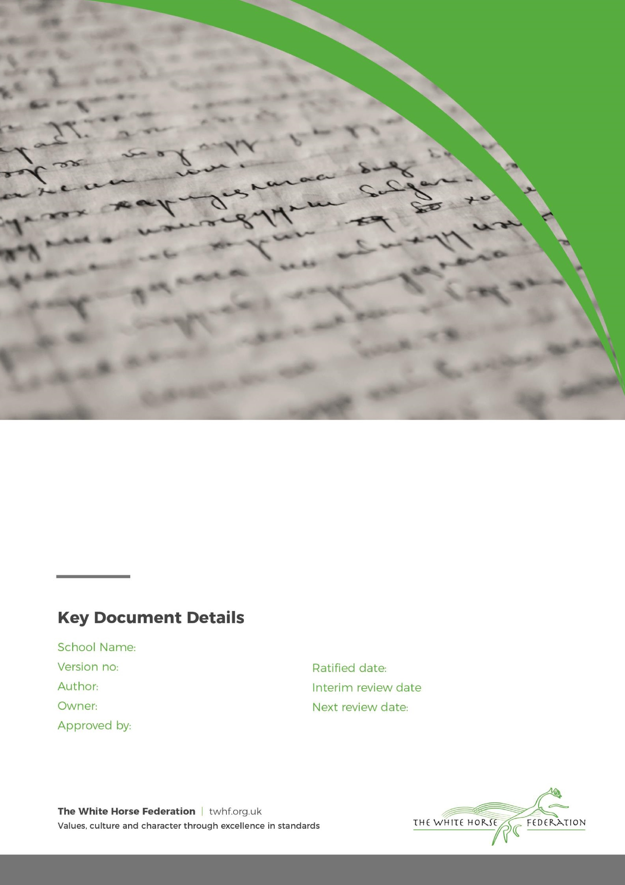

The Croft Primary School
Mobile Phone Policy


The Croft Primary School
1
Sept 2026
ElaineMurphy
Elaine Murphy
Sept 2027
Simon Cowley
Policy Statement
The Croft Primary School recognises that some pupils may need to bring a mobile phone to school for safety, communication, or family arrangements before and after the school day. However, mobile phones can create distractions, disrupt learning, compromise privacy, and present safeguarding concerns if not managed appropriately.
This policy sets out the expectations for pupils bringing mobile phones onto school premises and ensures that their use does not interfere with teaching, learning, safeguarding, or the wellbeing of the school community.
Scope
This policy applies to all pupils who bring a mobile phone onto school premises or to school-related activities.
1. Bringing Mobile Phones to School
1.1 Pupils may bring a mobile phone to school where parents/carers consider it necessary, for example, to support communication when travelling to and from school independently.
1.2 Mobile phones are brought to school entirely at the owner's risk. The Croft Primary School accepts no responsibility for the loss, theft, damage, or malfunction of any mobile phone brought onto school premises.
1.3 Parents/carers are encouraged to consider whether a mobile phone is essential before allowing their child to bring one to school.
2. Expectations for Mobile Phone Use
2.1 Mobile phones must be switched off, not set to silent mode, before a pupil enters the school grounds.
2.2 Mobile phones must not be used at any time during the school day, including before school, during lessons, break times, lunchtime, or while attending extra-curricular activities on school premises.
2.3 The following activities are strictly prohibited on school premises:
- Making or receiving phone calls.
- Sending or receiving text messages.
- Accessing the internet or social media platforms.
- Taking photographs, videos, or audio recordings.
- Playing games or using applications.
- Using messaging services of any kind.
2.4 Mobile phones must remain out of sight at all times while pupils are on school premises.
3. Procedures on Arrival at School
3.1 Upon entering the school grounds, pupils must ensure that their mobile phone remains switched off and securely stored in their school bag.
3.2 On arrival in their classroom, pupils must place their mobile phone in the designated secure storage container provided by the school.
3.3 Mobile phones will remain securely stored throughout the school day and must not be accessed by pupils.
3.4 Pupils are responsible for ensuring that their phone is handed in promptly each morning.
4. End of the School Day
4.1 Mobile phones will be returned to pupils at the end of the school day.
4.2 Once returned, pupils must place their phone immediately into their school bag.
4.3 Mobile phones must remain out of sight and unused until pupils have left the school grounds.
4.4 Pupils who attend after-school clubs or activities must follow the same expectations until they leave the school site.
5. Safeguarding and Privacy
5.1 The use of mobile phones with camera, video, or audio recording capabilities presents significant safeguarding and privacy risks.
5.2 Under no circumstances may pupils use a mobile phone to photograph, film, record, or share images or information relating to other pupils, staff, visitors, or school activities without explicit permission.
5.3 Any misuse of a mobile phone that compromises the privacy, dignity, safety, or wellbeing of others will be treated as a serious breach of school behaviour and safeguarding procedures.
6. Breaches of the Policy
6.1 Any pupil found using a mobile phone during the school day, or failing to comply with this policy, may have their phone confiscated.
6.2 In the event of a confiscation:
- The mobile phone will be retained securely by the school.
- Parents/carers will be informed.
- The phone may only be returned to a parent/carer or at a time determined by the Headteacher.
- The incident will be recorded in accordance with the school's behaviour procedures.
6.3 Repeated breaches of this policy may result in further sanctions in line with the school's Behaviour Policy and may lead to the withdrawal of permission for the pupil to bring a mobile phone to school.
6.4 Serious misuse of a mobile phone, including recording, photographing, sharing inappropriate content, or online bullying, may result in additional disciplinary action and, where appropriate, referral to external agencies.
7. Exceptions
7.1 Exceptions to this policy may be granted in exceptional circumstances, including where a pupil has a documented medical need, disability, or other specific requirement.
7.2 Any exception must be approved in advance by the Headteacher and documented accordingly.
7.3 Agreed arrangements will be communicated to relevant staff and reviewed periodically.
Roles and Responsibilities
Pupils
Pupils are responsible for:
- Complying with this policy at all times.
- Ensuring their mobile phone is switched off before entering school grounds.
- Handing their phone into the designated storage facility each morning.
- Respecting the privacy and safety of others.
Parents and Carers
Parents and carers are responsible for:
- Supporting the school's expectations regarding mobile phone use.
- Discussing this policy with their child.
- Contacting the school office if urgent communication with their child is required during the school day.
School Staff
School staff are responsible for:
- Implementing and monitoring this policy consistently.
- Ensuring secure storage arrangements are in place.
- Addressing breaches of the policy in line with school procedures.
Review
This policy will be reviewed regularly by the Headteacher and Governing Body to ensure it remains effective, appropriate, and in line with safeguarding and educational best practice.

