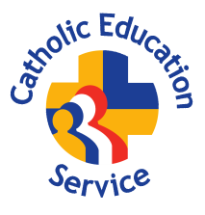
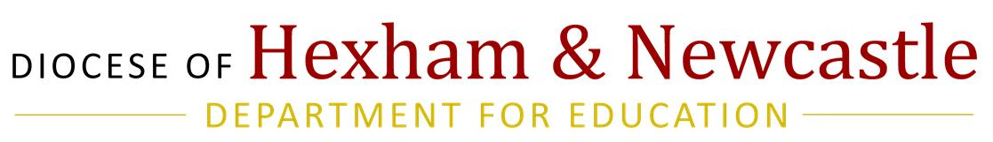

FOUNDATION GOVERNOR
SKILLS AUDIT
Name |  | Surname
School name |  | School Town

This audit has been produced by the Catholic Education Service (CES) and is intended to identify skill gaps and inform training needs for foundation governors. The school will keep this on file and send a copy to the Diocesan Department for Education.

Please indicate your level of experience in respect of each of the categories of skills, knowledge and experience in Sections A and B below. Where you consider that you would benefit from training in a particular category of skill, please tick the relevant box.

SECTION A - SKILLS, KNOWLEDGE AND EXPERIENCE RELATING TO THE CATHOLIC CHARACTER OF THE SCHOOL:

Category of skill, knowledge or experience | Level: Extensive | Level: Moderate | Level: Basic | Level: None | Training required?
- Understanding the mission of a Catholic school and Catholic education generally
- Understanding of catechesis and religious education
- Understanding of the liturgical and sacramental life of the school
- Understanding the history of the Catholic Church’s involvement in the provision of schools in England and Wales
- Ecclesiology: understanding the role of the Bishop and the Trustees and the governing body’s relationship with them
- Ability to evaluate the Catholic life of the school

SECTION B: GENERAL AND SPECIALIST SKILLS, KNOWLEDGE OR EXPERIENCE:

Category of skill, knowledge or experience | Level: Extensive | Level: Moderate | Level: Basic | Level: None | Training required?
Governance
- Experience of governance (including in any other sector)
- Chairing
- Leadership
- Taking meeting minutes
Staff Matters
- HR expertise
- Experience of staff recruitment
- Performance management and appraisal of (i) staff and/or (ii) organisation
Data
- ICT and/or management information systems
- Data analysis
- Knowledge of sources of relevant information/data e.g. RAISEonline, Ofsted’s Data Dashboard and other educational software programmes
Community Matters
- Community relations
- Knowledge of school and local community
- Knowledge of the local/regional economy and local government
- Parents perspective: current of the school
- Networks/alliances
Handling Conflict
- Conflict resolution
- Handling complaints, grievances and appeals
Skills particular to an educational setting
- Experience of an educational setting
- Teaching and pedagogy
- Safeguarding
- SEN and disability
- Phase – primary/nursery/secondary/FE and HE
- School in category
Professional Skills
- Financial management/accountancy
- Legal
Other skills, knowledge and experience
- Strategic planning
- Coaching/mentoring and/or continued professional development
- Communication skills, including listening
- Problem solving and/or creativity
- Negotiation and mediation
- Ability to influence
- Ability to work as part of a team
- Equal opportunities /equality and diversity
- Change management (particularly in respect of potential academy conversion)
- Carrying out surveys, consultation and/or research
- Quality assurance
- Health & safety
- Risk assessment
- Project management
- PR and marketing and/or working with the media
- Work placements/career planning
- Procurement/purchasing
- Premises and facilities management
- Fundraising
- Children’s and young people’s services/activities (any sector)
- Health services (particularly relevant in special schools)
- Self-evaluation and/or impact assessment

Signature: |  | Date:

Once completed, please return to the school

FAO THE SCHOOL
Please keep this audit on file for training purposes and send a copy to:
Diocesan Department for Education, St Cuthbert’s House, West Road, NE15 7PY

