Hamworthy Primary Schools
EYFS Progression of Skills – Writing

Writing
Nursery (3-4 years)  Use some of their print and letter knowledge in their early writing. For example: writing a pretend shopping list that starts at the top of the page; write ‘m’ for mummy. LITERACY  Write some or all of their name. LITERACY  Write some letters accurately. LITERACY  HANDWRITING  Use a comfortable grip with good control when holding pens and pencils. PD  Show a preference for a dominant hand. PD | Reception  Form lower-case and capital letters correctly. LITERACY  Spell words by identifying the sounds and then writing the sound with letter/s. LITERACY  Re-read what they have written to check that it makes sense. LITERACY  Write short sentences with words with known letter-sound correspondences using a capital letter and full stop. LITERACY  HANDWRITING  Develop their small motor skills so that they can use a range of tools competently, safely and confidently. Suggested tools: pencils for drawing and writing. PD  Develop the foundations of a handwriting style which is fast, accurate and efficient. PD | Early Learning Goal  - Write recognisable letters, most of which are correctly formed. WRITING  - Spell words by identifying sounds in them and representing the sounds with a letter or letters. WRITING  - Write simple phrases and sentences that can be read by others. WRITING  HANDWRITING  - Hold a pencil effectively in preparation for fluent writing- using the tripod grip in almost all cases. PD- FMS

Pre-Phonemic Stage/  Making marks | Random scribbling  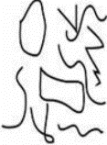  I explore making marks. I do not yet ascribe meaning to my marks. Starting point at any point of paper. | Pictures and Scribble writing  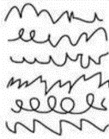  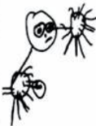  I can draw basic pictures. I can use lines to mimic writing in a left to right direction. I can begin to ascribe meaning. | Symbols that represent letters  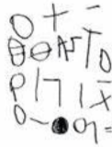  I use symbols and shapes to represent letters. I can ascribe meaning to my marks. | Random letters  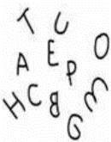  I use random letters to represent meaning. I can ascribe meaning to my marks. |  | Letter strings  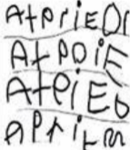  I use letter strings from left to right and move down the page. |  | Letter groups  I write letters with spaces between to resemble words.  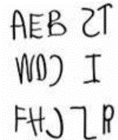 | Environmental words  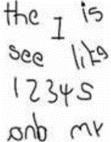  I copy words which I see in the environment. I may not know what these words say.
Developing writing- words | I am beginning to hear initial sounds and attempt to write them.  m- mum  Initial letter in name | I can hear initial sounds in words and write the letters down to match.  c-cat  t-tin  s-sun | I can write short strings of letters to represent words. Hearing /writing final sounds first and then medial. Left to right.  bna- banana  tgr- tiger | I can segment simple vc and cvc words and write the grapheme to match.  as sat  it pot |  | I can write simple High Frequency decodable and tricky words from memory.  mum dad and  I go to the no into |  | I can spell out words with consonant clusters, vowel digraphs and trigraphs.  buzz fill mess ship chip boat sheep soil chair pink
Developing writing- sentences | I can think of and say a simple sentence for writing. | I can think of a simple sentence and hold it in my memory before I begin to write it. | I can use beginning and ending letters to represent words in my sentence. I may use CEW.  I can read back my sentence. | I can use beginning, medial and ending sounds in my sentence. My sentence can be read by others. I write simple CEW spelt correctly. Expected |  | I can begin to put finger spaces between my words. |  | I can write a sentence with a full stop and capital letter. I can re-read it and check that it makes sense.
Forms of writing | I can write a simple label. | I can write a simple list. | I can write a short caption or message. Eg a greeting card or note. |  | I can write one than one related sentence eg captions for a picture |  | I can write multiple related sentences for a purpose such as a recount, story or instructions.
Readiness for Year 1
Hold pencils, pens and other marking making tools appropriately so that they can make marks in an increasingly controlled way.
Write simple sentences that can be read by others (including beginning the use of some finger spaces).
Start to develop an understanding of capital letters and full stops.
Begin to use digraphs when segmenting.
Begin to spell some HFW words accurately.

