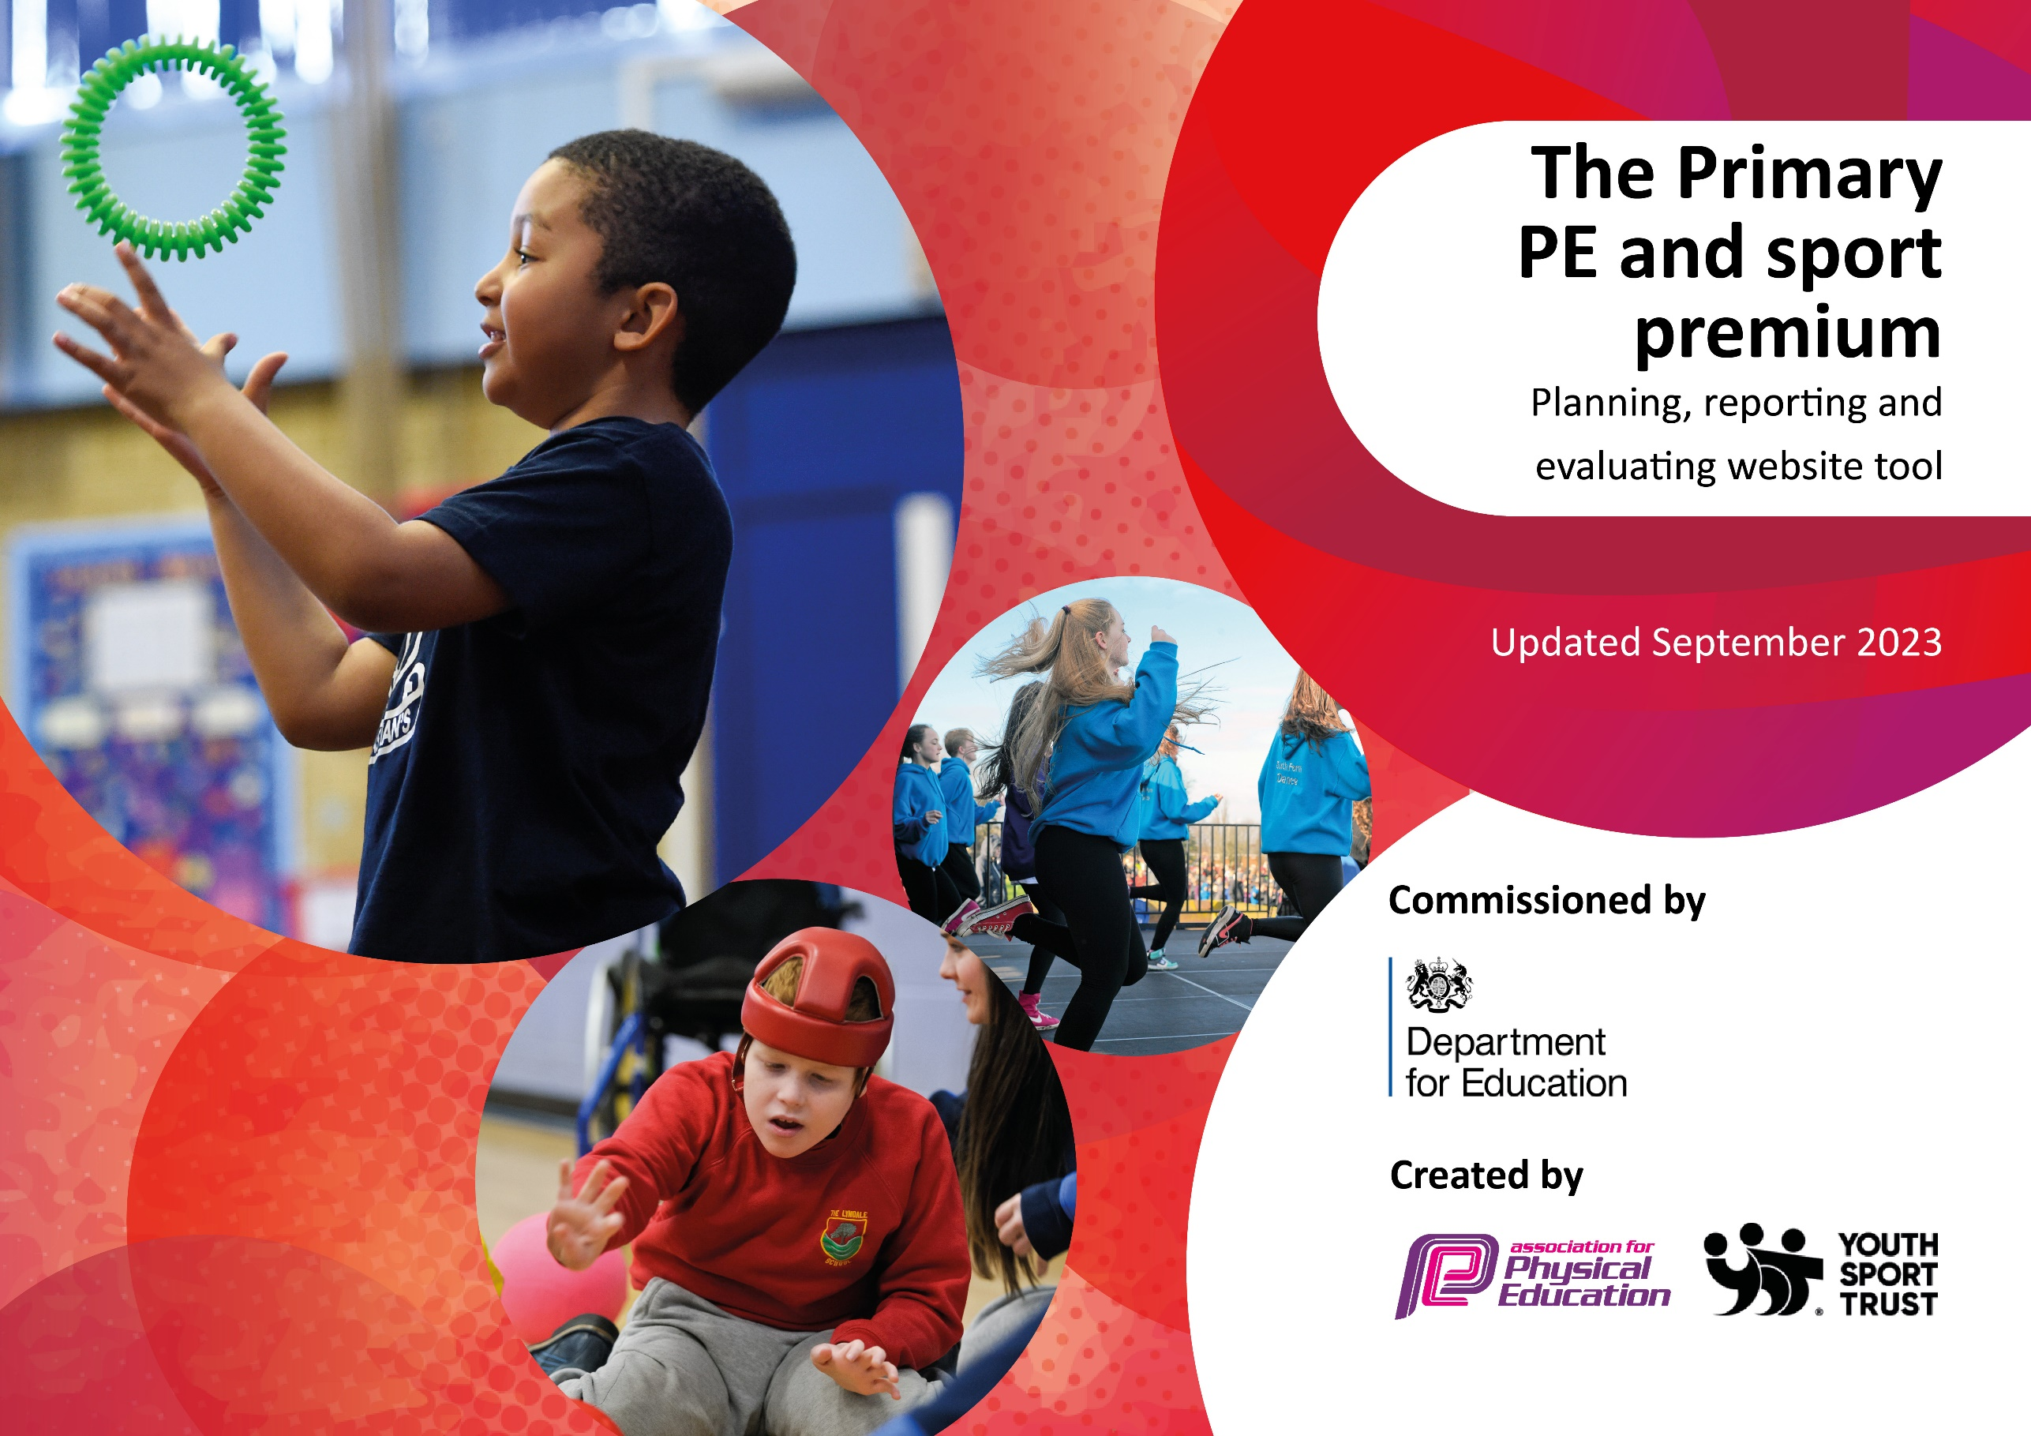

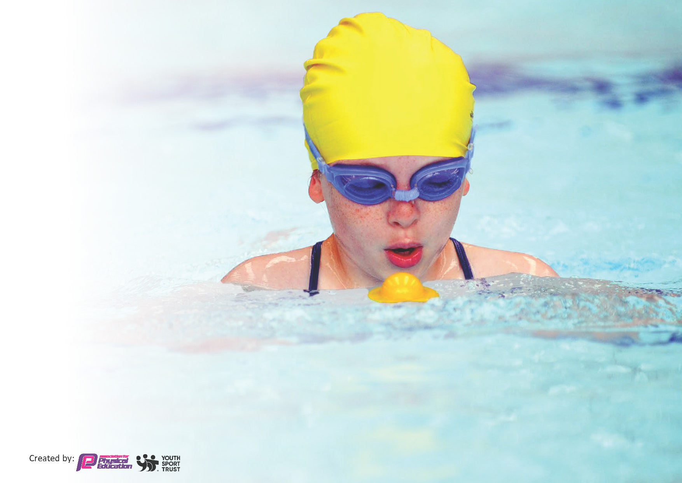
This template can be used for multiple purposes:
by:
- It enables schools to effectively plan their use of the Primary PE and sport premium
- It helps schools to meet the requirements (as set out in guidance) to publish information on their Primary PE and sport premium
- It will be an effective document to support Ofsted inspections enabling schools to evidence progress in Physical Education (PE) and evidence swimming attainment, which forms part of the PE National Curriculum. We would recommend schools consider
the Intent, Implementation and Impact of any spend, as examined within the Education Inspection Framework.

It is important that your grant is used effectively and based on school need.

Schools must use the funding to make additional and sustainable
improvements to the quality of the PE, School Sport and Physical Activity (PESSPA)
they offer. This means that you should use the Primary PE and sport premium to:

- Build capacity and capability within the school to ensure that improvements made now will benefit pupils joining the school in future years
- Develop or add to the PESSPA activities that your school already offers.

The Primary PE and sport premium should not be used to fund capital spend projects; the school’s core budget should fund these. Further detail on capital expenditure can be found in the updated Primary PE and sport premium guidance.

The Primary PE and sport premium guidance, outlines 5 key priorities that funding should be used towards. It is not

necessary that spending has to meet all the key priorities, you should select the priorities that you aim to use any funding towards.

Although completing this template is not a requirement for schools, schools are required to publish details of how they spend this funding. Schools must also outline what the impact this funding has had on pupils’ PE and sport participation and attainment and how any spending will be sustainable in the future. All funding must be spent by 31st July 2024.

The Department for Education has worked closely with the Association for Physical Education (afPE) and the Youth Sport Trust (YST) to develop this template and encourages schools to use it. This template is an effective way of meeting the reporting requirements of the Primary PE and sport premium.
Review of last year’s spend and key achievements (2022/2023)

We recommend you start by reflecting on the impact of current provision and reviewing your previous spend.

Activity/Action | Impact | Comments
To provide children with challenge in each PE lesson, with high levels of engagement and high quality PE teaching.  To improve the children’s fundamental movement skills and ensure they are making progress in each lesson.  To engage and motivate children and teachers in school with Real Legacy.  Engaging less active children in new sports.  Offer more activities to support activity during lunchtime and after school.  To offer the opportunity to take part in a variety of sports at a competitive level.  To participate in face to face events with other schools.  To allow children on the SEN register to engage in competition. | Staff continue to use Real PE as a scaffold for each PE lesson. It offers support and guidance for delivery of high quality PE lessons.  Children are aware of how to make progress with next steps and are able to give feedback to others about how they can improve.  Children’s fundamental movement skills are developing year on year.  Table tennis table is used daily.  It is used by all year groups, during break times and lunchtime and in after school club.  Children who can become dysregulated are using this as a break from the classroom environment.  A number of children from each class have learned to play table tennis and continue to practice to improve.  Some children from Key Stage 2 took part in competition with other schools for the first time.  Success in events improved the confidence of children to take part fully.  Long jump mat was used in practice for Warwick athletics events – we had 2 winners from Year 6 and year 4.  Children asking to take part in events, to be able to try new sports and be active.  SEN events support the needs of our children to take part and be successful. Allows them space to excel in other areas of school life. | Continue to plan in assessment lessons to monitor progress of skills.  Monitor planning of sports specific skills so that Year 5 and 6 have high quality PE lessons outside of the Real PE framework.  Possibility of trying to get a club going using the table. Try to use during sports weeks etc.  Meetings taking place to sort fixtures and clubs for next year.

Key priorities and Planning
This planning template will allow schools to accurately plan their spending.

Action – what are you planning to do | Who does this action impact? | Key indicator to meet | Impacts and how sustainability will be achieved? | Cost linked to the action
Introduce lunchtime sport sessions/activities for pupils. Encourage more interaction with adults and children.  Introduce more competitive sporting opportunities for the children at school.  To enhance after school activity and local inter school competition.  Develop PE coordinator skills in delivering sport specific planning units CPD  Year 6 children attending residential  All year 6 children to understand and learn about water safety and safe self-rescue  To purchase a new uniform for teaching staff.  To purchase T-shirts for children to use when taking part in events  Buy resources for lunchtimes and after school club to improve provision and activity.  Offer ‘Learn to swim’ weeks for Year 6 children who do not meet end of Key Stage expectations for swimming.  To provide children with the opportunity to access forest school.  To develop the use of Learning Nutrients within PE lessons. | Midday supervisors - as they need to lead the activity  pupils – as they will take part  Pupils in both Key Stages  Laura Eaves – PE coordinator  Support staff – taking children to the events  Pupils in both Key Stages  Laura Eaves – PE coordinator  PE coordinator  Year 6 children  Pupils in Year 5 and 6  Teaching staff and parent helpers.  Support from St Nicholas School in Alcester who have visited before.  PE coordinator  Head of School  David Brooker – Yorico Personalisation Services Ltd.  PE coordinator  Lunchtime supervisors  PE coordinator  Admin  Patrick – swimming coach  Children involved and their parents.  Forest school leader  Children to attend the sessions.  Teaching staff  Jess – Real Legacy support. | Key indicator 2 -The engagement of all pupils in regular physical activity – the Chief Medical Officer guidelines recommend that all children and young people aged 5 to 18 engage in at least 60 minutes of physical activity per day, of which 30 minutes should be in school.  Key Indicator 1: Increased confidence, knowledge, and skills of all staff in teaching PE and sport.  Key indicator 2 -The engagement of all pupils in regular physical activity – the Chief Medical Officer guidelines recommend that all children and young people aged 5 to 18 engage in at least 60 minutes of physical activity per day, of which 30 minutes should be in school.  Key indicator 4: Broader experience of a range of sports and activities offered to all pupils.  Key indicator 5: Increased participation in competitive sport.  Key Indicator 1: Increased confidence, knowledge, and skills of all staff in teaching PE and sport.  Key Indicator 3: The profile of PE and sport is raised across the school as a tool for whole school improvement  Key indicator 4: Broader experience of a range of sports and activities offered to all pupils.  Key Indicator 1: Increased confidence, knowledge, and skills of all staff in teaching PE and sport.  Key indicator 4: Broader experience of a range of sports and activities offered to all pupils.  Key Indicator 1: Increased confidence, knowledge, and skills of all staff in teaching PE and sport.  Key Indicator 3: The profile of PE and sport is raised across the school as a tool for whole school improvement  Key Indicator 1: Increased confidence, knowledge, and skills of all staff in teaching PE and sport.  Key indicator 2 -The engagement of all pupils in regular physical activity  Key indicator 4: Broader experience of a range of sports and activities offered to all pupils.  Key indicator 2 -The engagement of all pupils in regular physical activity.  Key Indicator 3: The profile of PE and sport is raised across the school as a tool for whole school improvement  Key indicator 2 -The engagement of all pupils in regular physical activity.  Key indicator 4: Broader experience of a range of sports and activities offered to all pupils.  Key Indicator 1: Increased confidence, knowledge, and skills of all staff in teaching PE and sport. | More pupils meeting their daily physical activity goal, more pupils encouraged to take part in PE and Sport Activities.  More pupils encouraged to take part in physical activity. Meeting other children and competing in friendly competition.  An opportunity to learn a new sport – some children hope to continue (girls football and Archery)  Contacts made with staff to continue arranging competitive opportunities.  Children knew we had listened to their voice – they wanted a football club and have enjoyed the competition. Enhanced our provision for girls’ football.  Planning created for Year 5 and 6 to be used alongside our Real PE units of work. One sport specific unit of work created per year group.  Children had the opportunity to experience sports and challenges, facing fears and overcoming obstacles. All children reminded and shown through positive role models of the importance of physical fitness. PE Lead observed that further support might be needed to develop balance and orienteering skills  All children leave school understanding the importance of safe self-rescue and dangers near the water. Continue this practice next year for all Year 5 pupils.  Staff feel more confident and feel a sense of team when wearing kits. Children can clearly identify staff when out at a sporting event and in school. The children see the importance of a PE kit and uniform.  Children’s uniforms look so smart, they represent their school with pride and parents have asked to make this our school PE kit!  Yet to see impact as these have only recently been bought. We are waiting to clear out old resources and then add new resources.  The speaker will be used at sports day.  1 child was unable to attend.  1 child learned to swim and parents have continued to take her for lessons weekly. She met expectations.  1 child developed water confidence and is continuing to access swimming lessons.  1 child (year 5) developed confidence and will have the opportunity to access another swim course in year 6  All pupils reported enjoying sessions, learning new skills,  being exposed to new and engaging physical challenges. Including teamwork, problem-solving, and resilience, which are transferable to other sports and life situations. Pupils demonstrated increased confidence in their abilities to try new activities and take on challenges outside their comfort zones.  Staff have developed the use of learning outcomes – whiteboards used for assessment in the hall each lesson. Children are able to support each other learning and self assess using the Learning outcomes and success criteria. | £300 cost for Carolyn Robinson to support Midday supervisors/After school provision. Support with games ideas and how to enhance games happening.  £935 costs for adult to attend the event, costs for entry and transport.  £462 cost contributed to the cost of after school club with ‘On you Marks’.  £267 cost for cover teacher.  £608 cost for staff to go with children on residential  £600 cost for year 5 and 6. Cost to cover the coach and adults to support.  £969.70 cost for staff hoodies and T-shirts, children’s T-shirts.  £153.98 for Bluetooth speaker and microphone (sports day and music for the playground)  £209.99 Maxi scooter x 2  £2,869.24 resources including large playground games, archery sets, basketballs, large chess set, hoops, tennis balls, skittles, pump…  £2988 for bikes, trikes and scooters to replace the old ones.  £264.30 cost for 4 children to access Learn to swim in Feb half term. One child did not attend as he was poorly.  £200 for Patrick to coach swimming lessons.  £947.13 costs based on 3hrs/week for 38 weeks. Forest school sessions.  £0 – funds through Real Legacy package we already have.

Key achievements 2023-2024
This template will be completed at the end of the academic year and will showcase the key achievements schools have made with their Primary PE and sport premium spending.

Activity/Action | Impact | Comments
Introduce more competitive sporting opportunities for the children at school.  To enhance after school activity and local inter school competition.  Offer ‘Learn to swim’ weeks for Year 6 children who do not meet end of Key Stage expectations for swimming.  All year 6 children to understand and learn about water safety and safe self-rescue  To purchase T-shirts for children to use when taking part in events | Girls playing more sport and some inactive girls participating. Real feel of group sports and the boys were supporting the girls team too.  SEN children having more opportunity to take part in competitive sport – Archery 4U and Rowing 4U. Children really liked the relaxed, safe atmosphere.  High take up for after school activities and opportunity of competition. Children have been talking about these with others who are now taking part and enjoying new sports like hockey and netball.  Two swimmers from Year 6 who were non-swimmers are now swimming and taking further lessons.  One year 5 swimmer developed more water confidence through the learn to swim weeks. We will continue this for her in Year 6.  A really valuable way to teach these life skills.  Children learned how to use items around them to safe themselves and others. Children learned how to perform safe self-rescue with floatation devices and clothing.  Year 5 and 6 children can perform safe self-rescue and support the rescue of others in water.  Children were so excited and proud to be wearing them at the athletics festival and other sporting events.  All children felt like part of the team, liked the material and how they felt and liked having Ferncumbe written on the back.  Parents have made positive comments and would like this to be part of The Ferncumbe PE kit – it is easy to wash and isn’t white. | Parents have been asking for more after school sports including girls football. Parents supported us with the girls football tournament and with training sessions as they were so keen for it to happen. Kits were bought by parents for the children to use when they played.  Learn to swim weeks have been really valuable. This has made us rethink the way we deliver swimming as a school – Year 3’s to swim for 2 terms. Learn to swim weeks for non-swimmers and extra sessions over a final term for Year 4,5,6 children who need more support with swimming.  This was recommended to us by another school and helps us to assess whether children can perform safe self-rescue and know water safety.  This will continue forward as an activity for Year 5 children during the summer term.  Will have conversations with SLT about whether to roll this out as uniform or continue to use these T-shirts for sporting events only outside if school.

Swimming Data
Meeting National Curriculum requirements for swimming and water safety.
Priority should always be given to ensuring that pupils can perform safe self-rescue even if they do not fully meet the first two requirements of the National Curriculum programme of study

Question | Stats: | Further context  Relative to local challenges
What percentage of your current Year 6 cohort can swim competently, confidently and proficiently over a distance of at least 25 metres? | 89% | Some children lacked experience and opportunity to learn to swim.
What percentage of your current Year 6 cohort can use a range of strokes effectively [for example, front crawl, backstroke, and breaststroke]? | 89% | Year 6 children have has lessons during their primary school life with a final half term block in year 6. They have practiced each stroke with swimming teachers and been assessed by teacher with the support of swimming instructors.

What percentage of your current Year 6 cohort are able to perform safe self-rescue in different water-based situations? | 100% | All Year 5 and 6 children visited Lenches Lakes in Evesham to learn about water based safety. They went in and around the water to practice land and water based rescue. They learned about dangers in and around water in the classroom element of the day.  We will continue to use provision at the Lenches for all Year 5 pupils.
If your schools swimming data is below national expectation, you can choose to use the Primary PE and sport premium to provide additional top-up sessions for those pupils that did not meet National Curriculum  requirements after the completion of core lessons. Have you done this? | Yes | Learn to swim weeks were taken up by 3 pupils, all now swimming 25 metres. One children could not attend and all others are continuing lessons outside of school.  We will continue this as a plan for next year.
Have you provided CPD to improve the knowledge and confidence of staff to be able to teach swimming and water safety? | Yes | Support for 2 members of staff at The Lenches – watching instructors in the water with the children and in the classroom.  We will continue to use provision at the Lenches for all Year 5 pupils.

Signed off by:

Head Teacher: | Tracey Webb, Head of School
Subject Leader or the individual responsible for the Primary PE and sport premium: | Laura Eaves, PE Coordinator and KS2 Teacher
Governor: | Donna Bothamley, Chair of Governors
Date: | 28.06.24

