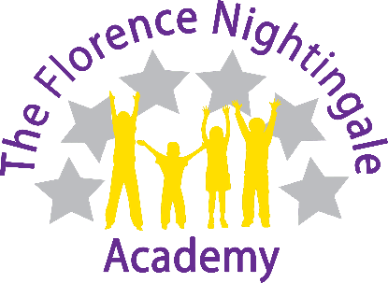

Thursday 5th February 2026

Dear Parents / Carers

Year 4 visit to The Open Centre, Derby – Thursday 23rd April 2026

As part of the KS2 curriculum, our children in Year 4 will be visiting The Open Centre in Derby. This is a fantastic opportunity for the children to see some of the religions that they are learning about in RE. They will get to experience and expand their knowledge of other cultures and to see places of worship that they may not necessarily get to visit.

We will depart from school at 8.55am, so children will need to be in school promptly at 8.45am to be registered. We will return to school for the normal collection time and will send out a text if there are any changes to this on the day.

Children will be required to wear a head covering inside the places of worship, along with having their arms and legs fully covered (normal school uniform of trousers and sweatshirts, will suffice). Any children wearing a skirt will need to wear thick dark tights. Shorts will not be able to be worn on this day.

Children will need to bring a packed lunch from home, no cans or bottles of fizzy pop. Children who are in receipt of free school meals can order a packed lunch from school.

The cost of the trip is £8.80 and is payable via the MCAS app.

Year 4 visit to The Open Centre, Derby – Thursday 23rd April 2026

Child’s Name:
Class:
I have paid the amount of £8.80 via MCAS: | YES / NO
I require a packed lunch from school (free school meal children only) | YES / NO (HAM or CHEESE)

