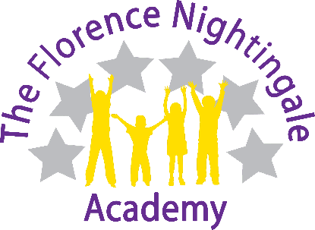
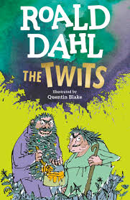

05.06.26

Dear Parent/Carer

Year 2 will be studying the book ‘The Twits’ as part of their English lessons this term. To reinforce your child’s learning experience and understanding of the literature, we are planning to show the film ‘The Twits’ during the summer term. We are informing you that the film is PG rated. I can assure you that the film will be shown in an appropriate context, including discussion and activities before and after viewing.

If you do not wish your child to view this material, please complete the form below and we will make other arrangements for them.

Please contact us if you have any further questions.

Mrs Jin and Mr Sainsbury
--------------------------------------------------------------------------------------------------------------------
Please complete the following:

Name of child ______________________________________

I do not wish my child to participate in this activity

