The Florence Nightingale Academy
Design and Technology Policy



Design and Technology Coordinator
Mrs Taylor
Reviewed: October 2022
Rationale
Here at The Florence Nightingale Academy we are architects, manufacturers, chefs, inventors, designers and engineers. We provide every child with the opportunity to develop their manufacturing and designing skills, ingenuity and creativity and the ability to positively critique their own and others work. Each project that the children complete requires them to think about and consider the intended user and proposed purpose for their product. They will discover past and present inventions that have shaped our world and develop the creativity to produce their own. Through effective teaching children will develop inventive minds, a curiosity to ask questions and be able to listen to feedback and act upon it. Children will be prepared to work in a range of different contexts and with a variety of materials. We want children to develop a passion for using different materials and to have the knowledge that one day they could be the one to introduce the world to the next life changing invention!
Introduction
This policy outlines the structure of Design and Technology for teaching and non-teaching staff to give guidance on planning, teaching and assessing within the subject.
Design and Technology is focused on using innovative ideas and designs in creative ways to solve real world problems. It provides children with the opportunity to investigate and analyse existing products and discover the manufacturing process in which they were made. As well as learning about some of the greatest influential people who have contributed inventions and created the world that we live in today. Design and Technology provides children with the freedom to explore their own ideas and present them in a variety of different ways. It also allows children to work in a wide range of contexts, highlighting the vast array of industries in which they may one day become a leader of.
Aims
The aims of design and technology are:
- To develop creativity, imagination and problem solving skills.
- To develop collaboration and communication through group project and discussions about ideas, designs and materials that should be used.
- To value everyone’s ideas and beliefs through working in groups and peer assessment of products.
- To understand the manufacturing processes set out in the national curriculum and how they can use knowledge from other subjects such as maths, science and ICT.
- To provide the tools and techniques to assess and critique projects, considering their use, the intended users and the impact on the environment.
- To have the ability to choose appropriate tools and techniques, using them safely and accurately.
- To provide nutritional knowledge and how it can be used when preparing and cooking food.
Curriculum
Our curriculum map for Design and Technology is planned and reviewed yearly to ensure that the knowledge, skills and concepts are taught in line with the national curriculum, therefore providing clear progression of skills and experiences as children progress through their educational journey. The long term plan has been devised to ensure a broad, balanced and purposeful curriculum which all children are able to access, routed in real world contexts. Through the teaching of Design and Technology children are provided with the opportunity to develop skills, attitudes and knowledge which can be used to support further learning in the subject and to help them become global citizen.

EYFS
Design and Technology is taught through adult led activities and child initiated learning. The children are provided with the opportunity to independently explore the ideas that underpin mechanisms and structures through their environmental resources. Children are able to immerse themselves in a range of activities which allows them to explore man-made and natural materials developing ideas of how they can be used and the key properties that they have. Throughout their time in EYFS children take part in cooking activities where they learn about healthy and unhealthy foods and simple ways to process ingredients.
Key Stage 1
During Key Stage 1, children are introduced to the five aspects of Design and Technology and work within local contexts such as schools and playgrounds. They learn about how to follow design criteria to produce design ideas and share them with others. Children build on their knowledge from EYFS and begin to use a range of self-chosen tools and techniques during practical sessions. Evaluation skills are taught through exploring existing products and considering how well their own products meets the design criteria. They develop knowledge of simple mechanisms such as sliders and levers and how to stabilise free standing structures. Children are taught about food ingredients, considering where they come from and if they are farmed, caught or reared. They also have the opportunity to prepare simple dishes without a heat source.
Key Stage 2
During Key Stage 2, children investigate and analyse existing products, inventions and key figures within Design and Technology who have shaped our world. They develop innovative designing skills through the use of computer aided design, annotated sketches and exploded diagrams. They then use these designs to pitch ideas and explain choices to peers. Children learn how to plan the manufacturing process and which tools they will need, considering the techniques that they will use. During the manufacturing process children will use their knowledge from other subjects to successful build and control their products. When evaluating work children will be taught how to take other people’s views as well as design criteria into account and suggest ways of improving their work. Children will build on the technical knowledge they gained in Key Stage 1 and learn about simple and complex electrical systems, complex mechanical systems and how to reinforce different 3D structures. They will learn how to cook a range of dishes considering nutritional value and availability of the ingredients and importance of food in other cultures.
Teaching and Learning
The school uses a variety of teaching and learning styles in Design and Technology lessons. Our pedagogy is based on research conducted by Rosenshine and his principles of instruction (2012),

Design and Technology Delivery Document
Intent | We take the National Curriculum statements and provide any enhanced version of this.  We map these in a coherent and sequential progression model that outlines the knowledge, skills and vocabulary needed at each stage that will build to clearly defined end points.  Teachers take the progression grid and map this into a long-term plan for their year group.  Teachers then plan at a more detailed level the sequencing of content to be taught across each unit
Implementation | Ensure that the teachers of the subject have excellent subject knowledge, and leadership supports that acquisition of this for NQT and non- specialist teachers.  Subject matter is presented clearly, teachers carefully check learning and identify misconceptions, providing direct feedback.  Teaching is designed to ensure children know more and remember more. Design and Technology is carefully resourced to ensure we have all the specialism and resources required.
Impact | Learners develop detailed knowledge and skills. We check this through regular pupil voice and collecting evidence of outcomes which we measure against our age base progression grids. Pupils are well prepared at each stage to be ready for the next stage of learning.

How do ensure that knowledge gained is transferred to working memory into long term memory?
All staff use Rosenshine’s principals in action when planning and delivering lessons
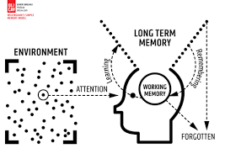.
Strategies identified | What do we expect to see in our History lessons?
Regular review | Academic or subject vocabulary and practical skills that have been taught will be modelled throughout teaching. Teachers will revisit prior knowledge (previous year group/lesson).
Present new materials using small steps | Design and Technology planning ensures achievable and repeated steps are provided to build children’s confidence, competence and retention.
Ask questions (Blooms taxonomy) | Questions help children practice new information and connect new material to their prior learning. The teacher will question children around the specific knowledge, vocabulary and practical skills that they have been using in this topic as well as others.
Provide models | Expert teachers /peer models/real life examples identified in the lesson will exemplify the specific skills/knowledge required for the task.
Guide student practice | Teachers will spend more time guiding children’s practice of new skills. It will be forgotten unless time is given for rehearsal we revisit tasks over and over again, allowing children lots of time to practice. This is always guided and supported by expert teaching.
Check for children’s understanding | Checking understanding at each point can help children learn the material with few errors. We would expect to see tasks/skills broken down into very small chunks, with regular assessment checking from teachers throughout.
Obtain a high success rate | In Design and Technology, we would expect to see that a skill is successfully taught before moving on. We take our time to achieve consistent success.
Provide scaffolds for difficult tasks | The teacher provides children with temporary supports and scaffolds to assist them when they learn more complex practical skills.
Independent practice | Children should have the opportunity to practice regularly and independently to transfer the knowledge into their long-term memory. In Design and Technology lessons there is opportunity for this through exploration of different materials and manufacturing techniques.
Weekly and monthly review | Children need to be involved in extensive practice in order to develop well connected and automatic knowledge. Weekly reviews can take place in Design and Technology lessons, where teachers return to knowledge learned in a previous unit, and following a period of forgetfulness the children use that knowledge again.
This is supported by the six effective learning strategies (Weinstein and Sumeracki 2019) to ensure that all of our children at The Florence Nightingale Academy become successful, independent learners who are actively engaged in their own learning.
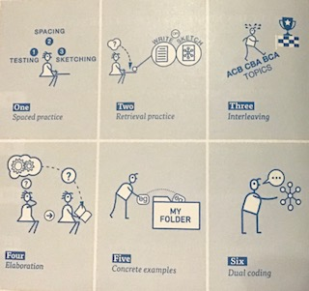

Through the use of this pedagogy children will build up a secure knowledge of practical skills, the ability to critically evaluate and the confidence to develop and share innovative designs.
Children are taught through enquiry based projects. Initially children are taught as a whole-class before developing ideas and designs and manufacturing products independently or as part of a team.
As part of the Design and Technology curriculum children will follow a set structure of lessons as they progress through their projects. This is supported by the project booklet that children complete for each product they make.
- Existing products – investigating and analysing what they are, how they are made and how innovative they are.
- Designing their own products – children will conduct research and develop design criteria to help guide their thinking.
- Making – children will plan the methods and order in which they will complete their manufacturing process before developing technical knowledge as the build or make their product.
- Evaluating – children will consider the views of others and how well their finished product matches the design criteria. They will also suggest ways in which their products could be improved.
To support the Design and Technology curriculum children will be able to take part in a range of experiences to enhance their learning journey. These include:
- First-hand experience of existing products.
- Visits to industries linked to their topics.
- Access to a wide range of resources.
- The ability to carry out research outside the classroom.
- Visitors to talk about their own role within different industries.
- They are shown, or use independently, resources from the internet.
- The use of non-fiction books to aid research.
- The opportunity to work in independently or in groups of varying sizes, abilities and year groups.
Whilst planning for Design and Technologies the differing needs and abilities of all children are considered. Therefore we provide opportunities for all through the use of our differentiated star challenge system. Planning also highlights extensions for gifted and talented children as well as extra support that may be needed for EAL or SEND children. Consequently challenging all children appropriately and setting expectations, tasks and outcomes that are achievable for all.
Each year group completes 3 Design and Technology projects a year.
Design and Technology curriculum planning
At Florence Nightingale Academy our curriculum has been planned to ensure full national curriculum coverage. The Projects have been developed to build on children’s prior knowledge as they progress through their educational journey. In EYFS the projects are linked to the children’s own knowledge and experiences, in Key Stage 1 to local contexts and in Key Stage 2 they are linked to wider contexts and industries. Our long-term plan ensures children are provided with the opportunity to work with a wide range of materials and to use them in a variety of ways. The long-term and medium-term plans map out the different topics covered in each key stage and show the progression within these from EYFS to Y6. The projects are reviewed each year by the Subject leader liaising with staff and SLT.
Assessment and Recording
Assessment is an essential part of the teaching process for Design and Technology and is used to help inform planning and ensure provision for any learning gaps that may arise. Assessment is carried out by observations and effective questioning during all lessons. Teachers then use this knowledge to make judgements against the knowledge statements on the back of each child’s project booklet. This is then collated by the teacher and entered onto the knowledge grid after each half-term project.
Providing links with Design and Technology and reading
There are countless reading opportunities in Design and Technology which support the schools aim of promoting a love for learning in all children. EYFS have the opportunity to read simple instructions and recipes, using the phonetic knowledge they are developing. Key Stage 1 access simple texts related to the existing products which they are investigating. Key Stage 2 children have the opportunity to access non-fiction texts through books and websites as well as exploring reviews of existing products. These opportunities will provide children with texts from a range of different contexts and of varying difficulties. All texts will provide children with new vocabulary which will be age appropriate and help them to develop an extensive vocabulary.
Monitoring
Monitoring is completed through learning walks, lesson observations, pupil and staff voices, book looks and teacher planning and takes place regularly throughout the year.
Roles and responsibilities
The subject is led by the staff as a while and each year time is set aside to review standards and monitor curriculum provision and ensure training and resources are up to date.
Resources
Design and Technology provides a wide range of resources to enable children to take part in practical activities where they explore electrical circuits, textiles and mechanical systems. Children have the opportunity to take part in wood work activities as well as cooking and baking where they can experience ingredients that have different tastes and textures. During Design and Technology lessons children have the opportunity to use technology to research and develop design ideas as well as to develop their understanding of the concepts that they are being taught.
Curriculum progression
EYFS - ELG for DT. Pupils will be taught to: |  | F1 | F2
Designing | Children represent their own ideas, thoughts and feelings through design and technology. | - Children use available resources to create props to support role play.  - Children capture experiences with a range of media. | - Children create simple representations of events, people and objects.  - Children choose particular colours to use for a purpose.
Making | Children safely use and explore a variety of materials, tools and techniques, experimenting with colour, design, texture, form and function. | - Children explore how colour can be changed.  - Children understand that they can use lines to enclose spaces and begin to use these shapes to represent objects.  - Children use various construction materials.  - Children are interested in and are beginning to describe the texture of things. (materials and dishes)  - Children begin to construct by stacking blocks vertically and horizontally. Making enclosures and creating spaces.  - Children join construction pieces together to build and balance.  - Children use shapes appropriately for tasks | - Children experiment to create different textures.  - Children understand that different media can be combined to create new effects.  - Children construct with a purpose in mind.
Evaluating | Children use what they have learnt about media in different ways, thinking about uses and purposes. | - Children can talk about why things happen and how things work. | - Children can talk about similarities and differences in relation to different materials.  - Children manipulate materials and can adapt work where necessary.
Technical knowledge | Children know how to use a range of tools and equipment effectively and safely. | - Children realise tools can be used for a purpose.  - Children use one-handed tools and equipment with good control.  - Children understand simple tools and equipment have to be used safely. | - Children use simple tools and techniques competently and appropriately.  - Children select tools and techniques to shape, assemble and join materials that they are using.  - Children practice some appropriate safety measures without direct supervision.
Cooking and Nutrition | Children know the importance for good health which includes a healthy diet. | - Children can say when they are hungry.  - Children are willing to try new food. | - Children eat a healthy range of foodstuffs.  - Children understand the need for variety in food.

Key stage 1 NC D&T – pupils will be taught to: |  | Y1 | Y2
Designing | Design purposeful, functional, appealing products for themselves and other users based on design criteria. | - States what products they are making.  - Work in a range of contexts including home, school and playgrounds.  - Uses simple design criteria to develop ideas.  - Use own experiences to generate ideas.  - Share ideas by talking.  - Use simple ICT skills to develop ideas. | - Say who they are making their products for, themselves or others.  - Say how their products work.  - Describe what their products are for.  - Use knowledge of existing products to develop own ideas.  - Use simple ICT skills to share and develop ideas.
Designing | Generate, develop, model and communicate their ideas through talking, drawing, templates, mock-ups and, where appropriate, information and communication technology
Making | Select from and use a range of tools and equipment to perform practical tasks [for example, cutting, shaping, joining and finishing] | - Select from a range of tools and equipment.  - Select from a range of materials and components.*  - Follow procedures for safety.  - Cut and shape materials.  - Assemble and join materials and components.  - Use a range of finishing techniques including those from art and design.* | - Select from a range of tools and equipment, explaining their choices.  - Select from a range of materials and components, according to their characteristics.*  - Use a range of materials, including construction materials, textiles, food ingredients and mechanical components.  - Measure, mark out, cut and shape materials and components.  - Select from a range of materials and components.*
Making | Select from and use a wide range of materials and components, including construction materials, textiles and ingredients, according to their characteristics
Evaluating | Explore and evaluate a range of existing products | - Talks about their design ideas and what they are making.  - Explores existing products and what products are.*  - Explores what products are for.  - Explores how products are used.  - Explores what they like and dislike about products. | - Makes simple judgements about their products and ideas against design criteria.  - Suggests how their products could be improved.  - Explores existing products and what products are.*  - Explores who products are for.  - Explores how products work.  - Explores where products might be used.  - Explores what materials products are made from.
Evaluating | Evaluate their ideas and products against design criteria
Technical knowledge | Builds structures, exploring how they can be made stronger, stiffer and more stable. | - Knows how to make freestanding structures, stronger, stiffer and more stable.  - Knows the correct technical vocabulary for the projects they are undertaking.*  - Knows how to use simple sewing techniques.  - Knows about the movement of simple mechanisms such as wheels and axels. | - Knows about the simple working characteristics of materials.  - Knows the correct technical vocabulary for the projects they are undertaking*.  - Knows how 3D products can be made using 2 identical fabric pieces.  - Knows about the movement of simple mechanisms such as sliders and levers.
Technical knowledge | Explores and use mechanisms [for example, levers, sliders, wheels and axles], in their products.
Cooking and Nutrition | Uses the basic principles of a healthy and varied diet to prepare dishes | - Knows that food has to be farmed, grown or caught elsewhere.  - Knows that everyone should eat at least five portions of fruit and vegetables a day.  - Knows how to prepare simple dishes safely, without a heat sauce.  - (cooking and nutrition to be taught as enrichment opportunities in Year 1 and not a focus project) | - Knows that all food comes from plants or animals.  - Knows how to name and sort foods in the five groups in the eatwell plate.  - Knows how to prepare simple dishes safely and hygienically, without a heat source.  - Knows how to use techniques such as cutting, peeling and grating.
Cooking and Nutrition | Understands where food comes from

Key stage 2 NC D&T – pupils will be taught to: |  | Y3 | Y4 | Y5 | Y6
Designing | Use research and develop design criteria to inform the design of innovative, functional, appealing products that are fit for purpose, aimed at particular individuals or groups. | - Generates realistic ideas focusing on the needs of the user.  - Develops their own design criteria.  - Indicates the design features of their products.  - Shares and clarifies ideas through discussion, with some accuracy.  - Model their ideas using prototypes.  - Uses annotated sketches to develop and communicate their ideas, with some accuracy.  - Uses computer aided design to develop and communicate ideas, with some accuracy. | - Gathers information about the needs and wants of particular individuals and groups.  - Develops their own design criteria and use these to inform their ideas.  - Share and clarify ideas through discussion, with accuracy.  - Uses annotated sketches to develop and communicate their ideas, with accuracy.  - Makes design decisions that takes into account availability of resources. | - Carries out research using interviews and questionnaires.  - Identifies the needs, wants and preferences of particular individuals and groups.  - Uses exploded diagrams to develop and communicate ideas.  - Generate ideas drawing on research. | - Carries out research using interviews, questionnaires and web based resources.  - Identifies the needs, wants, preferences and values of particular individuals and groups.  - Develops simple design specification to guide their thinking.  - Use cross-sectional drawings to develop and communicate ideas.  - Generate innovative ideas drawing on research.  - Uses computer aided design to develop and communicate ideas, with accuracy.
Designing | Generate, develop, model and communicate their ideas through discussion, annotated sketches, cross-sectional and exploded diagrams, prototypes, pattern pieces and computer-aided design
Making | Select from and use a wider range of tools and equipment to perform practical tasks [for example, cutting, shaping, joining and finishing], accurately | - Selects materials suitable for the task.  - Explains choice of materials according to functional properties.  - Orders the main stages of making, with some accuracy.  - Follows given safety and hygiene procedures with close supervision.  - Uses a wide range of materials including tapestry with some accuracy.  - Measures and marks out with some accuracy.  - Uses finishing techniques including those from art and design, with some accuracy. | - Explains choice of materials according to functional properties and their aesthetic qualities.  - Orders the main stages of making, with accuracy  - Follows given safety and hygiene procedures with supervision.  - Uses a wide range of materials including electrical components with some accuracy.  - Shapes and cuts materials and components with some accuracy.  - Uses finishing techniques including those from art and design with accuracy. | - Selects materials and components suitable for the task.  - Select suitable tools for the task.  - Produces appropriate list of equipment and materials that they will need.  - As a group formulates a step by step plan to guide making.  - Considers safety and hygiene procedures, with some accuracy.  - Uses a wide range of materials with accuracy.  - Accurately measure, mark out and cut materials and components.  - Uses a range of finishing techniques, with some accuracy.  - Begins to demonstrate resourcefulness when tackling practical problems. | - Produces appropriate list of tools, materials and equipment that they will need.  - Selects tools and equipment suitable for the task.  - Formulates a step by step plan to guide making.  - Considers safety and hygiene procedures with accuracy.  - Uses a wide range of self-chosen materials with accuracy.  - Accurately measure, mark out and cut materials and components. *  - Accurately assemble, join and combine materials and components.  - Accurately uses a wide range of finishing techniques.  - Demonstrate resourcefulness when tackling practical problems.
Making | Select from and use a wider range of materials and components, including construction materials, textiles and ingredients, according to their functional properties and aesthetic qualities
Evaluating | Investigate and analyse a range of existing products | - Investigate what methods of construction have been used.  - Investigate how well products work.  - Identify strengths and areas for development in their ideas and products, with some accuracy.  - Use design criteria to evaluate completed products.  - Investigate and analyse who and when products were made/designed.  - Knows about key ground breaking products and events in design and technology. | - Investigate and analyse whether products can be recycled or reused.  - Investigate how products meet the user’s needs.  - Identify strengths and areas for development in their ideas and products, with accuracy.  - Refer to the design criteria as they design and make products.  - Investigate and analyse how well products have been designed, with some accuracy.  - Knows about key ground breaking products and individuals in design and technology that have helped shape the world. | - Investigate and analyse how innovative products are.  - Consider the views of others, to improve their work.  - Investigate and analyse how products have been made.  - Investigate and analyse why materials have been chosen.  - Critically evaluate the design of their products during the designing and making processes.  - Investigate and analyse how well products have been designed, with accuracy.  - Knows about key inventors, designers, engineers, chefs and manufacturers who have developed ground breaking products and can talk about them with some accuracy. | - Investigate and analyse how sustainable materials in products are.  - Investigate and analyse what impact products have beyond their intended use.  - Investigate and analyse how much products cost.  - Consider the views of others, including intended users, to improve their work.  - Critically evaluate the manufacture and fitness for purposes of their products as they design and make.  - Investigate and analyse how products achieve their purpose.  - Knows about key inventors, designers, engineers, chefs and manufacturers who have developed ground breaking products and can talk about them with accuracy.
Evaluating | Evaluate their ideas and products against their own design criteria and consider the views of others to improve their work
Evaluating | Understand how key events and individuals in design and technology have helped shape the world
Technical knowledge | Apply their understanding of how to strengthen, stiffen and reinforce more complex structures | - Know how to use learning from mathematics to help design and make products that work, with some accuracy.  - Knows how to reinforce and strengthen 3D shell structures.  - Knows how to use nets of cubes, cuboids and where appropriate more complex 3D shapes.  - Knows how to join 2 fabric pieces together.  - Understands seam allowance and patterns. | - Knows how to use scientific knowledge to help design and make products that work, with some accuracy.  - Knows how simple electrical circuits and components can be used to create a functional product.  - Understands basic electrical systems and uses electrical systems such as bulbs and buzzers.  - Knows how to use their computing knowledge to control and program products.  - Knows how mechanical systems such as levers and linkages create movement. | - Know how to use learning from mathematics to help design and make products that work, with accuracy.  - Knows how to use scientific knowledge to help design and make products that work, with accuracy.  - Knows that electrical systems have inputs, outputs and processes and can name some of them.  - Knows how more complex electrical circuits and components can be used to create functional products and uses computing knowledge to control them.  - Knows how 3D textile products can be made from a combination of fabric pieces. | - Knows how to strengthen and reinforce a 3D framework.  - Knows how to use mechanical systems such as cams, pulleys or gears to create movement.  - Understands how gears and pulleys can be used to speed up, slow down or change the direction of movement.  - Understands that mechanical systems have an input, output and process and that these can be controlled.
Technical knowledge | Understand and use mechanical systems in their products [for example, gears, pulleys, cams, levers and linkages]
Technical knowledge | Understand and use electrical systems in their products [for example, series circuits incorporating switches, bulbs, buzzers and motors]
Technical knowledge | Apply their understanding of computing to program, monitor and control their products.
Cooking and Nutrition | Understand and apply the principles of a healthy and varied diet | - Knows that food is grown and reared in the UK and Europe.  - Knows how to prepare and cook a variety of predominantly savoury dishes safely and hygienically and where appropriate, with a heat source, with some accuracy.  - Knows that to be active and healthy, food and drink are needed to provide energy for the body. | - Knows that food is grown and reared in the UK, Europe and the wider world.  - Knows how to prepare and cook a variety of predominantly savoury dishes safely and hygienically and where appropriate, with a heat source, with accuracy.  - Knows how to use a range of techniques including spreading, kneading and baking.  - Knows that to be active and healthy, food and drink are needed to provide energy for the body as depicted in the Eatwell plate. | - Knows that food is grown, reared and caught in the UK, Europe and the wider world.  - Understands that seasons may affect the food available, with some accuracy.  - Knows how food is processed into ingredients that can be eaten or used in cooking.  - Knows how to use a range of techniques such as peeling, chopping, slicing, grating, mixing, spreading and baking, with some accuracy.  - Knows how to use utensils and appropriate equipment including heat sources to prepare and cook food.  - Knows that food and drink can contain different substances that are needed for health. | - Knows that food is grown, reared and caught in the UK, Europe and the wider world.  - Understands that seasons may affect the food available, with accuracy.  - Knows how to use a range of techniques such as peeling, chopping, slicing, grating, mixing, spreading and baking, with accuracy.  - Knows that recipes can be adapted to change the appearance, taste and texture.  - Knows that food and drink can contain different substances, – nutrients, water and fibre- that are needed for health.
Cooking and Nutrition | Prepare and cook a variety of predominantly savoury dishes using a range of cooking techniques
Cooking and Nutrition | Understand seasonality, and know where and how a variety of ingredients are grown, reared, caught and processed

Knowledge statements
Design and Technology knowledge statements contain descriptions of previously taught skills and concepts from all areas of the national curriculum. The knowledge statements and explanation document outline the national curriculum coverage and which topics to teach the specific skills in. They also include key vocabulary linked to the project to support staff to provide children with the opportunity to broaden their vocabulary which is one of our school’s main aims.
The knowledge statements structure the enquiry approach that the projects will follow. Each learning objective is set out in question form and linked to the skill which is to be taught. By doing this, children are able to access the Design and Technology projects in an analytical and investigative way, providing more opportunities for the promotion of ideas and innovation.
Knowledge to be built upon | EYFS – How things move: Children learn about what makes toys and vehicles move and explore what happens when different wheels are used.  EYFS – Investigating wheels: Children learn about the different types of vehicles and their features.  Year 1 – Wheels and axels - Children learn about the movement of wheels and axels through building their own shopping trolley.  Year 2 – moving pictures - Children will learn about how to create movement using sliders and levers.
Year 4 – Summer 1 | Current products – evaluation  Q. How do moving pictures work? What are their strengths and areas that they can be improved?  S. Investigate how well current products have been designed.
Year 4 – Summer 1 | Design – research  Q. Can you research key facts about recycling and use these to help develop your own design criteria?  S. Develops their own design criteria and uses these to inform their ideas.
Year 4 – Summer 1 | Design – own ideas and sharing them  Q. Can you draw a detailed sketch and annotate it to show your design ideas?  s. Uses annotated sketches to develop and communicate their ideas.
Year 4 – Summer 1 | Making – planning  Q. Can you explain the materials that you are going to use considering their functional and aesthetic properties?  S. Explains choice of materials according to functional properties and their aesthetics qualities.
Year 4 – Summer 1 | Making – including technical knowledge.  Q. Can you put at least one linkage in your moving picture?  S. Knows how mechanical systems such as levers and linkages create movement and distinguishes between fixed and loose pivots.
Year 4 – Summer 1 | Making –  Q. Can you finish your moving picture in an eye-catching and interesting way?  S. Uses finishing techniques including those from art and design.
Year 4 – Summer 1 | Own products – evaluation  Q. How well does your moving picture meet your design criteria? Is there anything that could be improved?  S. Identify strengths and areas to develop using your design criteria.
Key vocabulary | Levers, linkages, pneumatic system, movement, direction, speed, rotation, fixed pivot, loose pivot, bridge, guide

Knowledge organisers
For students to succeed in a particular area, they must have a foundation of factual knowledge, understand those facts in the context of conceptual framework and organise knowledge in order to facilitate retrieval and application (Bransford et al., 2000).
Knowledge organisers are part of the curriculum resources at The Florence Nightingale Academy to ensure that children have the best opportunity and success at retaining the knowledge they acquire throughout their time in school. They provide the opportunity for children to reference previous knowledge and key terminology which they can use to develop ideas and structure their thinking. They also help children to understand their learning journey through the different Design and Technology topics and make links between previous and current learning.

Making 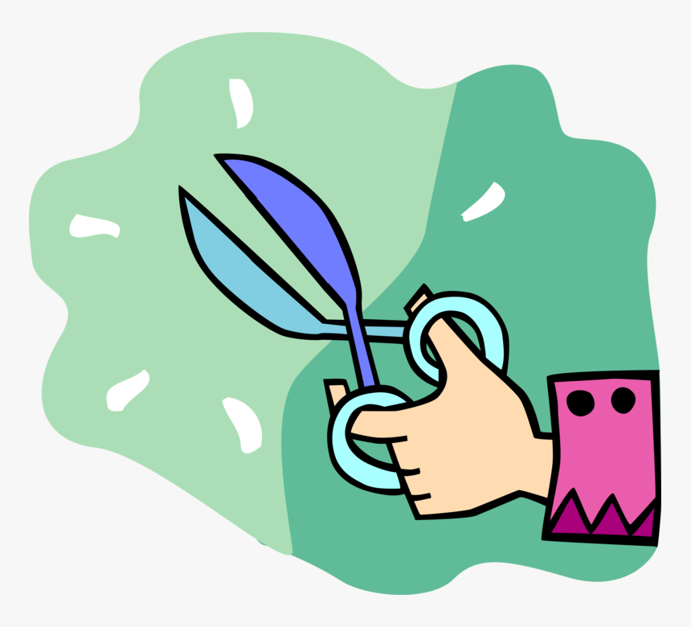
Sliders are made using lollipop sticks, cards and other thin, firm materials. Rulers should be used to measure and cut slots and guides with accuracy.
How to make sliders  Use a hole punch to start making the slot.  Guides can be made using strips of card and fixed with tape. | How to make levers:  Create a hole for the pivot by placing the backdrop paper over a piece of blu tack or plasticine and push a sharp pencil through.
Finishing techniques:
As well making sure the product works it also needs to looks good. Consider the use of colours and materials when completing the product.
 Health and safety
Use scissors with care, following the teacher’s instructions.
If you move around the room leave your project, including your scissors in a safe place.
Keep your work area clean and tidy.
Evaluating
Does the moving picture move up and down if a sliders has been used?
Does the moving picture move in a curve if a lever has been used?
Overview - What are sliders and levers?
Sliders and levers are mechanisms which create movement. They can be found all around us. For example:
Sliders  Children’s books  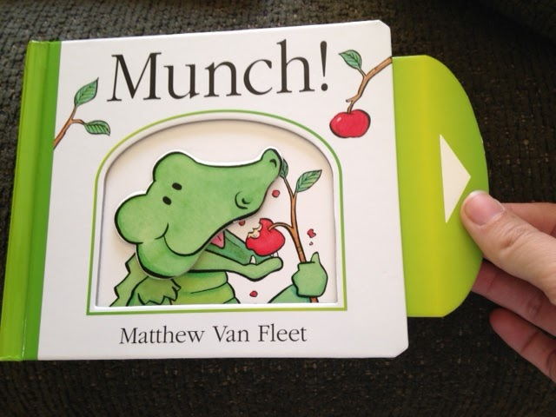  Draws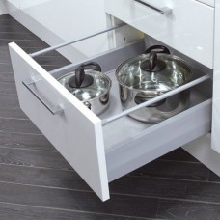 | Levers  Seesaw  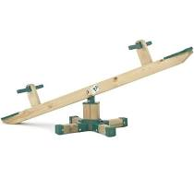  Scissors  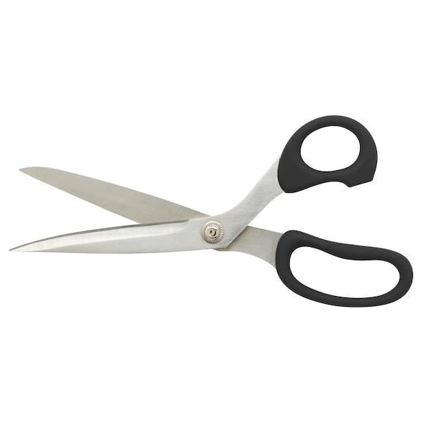

Y2 DT: Mechanism
Designing
Identify who the product is for and consider this when deciding which part of your picture needs to move.  Choose the appropriate mechanism to use based on the direction of travel you want.  Effective sliders and levers should move smoothly. | 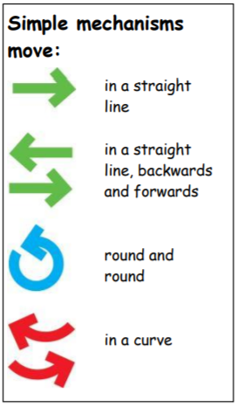

.

Key Vocabulary
Mechanisms – A device used to create movement.
Lever – A rigid bar which moves around a pivot.
Slider – A rigid bar which moves backwards and forwards along a straight line.
Loose pivot – Allows movement around a central point.
Fixed pivot – Fastens materials together without movement.
Slot – The hole which a lever or slider is placed.
Guide or bridge – A short card slip used to support the lever and control movement.
Movement – The direction something moves, E.g. horizontal, vertical, rotational
Prior Knowledge
Used paper and cards in different contexts.
Used scissors to shape and cut materials.
Understands movement can be made in different ways and explored wheels and axels as part of the Year 1 curriculum.

Technical Knowledge
Sliders and levers are usually made out of paper or card and produce a simple movement. Levers rotate around a pivot point.
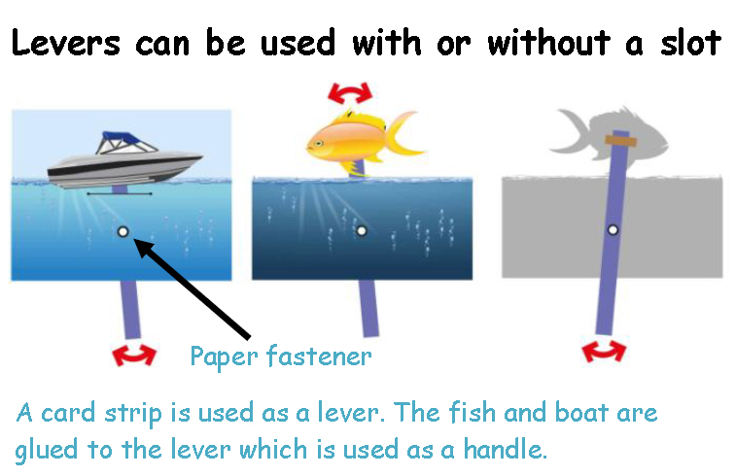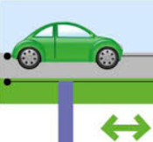
Heathy and Safety
Design and Technology resources are stored centrally and access by pupils may only be permitted with adult support. Specific guidance for risk assessments of DT projects is available for reference for all staff.
When working with tools, equipment and materials in practical activities and in different environments, including those that are unfamiliar, pupils will be taught:
1. About hazards, risks and risk control.
2. To recognise hazards, assess consequent risks and take steps to control the risk to themselves and others.
3. To use information to assess the immediate and cumulative risks.
4. To manage their environment to ensure the health and safety of themselves and others.
5. To explain the steps they take to control risk. There will be specific teaching of proper procedures for food safety and hygiene for all food DT projects.

