The Florence Nightingale Academy & Nursery School
Mandarin policy



MFL Coordinator – Mrs Kelly Withers
Mandarin- Hadija Jin
Review Date – 10/2022

Rationale

The study of Languages prepares pupils to participate in a rapidly changing world in which work and other activities are increasingly carried out in languages other than English. Pupils use languages to communicate information responsibly and creatively. They learn how to use languages to enable access to ideas and experiences from a wide range of people, communities and cultures. In addition, understanding a modern foreign language increases a child’s understanding of their own language. The process of learning a foreign language reinforces fluency and understanding of grammar, syntax, sentence structure and verbal precision. Increased capability in the use of languages can also promote initiative and independent learning and encourages diversity within society.

Introduction
As part of the new primary National Curriculum, learning a MFL became a requirement for children within primary schools, it also added enrichment and cultural diversity to the curriculum. The Florence Nightingale Academy introduced Mandarin lessons as part of the curriculum with a Specialist Mandarin teacher in 2019.

Aims
The aims of Mandarin teaching are:

- To develop children’s experience of language acquisition and encourage curiosity about languages and widen students’ vision on cultural diversity. To equip them with confidence and language skills for their future.

- To develop their understanding of what they hear and read, and have an ability to express themselves in speech and writing.

- To extend their knowledge of how language works and explore differences between Mandarin and English.

- To strengthen their sense of identity through learning about cultures in other countries and comparing it with their own culture.

Curriculum
The children undertake a broad and balanced programme that is primarily based on their daily life and communicative needs. Through Mandarin learning, the children learn a range of skills including listening, speaking, reading and writing, it cultivates their concepts of different language structures, and it develops their awareness on cultural diversities.

Early Years
Mandarin is taught in Foundation 2 once a week. Target vocabulary is following the half termly topics which is also supported by familiar nursery rhymes to enhance language acquisition. Lessons are integrated with activities, games, songs as well as arts and crafts.

Key Stage 1
During Key Stage 1, pupils learn a new set of vocabulary every half term as well as some useful structures. The topics cover their family, school life, animals, numbers and hobbies, etc. Pinyin-Chinese phonetic system are introduced inductively where children get exposed to a wide range of sounds first and gradually start to apply them to new vocabulary. New language focus is introduced and taught in a communicative way where children get the opportunities to use the language in real life situations. There is a half termly cultural topic about Chinese festivals, traditions, art, etc.

Key Stage 2
During Key Stage 2, pupils learn a wider range of vocabulary and more complicated language structures. The topics cover their family, school life, animals, numbers and hobbies, etc. Pinyin-Chinese phonetic system are introduced at the beginning of each lesson. New language focus is introduced and taught in a communicative approach where children get the opportunities to use the language in real life situations. There is a half termly cultural topic about Chinese festivals, traditions, art, etc.

Teaching and Learning
As the centrality of grammar in language teaching and learning was questioned, recent years’ Language Learning researches show that learners learn a second or foreign language through:

- Interaction between the learner and users of the language;
- Collaborative creation of meaning;
- Creating meaningful and purposeful interaction through language;
- Learning through attending to the feedback learners get when they use the language;
- Paying attention to the language one hears (the input) and trying to incorporate new forms into one’s developing communicative competence. (Jack. C. Richard, 2006)

To ensure that we provide the maximum learning opportunities for our pupils, we use the Communicative Language Teaching (CLT) with modifications in place which takes the group size of a primary class into consideration as well as allowing for the individual and differentiated needs of the children.

Mandarin Delivery Document

Intent | As we deliver Mandarin lessons across school with mixed abilities and relatively larger group size compared to traditional ELT setting, we will follow the main principle of CLT approach with some modifications based on our particularity.  All lessons are planned to develop pupils’ communicative competence including linguistic competence, socio-cultural competence, and strategic competence. (Celce-Murcia M, 2008)
Implementation | Ensure that the teachers of the subject have excellent language and teaching knowledge.  Subject matter is presented clearly, teachers carefully check learning and identify misconceptions, providing direct feedback.  Teaching is designed to ensure children are engaged and uses target language in class.  Cultural facts and experiences are incorporated.
Impact | At the end of the academic year, students will be able to:  • understand and respond to spoken and written language (pinyin) from a variety of authentic sources  • speak with increasing confidence, fluency and spontaneity, finding ways of communicating what they want to say, including asking simple questions, and continually improving the accuracy of their pronunciation and intonation  • can write at varying length in Pinyin, for different purposes and audiences, using the variety of grammatical structures that they have learnt.  • discover and develop an appreciation of different cultures.

How do ensure our goal of communicative competence when teaching Mandarin?

Competence | Action
Linguistic Competence | - -All new vocabulary and language focus are reviewed in every lesson.  - -New language functions are introduced and modelled with ample practice.  - -Vocabulary is always taught with a sentence structure for pupils to practice the language.  - -Longer sentences are taught using small steps. E.g, lesson one:I have pencils; lesson two: I have five pencils; lesson three: I have five pink pencils.
Socio-cultural Competence | - Planning ensures all cultural background knowledge are explained.  - Role plays and dialogues are implemented in the lesson to encourage correct use of languages.
Strategic Competence | - All activities are pitched at different challenge levels to encourage all pupils to use the skills of inferring and negotiating meanings.  - Group and pair activities are planned in Mandarin lessons to allow peer negotiation and interaction.
Provide models | Teachers /peer models identified in the lesson will exemplify the specific skills/knowledge required for the task.
Guide student practice | Vocabulary list and scaffolding sheet are provided.
Check for children’s understanding | During consolidation stage of the lesson, taught language focus as well as previous language are tested in plenary.
Independent practice | Children have the opportunity to practice regularly and independently to transfer the knowledge into their long-term memory.
Regular Review | - As the nature of language, previous knowledge is constantly revised during the activities.  - At the end of year, there is opportunity to review all vocabulary and language focus.
Functional Syllabus | - The syllabus is function oriented rather than grammar oriented. Pupils learn to use the language in a specific context.
Our principal aim through this pedagogy is to develop the children’s knowledge, language skills and communicative skills in Mandarin.
We believe children as part of their MFL curriculum should access a variety of activities in Mandarin lessons such as:
- Flashcard games for visual learners;
- Videos, songs and nursery rhymes for auditory learners;
- Task-based activities for kinaesthetic learners;
- Group tasks to develop their problem solving, cooperating skills;
- Speaking activities to reinforce fluency and confidence;
- Invite visitors to school;
- Activities related to traditional Chinese festivals to provide cultural experiences;
- They are provided with opportunities to work independently or collaboratively, to ask as well as answer questions in Mandarin.

We recognise the fact that we have children of differing ability in all our classes, and so we provide suitable learning opportunities for all children by matching the challenge of the task to the ability of the child using our differentiated star challenges. We achieve this through a range of strategies which are differentiated by task, expected outcome and/or support from peers or adults.
Based on combining pedagogy of CLT approach and various metacognition strategies Mandarin lessons should follow the following structure:
1) Review of prior knowledge e.g. low stake quizzes using knowledge organisers.

2) Introduce new knowledge and skill for this lesson in small steps following “PPP” framework
Presentation-Teacher presents the target language;
Practice- Teacher conducts controlled practice where scaffolding and word lists are provided;
Produce- Pupils produces language without teacher prompts and scaffolding.
3) Children practise and apply lesson skill
Target language should always be presented in a real-life context to encourage meaningful practice.
Authentic materials are applied in the lessons.
4) Evaluate and reflect upon the language skills used to check Student understanding.
Every Mandarin lesson finishes with a consolidation when target language is revised and concluded.
Fun quizzes of Language skills and knowledge are provided during the lesson.

Each year group undertakes 6 Mandarin topics a year and these are taught in 75 minute weekly sessions for the half term that the topic is being taught.

Mandarin curriculum planning
At FNA, our curriculum is carefully planned to ensure full national curriculum coverage. The topics we have selected are to help strengthen our children’s knowledge of significant individuals and to enable the children to use the target language in real life situations. Our long-term and medium-term plans map out the skills and themes covered each term for each key stage. These plans define what we will teach and ensure an appropriate balance and distribution of work across each term. Topics are reviewed yearly by the Subject leader liaising with staff and SLT.

Assessment and Recording
At FNA, assessment is an integral part of the teaching process. Assessment is used to inform planning and to facilitate differentiation. The assessment of children’s work is on-going to ensure that understanding is being achieved and that progress is being made. Feedback is given to the children as soon as possible, and marking work will be guided by the school’s Marking Policy. The knowledge statements are ticked off in individual children’s books accordingly when a child has met the learning objective and this data is collated by class teachers.

Promoting links with Mandarin and Chinese Culture
At FNA, we encourage our pupils to become global citizens. By introducing Chinese culture, we develop their understanding of cultural diversity, cultivate curiosity of the world within our pupils. Experiencing some cultural activities also help promoting intrinsic motivation on Mandarin language learning.

Monitoring
Monitoring takes place regularly through sampling children’s work, and teacher planning, through book looks, pupil voice and lesson observations.

Roles and Responsibilities
Mandarin is planned, resourced and delivered by school Mandarin teacher from F2 to Year 6. Each term time is set aside to review standards with MFL subject leader to monitor curriculum provision and ensure training and resources are up to date.

Resources
We have a wide range of story book in English and Mandarin available for KS1. For KS2, we have some traditional Chinese fables.

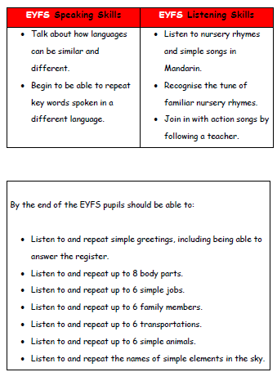
Curriculum progression
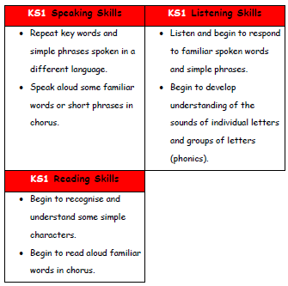

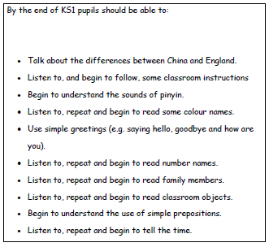
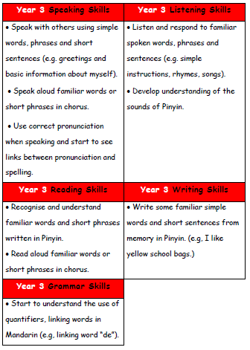

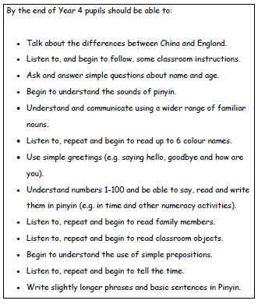

Knowledge statements
Our knowledge statements outline curriculum coverage for each topic and ensure full national curriculum coverage alongside a breadth of knowledge and historical skills.
They contain information of prior curriculum knowledge that the children have learnt throughout their primary curriculum to enable Staff to support the children to make links to their prior knowledge.
Our knowledge organisers also help to include previous language in our new topics. E.g, we learn family members in Spring 1, and use the language again in Spring 2, Summer 1 and Summer 2.
All learning objectives are also devised in a question format to structure all lessons to follow an enquiry approach. This allows our children to fully take on the role of a Historian and interpret and interrogate the evidence they are presented with before being able to devise their own well-constructed conclusions to the question lesson focus.
Knowledge statements also outline key vocabulary to be taught within each topic to help address our whole school focus of narrowing the vocabulary gap.
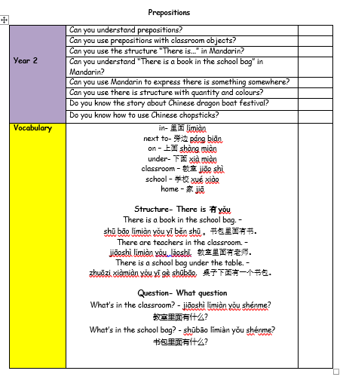

Knowledge organisers

For students to succeed in a particular area, they must have a foundation of factual knowledge, understand those facts in the context of a conceptual framework and organise knowledge in order to facilitate retrieval and application (Bransford et al., 2000).

At FNA Leys, we use knowledge organisers to support each topic. Through analysing various studies and research, we want them to support our history curriculum in the following way:

-Allow children at the start of the topic to see the historical learning journey that we will be completing

-Allow children to make links between previous knowledge that links to the new topic we will be undertaking

-Outline key knowledge that will be covered throughout the topic

-Support low-stake quizzes at the start of each lesson through regular retrieval of the information outlined

-Children to refer to them in lessons to support their chronology understanding

-Children to refer to the vocabulary outlined on them to help minimise the vocabulary gap our children encounter

