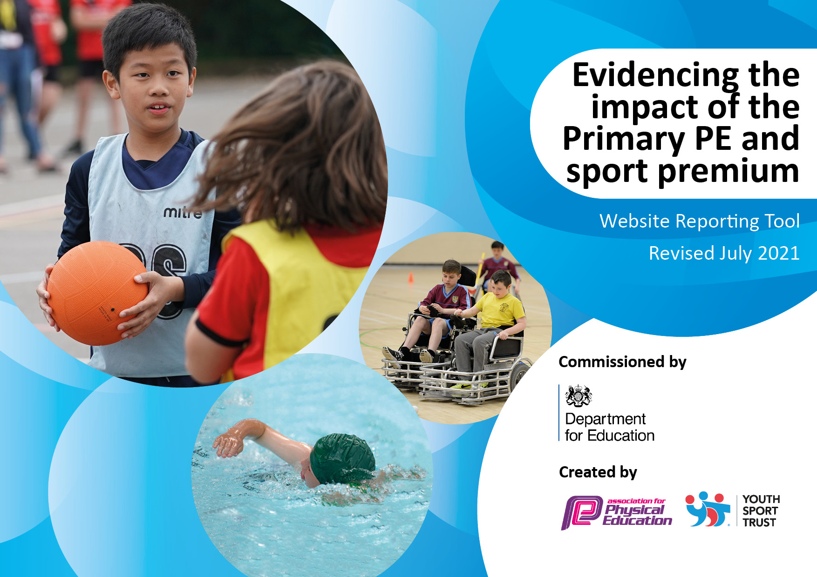
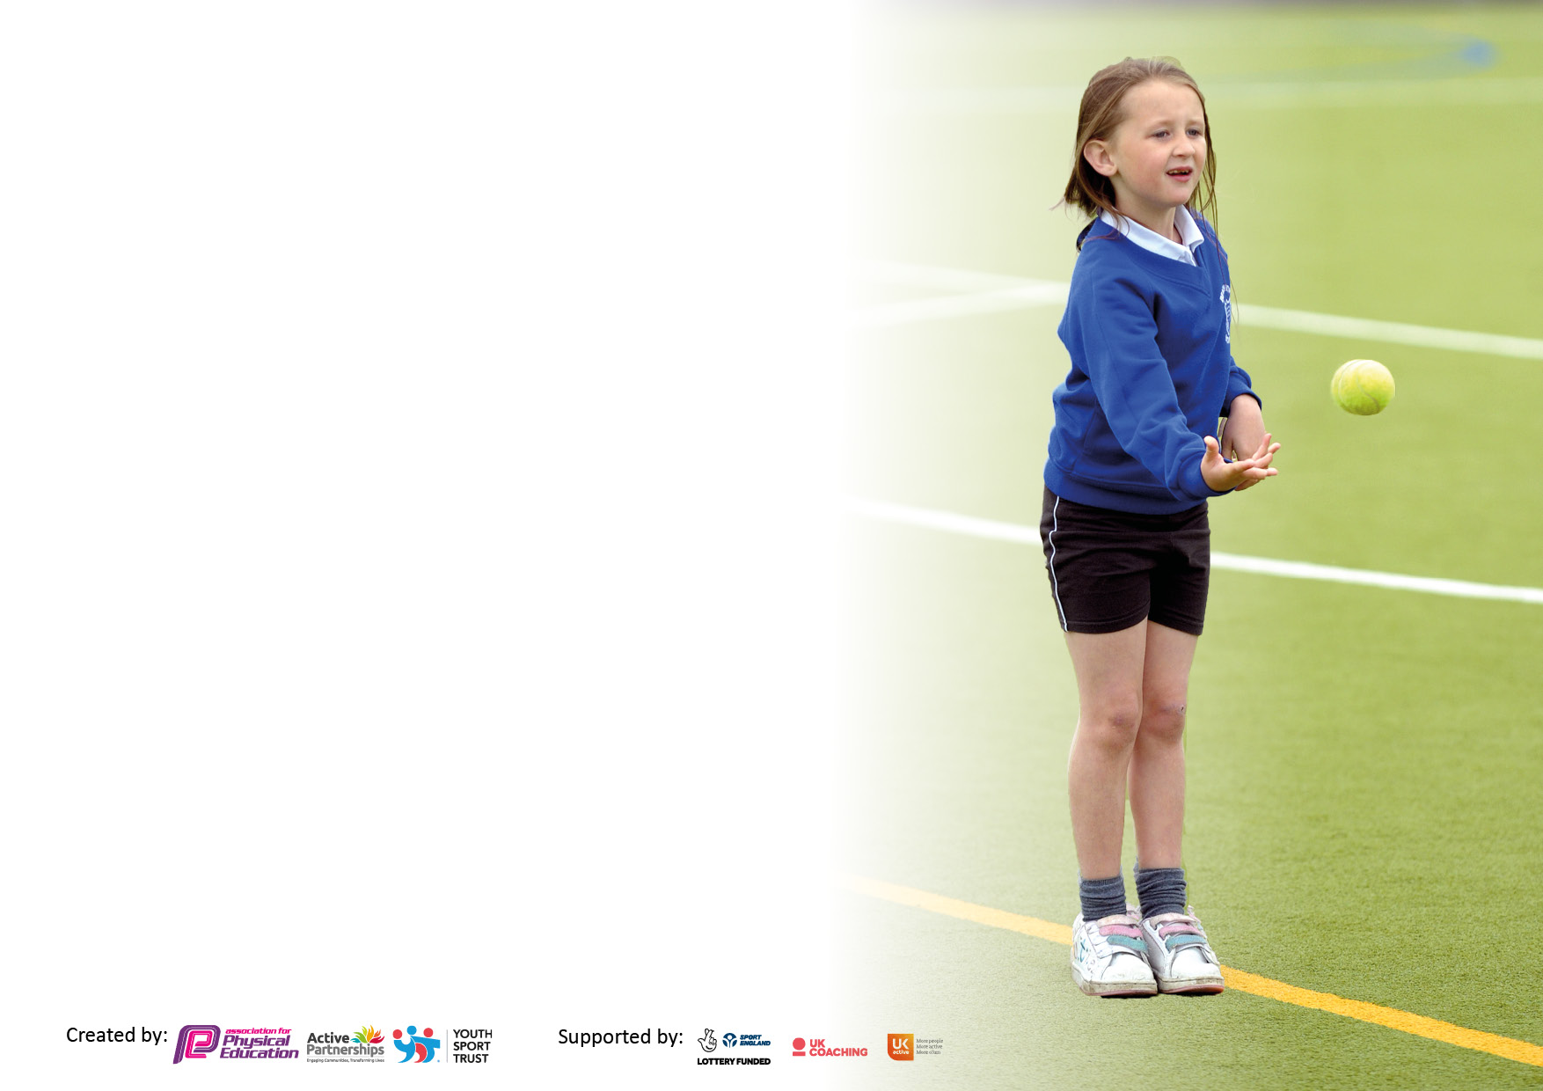

It is important that your grant is used effectively and based on school need. The Education Inspection Framework makes clear there will be a focus on ‘whether leaders and those responsible for governors all understand their respective roles and perform these in a way that enhances the effectiveness of the school’.

Under the Quality of Education Ofsted inspectors consider:
Intent - Curriculum design, coverage and appropriateness
Implementation - Curriculum delivery, Teaching (pedagogy) and Assessment
Impact - Attainment and progress

To assist schools with common transferable language this template has been developed to utilise the same three headings which should make your plans easily transferable between working documents.

Schools must use the funding to make additional and sustainable improvements to the quality of Physical Education, School Sport and Physical Activity (PESSPA) they offer. This means that you should use the Primary PE and sport premium to:

- Develop or add to the PESSPA activities that your school already offer
- Build capacity and capability within the school to ensure that improvements made now will benefit pupils joining the school in future years
- The Primary PE and sport premium should not be used to fund capital spend projects; the school’s budget should fund these.

Pleasevisitgov.ukfortherevisedDfEguidanceincludingthe5keyindicatorsacrosswhichschoolsshoulddemonstrate animprovement.Thisdocumentwillhelpyoutoreviewyourprovisionandtoreportyourspend.DfEencouragesschools to use this template as an effective way of meeting the reporting requirements of the Primary PE and sport premium.

We recommend you start by reflecting on the impact of current provision and reviewing the previous spend.

Schools are required to publish details of how they spend this funding, including any under-spend from 2019/2020, as well as on the impact it has on pupils’ PE and sport participation and attainment. All funding must be spent by 31st July 2022.

We recommend regularly updating the table and publishing it on your website throughout the year. This evidences your ongoing self-evaluation of how you are using the funding to secure maximum, sustainable impact. Final copy must be posted on your website by the end of the academic year and no later than the 31st July 2021. To see an example of how to complete the table please click HERE.
Created by: Supported by:

Details with regard to funding
Please complete the table below.

Total amount carried over from 2019/20 | £0
Total amount allocated for 2020/21 | £9,250
How much (if any) do you intend to carry over from this total fund into 2021/22? | £4,848
Total amount allocated for 2021/22 | £7,416
Total amount of funding for 2021/22. To be spent and reported on by 31st July 2022. | £12,264
Swimming Data
Please report on your Swimming Data below.

Meeting national curriculum requirements for swimming and water safety.

N.B. Complete this section to your best ability. For example you might have practised safe self-rescue techniques on dry land which you can then transfer to the pool when school swimming restarts.
Due to exceptional circumstances priority should be given to ensuring that pupils can perform safe self rescue even if they do not fully meet the first two requirements of the NC programme of study
What percentage of your current Year 6 cohort swim competently, confidently and proficiently over a distance of at least 25 metres?  N.B. Even though your pupils may swim in another year please report on their attainment on leaving primary school at the end of the summer term 2020.  Please see note above | 100%
What percentage of your current Year 6 cohort use a range of strokes effectively [for example, front crawl, backstroke and breaststroke]?  Please see note above | 100%
What percentage of your current Year 6 cohort perform safe self-rescue in different water-based situations? | 100%
Schools can choose to use the Primary PE and sport premium to provide additional provision for swimming but this must be for activity over and above the national curriculum requirements. Have you used it in this way? | No

Action Plan and Budget Tracking
Capture your intended annual spend against the 5 key indicators. Clarify the success criteria and evidence of impact that you intend to measure to evaluate for pupils today and for the future.
0
Academic Year: 2021/22 | Total fund allocated:£12,264 | Date Updated: July 22
Key indicator 1: The engagement of all pupils in regular physical activity – Chief Medical Officers guidelines recommend that primary school pupils undertake at least 30 minutes of physical activity a day in school |  |  |  | Percentage of total allocation:
 |  |  |  | 44%
Intent | Implementation |  | Impact
Your school focus should be clear what you want the pupils to know and be able to do and about  what they need to learn and to  consolidate through practice: | Make sure your actions to achieve are linked to your intentions: | Funding allocated: | Evidence of impact: what do pupils now know and what can they now do? What has changed?: | Sustainability and suggested next steps:
Provide all pupils with opportunities to engage in a range of physical activities.  To develop confidence in being able to try new sports and develop key skills associated with participation in a range of sports and swimming. | To access trampolining and gymnastics in specialist setting.  To access climbing, boxing and gym for a range of activities.  To access Blandford swimming pool  Physical activity breaks timetabled as part of sensory programme. | £5250.77 | Pupils are active daily. Activity has a positive impact on behaviour and wellbeing, as evidenced on Schoolpod and through attendance data. | Engaging pupils in enjoyment of sport and physical activity to foster physical and emotional well-being.
Key indicator 2: The profile of PESSPA being raised across the school as a tool for whole school improvement |  |  |  | Percentage of total allocation:
 |  |  |  | 3%
Intent | Implementation |  | Impact
Your school focus should be clear what you want the pupils to know and be able to do and about  what they need to learn and to  consolidate through practice: | Make sure your actions to achieve are linked to your intentions: | Funding allocated: | Evidence of impact: what do pupils now know and what can they now do? What has changed?: | Sustainability and suggested next steps:
Pupils at TFC are referred to us through a variety of routes. The PE curriculum matches the needs of our pupils to support wider learning of key skills such as social interaction, determination, leadership skills, problem solving, ambition etc. | Curriculum planning is purposeful and linked to cross curricular outcomes.  Purchase of new equipment to support curriculum PE and swimming activities. | £233.46 | Sequential learning may be identified through the medium plans. All pupils engage with sport and PE happily and are benefitting on several fronts. | Use pupil voice to assist with the choice of activity to ensure engagement from pupils.

Key indicator 3: Increased confidence, knowledge and skills of all staff in teaching PE and sport |  |  |  | Percentage of total allocation:
 |  |  |  | %
Intent | Implementation |  | Impact
Your school focus should be clear | Make sure your actions to | Funding | Evidence of impact: what do | Sustainability and suggested
what you want the pupils to know | achieve are linked to your | allocated: | pupils now know and what | next steps:
and be able to do and about | intentions: |  | can they now do? What has
what they need to learn and to |  |  | changed?:
consolidate through practice:
Specialist staff in all key stages , supported by TAs that are provided with opportunities for CPD to ensure learning opportunities are maximised. | Specialist staff receive ongoing training and updates to knowledge, to ensure that pupils needs are met as fully as possible. | £0 | Staff are confident to plan activities to meet all pupils needs and ensure good progress.  Pupils wellbeing and confidence is improved. | Ensure access to CPD for all key staff as required.  New activities introduced and staff trained as necessary.
Key indicator 4: Broader experience of a range of sports and activities offered to all pupils |  |  |  | Percentage of total allocation:
 |  |  |  | 48%
Intent | Implementation |  | Impact
Your school focus should be clear | Make sure your actions to | Funding | Evidence of impact: what do | Sustainability and suggested
what you want the pupils to know | achieve are linked to your | allocated: | pupils now know and what | next steps:
and be able to do and about | intentions: |  | can they now do? What has
what they need to learn and to |  |  | changed?:
consolidate through practice:
Additional achievements:  Pupils are provided with opportunities throughout the week to experience a wide range of physical activity and sports.  Opportunities to be physically active, to meet sensory needs are included for young people as necessary. | To access a range of activities like gymnastics, trampolining, dance, climbing, parkour and swimming that some students wouldn’t have access to otherwise. | £5820 | Sports lessons at school are taught by specialists to ensure key skills are taught safely with greatest opportunity to achieve successful outcomes. | Support staff receive CPD to ensure opportunities for skill development are maximised.

Key indicator 5: Increased participation in competitive sport |  |  |  | Percentage of total allocation:
 |  |  |  | 5%
Intent | Implementation |  | Impact
Your school focus should be clear | Make sure your actions to | Funding | Evidence of impact: what do | Sustainability and suggested
what you want the pupils to know | achieve are linked to your | allocated: | pupils now know and what | next steps:
and be able to do and about | intentions: |  | can they now do? What has
what they need to learn and to |  |  | changed?:
consolidate through practice:
Provide opportunities for competitive sports against other pupils, AP providers and other schools.  Pupils work towards participation in sports. | Ensure pupils have access to festivals, tournaments and competitions.  Certification through nationally recognised schemes. | £628 | Pupils have taken part in Gymnastic team competitions. Football tournaments and dance displays.  Trampolining awards have been achieved by all pupils. | We will continue to look for opportunities to expand the competitive events available to our pupils.  We will continue to work as a soft federation with the other PRUs next year.

Signed off by
Head Teacher: | Kim Rickford
Date: | 18/07/22
Subject Leader: | Adam Fergani
Date: | 18/07/22
Governor: | Mark Lawson
Date: | 18/07/22

