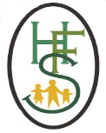
The Holy Family Catholic Primary School
Acceptable Use Agreement- KS1
2020-2021

Please tick:
- I always ask a teacher or suitable adult if I want to use the computers, tablets or cameras
- I only open activities that an adult has told or allowed me to use
- I know that I must tell an adult if I see something on a screen that upsets me, or I am unsure of
- I keep my passwords safe and will never use someone else’s
- I know personal information such as my address and birthday should never be shared online
- I know I must never communicate with strangers online
- I am always polite when I post to our blogs, use our email and other communication tools
- I understand this agreement

Class:
Date:

