**TKAW Pastoral Handbook**

**2023-2024**

**KEY PASTORAL DOCUMENTS**



**Pastoral Monitoring Sheet**

**Name of Student: Form: Year Group:**

|  |  |  |
| --- | --- | --- |
| **Stage (Sanctions)** | **Date** | **Outcome/Action** |
| Subject Teacher Intervention  Subject Teacher Report |  |  |
| Attendance and Punctuality: Report |  |  |
| Form Tutor Report |  |  |
| Head of Year report card Positive/Negative |  |  |
| AP Pastoral Report |  |  |
| Detentions |  | No:  30min  60min  SLT 1.30min |
| Contemplation |  |  |
| Fixed Term Suspension |  |  |
| Managed Move |  |  |
| Alternative Provision |  |  |
| Permanent Exclusion |  |  |

|  |  |  |
| --- | --- | --- |
| **Interventions** | **Date** | **Outcome/ Action** |
| Inclusion Support- Behaviour  (Classroom, one to one, mediation, restorative justice ) |  |  |
| SSC Support - Emotional/social  (TAC sessions anger, self-esteem) |  |  |
| Counselling/Mentoring. |  |  |
| Parental meetings |  |  |
| Attendance support |  |  |
| Rag Timetable |  |  |
| Pastoral Support Plan |  |  |
| Behaviour Contract |  |  |
| KAS (Khalsa Around a Student) |  |  |
| Request for Safeguarding Intervention (safeguarding team, MASH). |  |  |
| Early Help Assessment. |  |  |
| School Nurse Referral |  |  |
| SENDCO Referral |  |  |
| External Agency Support (In School):  CAMHS  BASE 25 |  |  |

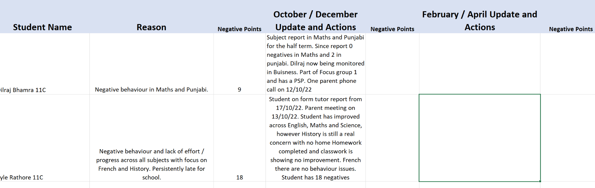

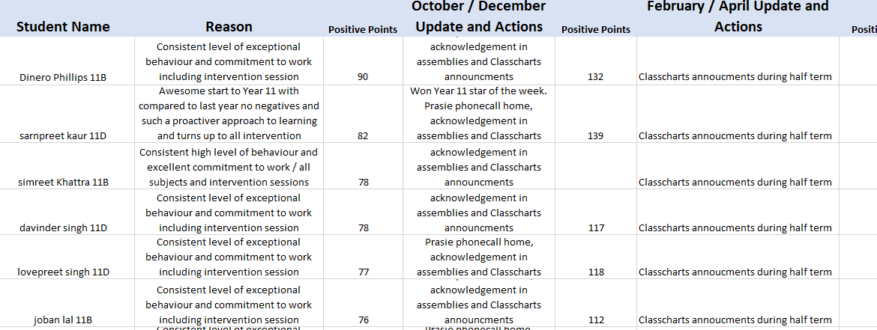

**Personal Support Plan**

|  |  |  |  |  |  |  |  |  |  |  |
| --- | --- | --- | --- | --- | --- | --- | --- | --- | --- | --- |
|  | **Pastoral Support Plan** | | | | | | | | | |
|  |  | | | | | | | | | |
| **Pupil Information:** | | | | | | |  |  | PICTURE | |
| Pupil Name: | | Demo | | Tutor Group: | | 9C |  |
| SEN Status: | | **Autism** | |  | | Statement | No |
| Reason for statement: | |  | | | | |  |
| CATS verbal: |  | | CATs   Non-verbal: |  | CATs Quantitative |  | CATs Spatial |
| KS2 English Level: | | Reading 104 | | KS3 English level: | | 1 |  |
| KS2 Maths level: | | 103 | | KS3 Maths level: | | 2- |  |
| KS2 Science level: | |  | | KS3 Science Level: | | 1- |  |
| Attendance | |  | | Attendance To date: | | 100% |  |
|  |  | | | | | | | | | |
|  | **Vulnerable Group:** | | | | | | | | | |
| **Pupil Premium** | English as another Language | | In care | Traveller | Gifted and Talented | Summer Born |  | SEN – school action | SEN - School action plus | SEN - Statement |
|  | Other Vulnerable Group: | | | | | | | | | |
|  |  | | | | | | | | | |
|  | **Context - Barriers to Learning:** | | | | | | | | | |
|  | **Barriers to my learning:**  I distract other students by talking and calling out in classroom  I find it difficult to understand the teacher in French and Punjabi  Sitting next to or close to Dylan Bassi and Karanveer.  Seating plans when I am around people I can talk or turn around too.  I do not work well with big whole targets.  I get angry and can't focus on work.  Finds French, Punjabi, Art and sometimes Science  Sometimes I do not understand the lessons - depending on teacher I ask for help - but not often enough  Using my mobile late at night makes I tired at school the next day. | | | | | | | | | |
|  | **Khalsa Academy staff that are helping me with my behaviour:** | | | | | | | | | |
|  | **Staff who help me**  Ms Mulloy - she listens to me and understands what I say.  Mr Ward - he talks to me and is reasonable with me | | | | | | | | | |
|  |  | | | | | | | | | |
|  | **External Agencies / Who else is Involved:** | | | | | | | | | |
|  | **External Agencies**  none | | | | | | | | | |
|  |  | | | | | | | | | |
|  | **I respond well when…** | | | | | | | | | |
|  | **I respond well:**  If I can sit as close as I can to the teacher to avoid distractions  I am better at working on - we do **tasks independently** or silently doing - we do tasks.  When I have small tasks with smaller understandable targets to meet.  Given timeframe to complete tasks to keep me focused  Teacher checks my work to ensure I am doing it correctly.  I work better in practical lessons as I am busy and do not get distracted. | | | | | | | | | |
|  |  | | | | | | | | | |
|  | **I have difficulties when…** | | | | | | | | | |
|  | **I do not respond well when:**  I sit next to people who I distract  Dylan Bassi and Karanveer  When I am encouraged to misbehave by my friends  When I find work really hard I do not ask to help  When I have finished my work in maths and English I get bored and misbehave | | | | | | | | | |
|  |  | | | | | | | | | |
|  | **How I see myself…** | | | | | | | | | |
|  | **How I see myself:**  Immature  I try to be funny in the class  Sometimes I feel dumb - sometimes in Science and DT  I have trouble processing my thoughts in lessons  Naughty and can be rude to other students  I need my teachers to have patience with me when I am struggling – to help me progress within the lesson I need my teacher to check my understanding throughout the lesson, it would help me if teachers gave me a separate worksheet to right me answers on with the teachers asks the class questions which can then be checked to identify any knowledge gaps or misconceptions. | | | | | | | | | |
|  |  | | | | | | | | | |
|  | **What I really need to be successful…** | | | | | | | | | |
|  | **What I need to be successful:**  Ask for help  No to distract others in the class  Make better choices - give myself time to think  Sit towards front of class  Think before I speak  **I know I need to implement all these into my day / lessons.** | | | | | | | | | |
|  |  | | | | | | | | | |
| **Date created:** | | | | | BDU | 28.02.2022 | | | | |
|  |  | | | | | | | | | |
| **Review Date:** | | | | | Demo Pupil | 07.03.2022 | | | | |
|  | | | | |  |  | | | | |

**RAG Timetable**

