**Anti-bullying**

**Policy**

**2024-2025**

**DRAFT**

| **Policy owner** | Emma Hulance |
| --- | --- |
| **Last update** | September 2023 |
| **Approved by governing board** |  |
| **Next review** | September 2025 |

**Contents**

1. Values and vision
2. Defining terms
3. Identifying victims
4. A whole-school approach to bullying prevention
5. Reporting mechanisms
6. Response strategy
7. Stakeholder responsibilities
8. Linked documents and references
9. **Values and vision**

The Kingsway School has a culture rooted in a sense of community, creating students who are compassionate towards themselves and towards each other. The school strives for all students to have a positive view of themselves and their value within the school community as well as empathetic relationships with their peers and their teachers. To these ends and in line with our safeguarding intent, all stakeholders are committed to providing a safe and secure environment so that school life is nurturing, purposeful and inclusive in line with our positive behaviour values of ‘Ready. Respect. Safe.’

| **Safeguarding Intent**  At the Kingsway School, we recognise that it is everyone’s moral as well as statutory responsibility to safeguard and promote the welfare of all children. We work to provide a safe, secure and welcoming environment where students are respected, valued and held in positive regard. We promote a climate where children feel confident sharing concerns about their own safety and wellbeing and that of others. |
| --- |

Every student deserves to know what wellbeing is and how to harness it; they deserve to have supportive friends and trusted adults because these things are protective factors against the wide range of safeguarding and wellbeing risks that exist in the modern world. The school therefore enforces a zero-tolerance approach to bullying, hate and prejudice of all kinds. Achieving this is only possible through collaboration of all our stakeholders: students; their families; all staff and governance.

The school actively promotes values of equality, ensuring that diversity is celebrated. For this reason, there is a whole-school approach to anti-bullying and positive relationship education which is facilitated through our pastoral programs. All stakeholders know how and where to raise concerns if they become aware of instances of bullying, hateful or prejudiced behaviours or attitudes. Pastoral teams respond to these using timely and effective strategies so that ‘zero-tolerance’ is upheld.

1. **Defining terms**
2. **Unkindness**

Students at our school are at the developmental stage where they are learning how to be empathetic, compassionate people who care for and look out for one another. It is inevitable that part of this process involves instances of conflict (for example, peers fall outs). When this happens, some students are unkind to one another; this is not always bullying, so we use the term ‘unkindness’ to denote incivility and microaggressions. Staff are trained to challenge any instances of unkindness and facilitate restorative conversations between classmates which include education on how to handle conflict more effectively in the future.

Unkindness is also sanctioned using the school’s behaviour policy. If comments made include derogatory or hateful language (for example, racist, homophobic or sexist slurs) these are recorded as bullying because they have no place in our school. Because our curriculum actively educates against such hate, students know this and so are held to account over use of such language, even if it is not directed at specific individuals.

Unkindness may be physical, emotional, verbal, nonverbal, indirect, in person or online but does not meet the threshold of the definition of bullying below. These behaviours are not acceptable and are dealt with through our behaviour policy. However, they tend to occur as isolated incidents between peers who learn from their mistakes.

1. **Bullying**

There are multiple methods of bullying, outlined below. Bullying is always an intentionally hurtful behaviour in which power imbalance is exploited and it *usually* involves the targeting of an individual over time. Herein, those who are targets of bullying are referred to as victims and those who target are referred to as perpetrators. However, the reality is more complex: perpetrators in one situation are often victims in another. Furthermore, it is important to understand bullying is a group behaviour, witnessed in over 80% of instances (Espalage et al., 2012), and therefore responsibility is dispersed in many cases. It should also be noted that prior friends can become victim-bully dyads, and this is especially the case where there has been a prior romantic relationship (Felmlee and Faris, 2016).

| Definition of bullying:  ‘The **repetitive**, **intentional** **hurting** of one person or group by another person or group, where the relationship involves an **imbalance of power**. Bullying can be physical, verbal or psychological. It can happen face-to-face or online’.  *Anti-bullying alliance* |
| --- |

Bullying will often involve combinations of the methods below; bullying that starts online may come into school and vice versa, for example.

| **Method** | **Examples** |
| --- | --- |
| Physical | Hitting, kicking, biting, pinching, tripping up, spitting, using force to demand money/goods. |
| Emotional | Humiliation, coercion, hiding possessions, gaslighting. |
| Verbal | Name-calling, threatening, insulting, teasing, mocking, referring to upsetting past events, sarcasm, belittling, ridiculing. |
| Non-verbal | Staring, intimidating with body language, gestures. |
| Indirect/relational | Excluding, spreading rumours, gossiping, spreading notes; peer-pressure to involve others in bullying; writing graffiti about someone. |
| Cyber/online | Sending threatening messages; asking offensive questions via social media; targeting in ‘group chats’; creating and/or sharing offensive images; online shaming; ghosting. |

1. **Prejudice and hate crime**

Because bullying involves power imbalance, perpetrators identify victims’ weaknesses (although this may be subconscious). When weaknesses are related to any of the nine protected characteristics of The Equality Act 2010, bullying involves prejudice and is therefore a hate crime. School leaders evaluate which students appear to hold power in our school community and over whom so that the consequences of these pockets of peer culture can be eradicated through a relentless focus on equality.

| Definition of hate crime:  ‘A hate crime is any criminal offence which is perceived by the victim or any other person, to be **motivated by hostility or prejudice** based on a person's race or perceived race; religion or perceived religion; sexual orientation or perceived sexual orientation; disability or perceived disability and any crime motivated by hostility or prejudice against a person who is transgender or perceived to be transgender.  *Police and Crime Prosecution Service* |
| --- |

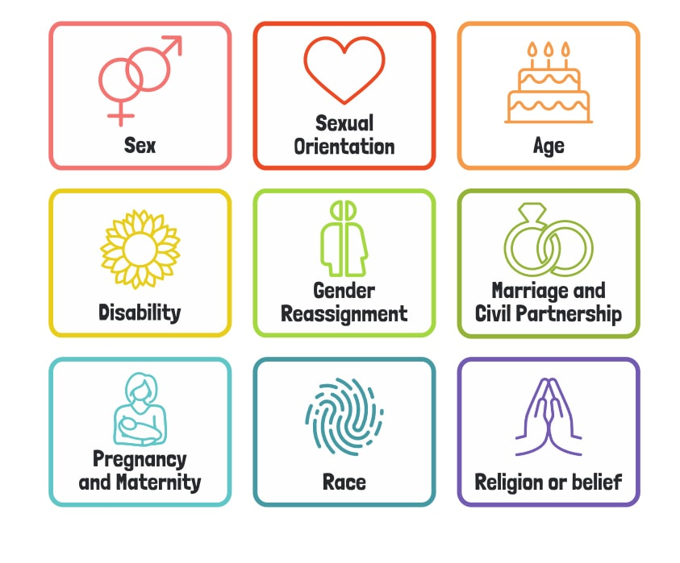

Because it is important that students are prepared for life in modern Britain and understand we belong to a diverse and equal society, the school recognises the nine protected characteristics and takes discriminatory behaviour against individuals with any of these characteristics extremely seriously.

1. **Bullying and child-on-child abuse**

Bullying is one aspect of child-on-child abuse, as outlined by the government’s guidance document ’Keeping Children safe in Education’. Child-on-Child abuse manifests in multiple ways, including:

• bullying, including cyberbullying and prejudice-based or discriminatory bullying.

• abuse in intimate personal relationships between peers (also known as teenage relationship abuse).

• physical abuse

• sexual violence

• sexual harassment, including online sexual harassment, which may be stand alone or be part of a broader pattern of abuse.

• causing someone to engage in sexual activity without consent, such as forcing someone to strip, touch themselves sexually, or to engage in sexual activity with a third party

• the consensual and non-consensual sharing of nude and semi-nude images and/or videos.

• upskirting.

• initiation- and hazing-type violence and rituals, which can include activities involving harassment, abuse or humiliation used as a way of initiating a person into a group and may also include an online element.

All staff are clear on the school’s policy and procedures regarding child-on-child abuse and the role they play in preventing it and responding where they believe a child may be at risk from it. All staff know of the heightened vulnerability of children with SEND, who evidence suggests are more likely to be victims of child-on-child abuse than their peers.

Most cases of children hurting other children will be dealt with under the school’s Behaviour policy; however, the Safeguarding and Child protection policy outlines that incidents must be reported to the police and children’s social care if the alleged behaviour:

• is serious, and potentially a criminal offence

• could put children in the school at risk

• is violent

• involves children being forced to use drugs or alcohol

• involves sexual exploitation, sexual abuse or sexual harassment, such as indecent exposure, sexual assault, upskirting or sexually inappropriate pictures or videos (including the sharing of nudes and semi-nudes)

1. **Identifying victims**

We recognise the nine protected characteristics because they are reflected in statistics that show students are more likely to be victims of bullying if they: have a disability or special educational needs; they identify or are believed to identify as LGBT+ or if they are otherwise arbitrarily perceived as ‘different’ by their peers. There is also a well-documented rise in misogynistic attitudes and behaviours in UK schools that manifests in the higher frequency of female victims of child-on-child abuse. It is crucial that all stakeholders are aware that bullying can take the form of sexual harassment both in person and online. The school’s preventative and responsive measures take account of this.

School staff work hard to ensure that students feel able to report bullying as outlined below. However, staff should also be vigilant of the following indicators and should raise concerns if:

• a student becomes quieter or withdrawn over time

• there is a noticeable change in character

• there is a noticeable change in appearance

• the child has changed sleeping or eating habits

• the child begins to avoid school/a subject/socialising at break times

• the child avoids of an area of school (e.g., toilets; outdoor areas)

• the child noticeably makes extra efforts to ‘fit in’

• the child claims to be happy being alone

• the child engages in unkindness/bullying themself

• there is evidence of self-harm (or intention to self-harm) of any kind

1. **A whole-school approach to bullying prevention**

The school’s approach to bullying is to prevent, not tolerate. A whole-school approach means that every person connected to the school can have their voice heard and every student receives persistent anti-hate messages. This is achieved through our Personal Development offer that is delivered through the multidisciplinary subject of Philosophy, Politics and Economics (PPE) which is taught as a discreet curriculum subject and through assemblies and weekly form time activities. Furthermore, our whole-school curriculum is regularly audited for representation and celebration of diversity with a view to combating any prejudiced attitudes that some students may come into contact with.

Because over 80% of bullying incidents are witnessed by peers but not adults (likely even more so given the online context of many cases), peer-based prevention strategies in the form of bystander anti-bullying lessons are crucial. These form part of our PPE curriculum. In the first instance, students are provided with mechanisms to report concerns about incidents they have witnessed. This is developed by encouraging age-appropriate interventions such as ‘stealing the show’ (whereby students are taught to distract attention from the victim using humour) and ‘coaching compassion’ (in which trained anti-bully ambassadors challenge younger students about their role in bullying incidents). The focus on peer-based prevention is particularly important when dealing with incidents that occur on journeys to and from school and online: contexts outside of the control of both home and school and yet incidents which have a clear impact on individuals’ wellbeing and attendance to school. This approach is also used because student voice on the topic of bullying and conflict has historically shown that group-bullying, where a number of students target an individual in a public context (usually online), is students’ biggest concern.

1. **Reporting mechanisms**

**Students**

Form tutors identify themselves as ‘safe to talk to’ regarding bullying or unkindness at the start of the school year. This message is reiterated throughout the year during form time and in assemblies. All students are made aware of the safeguarding core team and the extended safeguarding network of their pastoral teams during assemblies; they know these staff members can be sought in the instance of a concern about themself or a peer and that incidents will be treated seriously and confidentially.

Displays around school detail how to raise concerns and with whom, with photographs of key staff. In addition, all students are informed of the facility to report concerns via an online mechanism, ‘Whisper’, through their student IT portal should they feel more comfortable reporting in this way. However, they know that a concern raised virtually will mean a member of pastoral staff will discuss it with them face to face - though they will be assured this will be done in a discreet manner.

In the event of any disclosure of bullying made, students are informed that serious issues must be passed on to relevant professional bodies. However, as much agency as possible will be afforded regarding how this occurs. Any follow-up actions, such as restorative work or other interventions will always be undertaken with the child’s wishes and/or their welfare at the centre of decisions.

**Staff**

All staff are trained on the use of our ‘Response to Bullying flowchart’ which has been designed to ensure that incidents of bullying receive a consistent and timely response. A ‘Potential Bullying form’ works alongside the flowchart so that the leadership team can track the process of any investigation info bullying and ensure follow up actions are appropriate. These forms are stored on CPOMS and incidents are also recorded on the Child on Child log that is held by the Designated Safeguarding Lead. All incidents of bullying are overseen by a senior leader. 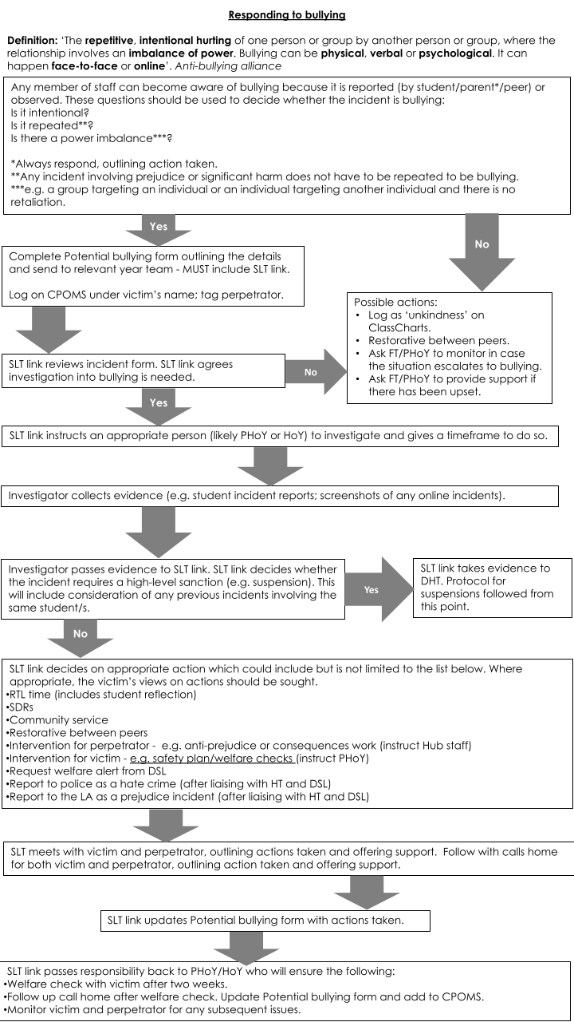

**Parents and carers**

It is important that students’ families raise concerns at their earliest opportunities to prevent situations escalating. In the first instance, a student’s form tutor should be informed; form tutors redirect concerns to relevant staff in school if needed. Where parents and carers have evidence of bullying (for example, screenshots of cyber incidents) it is helpful for school staff to be emailed these.

**6. Response strategy**

Despite our zero-tolerance attitude to bullying and prejudice of all kinds, one-fifth of children surveyed in the UK report having been bullied (Anti-bullying alliance) and so the school has strategies in place to tackle incidents that may occur.

A senior leader always oversees any investigation which is usually carried out by pastoral year teams. Sanctions for bullying range from Same Day Reflections (SDRs) to suspensions. Bullying incidents are considered on a case by case basis, with senior leaders involved in decision making about appropriate action.

Perpetrators’ families are always informed of incidents and given the opportunity to raise any issues they believe their child to have which may have led to them bullying. Perpetrators who repeat similar behaviours are discussed at a senior leadership level following submission of a Central Referral Form (CFR) by their year team. This facilitates appropriate interventions.

Victims’ families are also always informed of incidents and are reassured that their child will be kept safe in school and that issues have been dealt with using the Behaviour policy (though we do not share information about sanctions for perpetrators with victims’ families). Parents may be advised to inform the police of an incident should it contravene law. This may particularly be the case for incidents that occur on journeys to and from school or online because it is challenging for school staff to be in receipt of full facts in these cases. However, incidents that occur outside of school hours and off of the school site are investigated and sanctions applied where appropriate.

Depending on the severity of bullying, victims may be offered support ranging from mentoring by an anti-bullying ambassador, to self-esteem group sessions to one-to-one counselling in the most serious cases. In all cases, the victim’s wellbeing is monitored over time by their form tutor and year team who will keep in contact with their family following the incident.

Our reporting and response strategies are continually reviewed through the school’s safeguarding supervision model. Feedback on the approaches used is welcome from any stakeholder and is always evaluated as the school strives to eradicate all bullying and unkindness.

1. **Stakeholder responsibilities**

All stakeholders play a vital role in realising the vision set out in this policy.

**Students’ responsibilities:**

* To follow the school’s guidance regarding ‘Respect. Ready. Safe’ which encapsulates the empathy and sense of belonging that we strive to achieve for all members of the school.
* To know what bullying is and how this links to prejudice, hate crime and child-on-child abuse.
* To report concerns about themselves or peers so that issues can be effectively dealt with.
* To know how to diffuse situations that could result in bullying in person and online, using non-confrontational strategies learned in Wellbeing lessons.

**Staff responsibilities:**

* To promote empathy, respect and a sense of community at every opportunity because every interaction is an intervention.
* To deliver PPE content effectively, promoting student leadership and maturity in discussions about sensitive topics.
* To always be vigilant, especially of those students who belong to vulnerable groups or could be defined using the nine protected characteristics.
* To respond to incidents of bullying behaviour witnessed using the Behaviour policy and the ‘Response to Bullying flowchart.’
* To take incidents reported seriously and reassure students who have spoken out.
* To report concerns about victims of bullying via CPOMS.

**Parents’ and carers’ responsibilities:**

* To raise concerns early and provide any evidence possible (with the form tutor in the first instance).
* To be vigilant of signs of bullying and discuss concerns at home.
* If there are significant concerns, arrange to meet with a member of the pastoral team before letting instances of bullying impact on attendance and every student’s right to education.
* Understand that the school will sanction bullying and prejudice behaviour and parental support for any sanctions given make these more impactful: we all have the shared aim of allowing children to learn from mistakes.
* Communicate with school staff to address concerns in the knowledge that these will be listened to.

**Governance:**

* To hold school leaders to account over the contents of this policy.
* To support decisions that school leaders make about instances of bullying and prejudice.
* To share the school’s ‘zero-tolerance’ to all forms of hate.

**8. Linked documents and references**

* Keeping Children Safe in Education DFE update 2023.
* Anti-Bullying Review Guidance for Stockport LA.
* Preventing and Tackling Bullying DFE July 2017.
* The Equality Act 2010.
* Cyberbullying: Advice for head teachers and school staff DFE November 2014.
* The Anti-bullying alliance: https://anti-bullyingalliance.org.uk/
* The Kingsway School Behaviour Policy 2023-2024.
* ELT Safeguarding and Child Protection Policy 2023-2024.
* Espalage, D., Pigott, T., Polanin, J. (2012) ‘A Meta‐Analysis of School‐Based Bullying Prevention Programs: Effects on Bystander Intervention Behaviour.’ *School Psychology Review*, 41(1) pp. 47–65.
* Felmlee, D., and Faris, R. (2016). ‘Toxic Ties: Networks of Friendship, Dating, and Cyber Victimization.’ *Social Psychology Quarterly*, 79(3), pp. 243–262.