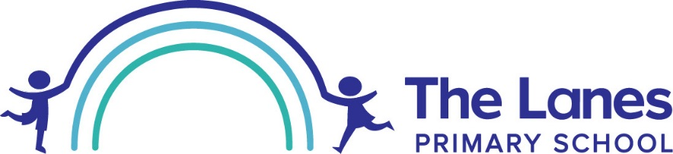
September 2025
Cator Lane, Chilwell, Nottingham NG9 4BB
Head Teacher: Mr P Wilkes

Dear Parent/Carer

We have access to a team of peripatetic music teachers who can offer our pupils music lessons in which your child has expressed an interest. Lessons take place during the school day and your child may be withdrawn from class to take part.

MUSIC TEACHERS | INSTRUMENTS
Mrs S Adams | Violin and Piano
Mr L Brookes | Drums
Mrs D Fraser | Flute
Mr N Clark | Guitar
Mrs C Weston | Clarinet and Piano
Mrs S Trevers | Singing
Mr T Davis | Trumpet and trombone

Fees listed here are for a full term of 10 lessons. Additional lessons can be arranged directly with your child’s music teacher.

- Individual Lesson £117.00 per term (20 mins)
- Individual Lesson £175.00 per term (30 mins)

The instrumental teachers operate on a self-employed basis. Parents and carers enter into a private business relationship with the teacher to whom fees are payable directly. Individual teachers will contact you with regard to invoices, payment and when your child is able to start. School provides a venue and ensures that Music Teachers have a DBS (Disclosure & Barring Service) check, or its predecessor a CRB (Criminal Records Bureau) check.

The school also has a limited supply of musical instruments which can be loaned to families for a small termly charge. Some children may have to wait until an instrument becomes available or until a teacher has the capacity to take them on especially drums and guitars. School is unable to provide guitars, pianos and drum kits so in these cases pupils need to have access to their own instrument to practice. If your child participates in these lessons we will expect them to take part in musical clubs that is relevant to their instrument, e.g. choir, drumming group, etc.

Learning to play an instrument is great fun and provides invaluable skills for later life. Like any skill worth learning, it does require commitment and we ask that children practice daily.

We hope that your child enjoys learning an instrument and look forward to hearing their contributions. By completing this form you agree to your data being passed on to the music teachers.

Yours sincerely
Music Team
(music@thelanes.notts.sch.uk)
----------------------------------------------------------------------------------------------------------------------------------------------------------------------------------------
The Lanes Primary School - Instrumental Tuition Request Slip 2025-26

I would like my child ............................................................................................. Class .....................................

to learn .......................................................... (instrument).

We understand the requirement to practice regularly and that my child may miss some class lesson time.

Name ………………………………………………….………………… Signature of Parent/Carer ....................................................................

Tel. No. ..................................................................... Email address ……………………………………………………………………………………

We will let you know about the availability of instruments and lesson slots as soon as possible. For some instruments it may be necessary for your child to go on a waiting list.

