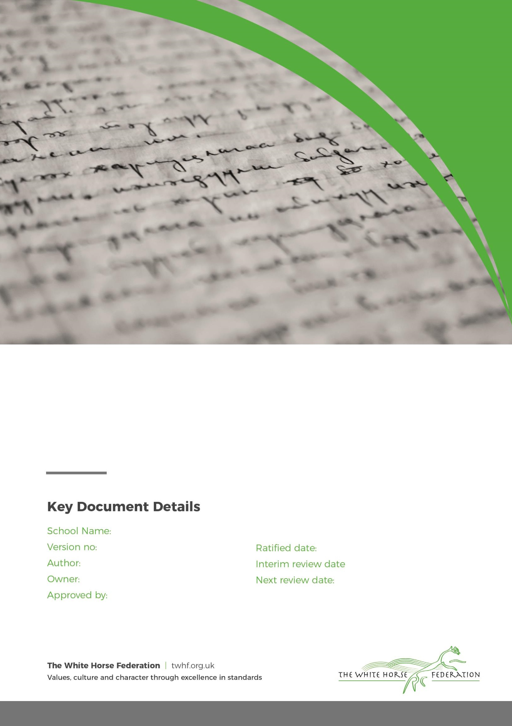

Early Years Policy

2

Lisa Davies

Director of Education

July 2025

September 2028

The Manor School and Little Lights Nursery

Director of Education
September 2027
Changes 2
Section 1 – Aims 2
Section 2 – Legislation 3
Section 3 – Structure of the EYFS 3
Section 4 – Curriculum 3
4.1 EYFS Framework 3
4.2 TWHF ENRich Curriculum 3
4.3 Planning 4
4.4 Teaching 5
Section 5 – Assessment 5
Section 6 – Working with parents and carers 6
Section 7 – Safeguarding and welfare procedures 6
7.1 - Safer Eating ………………………………………………………………………………………………… …7
7.2 - Safer Sleeping …………………………………………………………………………………………………..7
7.3 - Screentime ……………………………………………………………………………………………………7
7.4 Oral health and tooth brushing 8
Appendix 1. List of statutory policies and procedures for the EYFS 8
Version | Date | Page document | Change | Origin of change e.g. Change in legislation, Policy review.
1.0 | July 2025 | All | Improved layout to support printing and rebranded.
2.0 | September 2026 | 7-8 | Incorporates new guidance on :  Safer eating  Safer sleeping  Screen time

Section 1 – Aims
This policy aims to ensure:

- That children access a broad and balanced curriculum that gives them the broad range of knowledge and skills needed for good progress through school and life
- Quality and consistency in teaching and learning so that every child makes good progress and no child gets left behind
- A close working partnership between staff and parents and/or carers
- Every child is included and supported through equality of opportunity and anti-discriminatory practice

Our TWHF Core Commitments: What Matters Most
At The Manor School, Little Lights Nursery and The White Horse Federation, we are united by a shared ambition: The Best Start in Life. Our eight EYFS Core Commitments are embedded to ensure that every child receives an equitable, high-quality early years offer. These commitments are not just statements; they are lived values that shape our daily practice and long-term vision.

Our Core Commitments:
- A Nurturing, Inclusive Environment with a Strong Sense of Belonging
- Exceptional Teaching, High-Quality CPD, and Meaningful Interactions
- Oracy and Language-Rich Environments
- Immersive Literacy and Numeracy: Books, Rhymes, Number and Storytelling
- Child-Centred, Play-Based Learning
- Equity for All Groups of Learners
- Personal Development and Positive Behaviour Foundations
- Strong Parent and Carer Partnerships

Across our school, we ensure that:

- Quality talk and meaningful discussion permeate every learning environment.
- Children are immersed in language-rich, playful experiences that support their communication, thinking, and creativity.
- A strong sense of belonging and community is nurtured—for both children and their families—so that every child feels safe, valued, and ready to thrive.
- Our staff team are empowered through high-quality CPD and collaboration, ensuring consistency and excellence in teaching and care.
- We foster equity, inclusion, and aspiration, giving every child the very best start in life.

Section 2 – Legislation

This policy is based on requirements set out in the statutory framework for the Early Years Foundation Stage (EYFS) for 2026.

Section 3 – Structure of the EYFS

At the White Horse Federation, we have children from 2-5 years of age across our Early Years.

Little Lights Nursery provides a nurturing and engaging environment for children aged 3 to 4 years, delivered by a caring team of experienced practitioners and educators.
We are open Monday to Friday during term time, from 8:45 a.m. to 3:15 p.m., offering families the flexibility to choose morning, afternoon, or full-day sessions to suit their needs.
Children’s development is at the heart of everything we do. We follow the Early Years Foundation Stage (EYFS) framework, ensuring our curriculum supports children to:
- Learn and develop with confidence
- Feel safe, secure, and healthy
- Gain the knowledge and skills they need for a happy and successful start to school

Our curriculum is complemented by our excellent facilities and carefully chosen resources. We believe that a well-planned, welcoming environment plays a vital role in supporting children’s learning and development.

Little Lights Nursery offers:
- A bright, spacious, and well-resourced classroom, thoughtfully designed to comfortably accommodate up to 26 children
- A brand-new, large outdoor learning area that encourages exploration, discovery, and active play
- Secure boundaries throughout the setting to ensure children feel safe and protected
- Toilets conveniently located within the main classroom area, including accessible facilities.

Optional Additional Charges

Extra session £16.50 (must be pre-agreed with staff)

Hot lunch £2.61 per day

Snack £0.50 per session

These items are all optional and if required should be booked via ParentPay. If you do not wish to purchase a hot lunch or snack, please send your child with a packed lunch (if staying the full day), a water bottle and a snack. Please contact the office if you have any questions.

Section 4 – Curriculum
- EYFS Framework

Our early years follows the curriculum as outlined in the latest EYFS statutory framework, alongside our TWHF Early Years Common Curriculum.

The EYFS framework includes 7 areas of learning and development that are equally important and inter-connected. Three areas, known as the prime areas, are seen as particularly important for building children’s capacity to learn, form relationships and thrive.

The prime areas are:
- Communication and language
- Physical development
- Personal, social and emotional development

The prime areas are strengthened and developed, and children’s curiosity and enthusiasm are ignited, through 4 specific areas:
- Literacy
- Mathematics
- Understanding the world
- Expressive arts and design

Each area of learning and development is implemented through planned, purposeful play, and through a mix of adult-led and child-initiated activities.

- TWHF ENRich Curriculum

At The White Horse Federation, we are committed to giving every child the best start in life. Our Early Years follows the TWHF ENRich curriculum from the age of 2-5. This ensures a consistent, high-quality offer across all our settings.

Language, Oracy and Literacy

We use the Talk for Writing approach across all EYFS age groups. This method supports children in developing their spoken language skills by encouraging them to orally rehearse sentences before writing them. Through this process, children build confidence, fluency, and a deeper understanding of sentence structure.

Each term, children are immersed in a carefully curated selection of high-quality texts. These include a mix of traditional tales and well-loved children’s classics. The chosen texts are not only engaging but also rich in vocabulary and storytelling techniques, helping to foster a genuine love of reading and storytelling.

Our curriculum is intentionally designed to be language-rich, ensuring that children are surrounded by meaningful vocabulary and expressive language throughout their day. This immersive environment helps to break down barriers to learning, enabling all children to access the curriculum and achieve well.

Phonics

Children follow their SSP in phonics, and the love of reading is further developed through the core text immersion, as well as book guides to help teachers reflect on key questions and tier 2 vocabulary when reading with their class . This approach ensures that children develop from the EYFS as confident emerging readers.

At Light Lights, children begin their phonics journey in Nursery through the Little Wandle Letters and Sounds programme. In Nursery, children develop their speaking and listening skills, tune into different sounds, learn rhythm and rhyme, and begin to recognise and distinguish sounds in words. These early experiences build the strong foundations needed for learning to read and write.

As children move into Reception, their phonics learning becomes more structured and systematic. Using the Little Wandle Letters and Sounds Revised programme, children are taught daily phonics sessions where they learn grapheme-phoneme correspondences, practise blending sounds to read words, and segment words for spelling. The programme is carefully sequenced, allowing children to build on the skills developed in Nursery and progress with confidence.

Through regular assessment and targeted support, every child is encouraged to keep up with the programme, ensuring they become fluent readers. This consistent approach helps children develop a love of reading, grow in confidence, and acquire the essential literacy skills they need for future learning

Mathematics

We follow our TWHF ENRich EYFS maths curriculum, ensuring children have a strong foundational knowledge of maths.

This is delivered through taught sessions and a number-rich learning environment where children can grow and develop their mathematical understanding.

Play Progressions

TWHF Play progressions have been produced to support effective play in the following 9 areas:

- Small world
- Construction
- Role play
- Malleable
- Sand play
- Water play
- Mud kitchen play
- Fine motor skills play
- Stage, performance and drama

These are carefully constructed to take into account oracy, problem solving and language, alongside a child’s level of play.

- Planning

We use carefully considered and well sequenced TWHF planning for :
- T4W
- Maths
- Continuous Provision Plans
- Book talk
- Play Progressions

TWHF continuous provision plans are carefully mapped out to enrich the stories and tales while still developing our children in all areas.

Our EYFS team also take into account the individual needs, interests, and stage of development of each child in their care, and use this information to plan a challenging and enjoyable experience. It is important that teachers use their baseline knowledge to also purposefully plan their provision to bridge any gaps and so that all children achieve well.

Enhanced provision is always inviting and stimulating, and carefully and well planned to support the needs or interests of the learners.

Where a child may have a special educational need or disability (SEND), staff consider whether specialist support is required, linking with relevant services from other agencies, where appropriate.

In planning and guiding children’s activities, staff reflect on the different ways that children learn and include these in their practice.

- Teaching

Each area of learning and development is implemented through planned, purposeful play, and through a mix of adult-led and child-initiated activities. Staff respond to each child’s emerging needs and interests, guiding their development through warm, positive interaction.

As the children grow older, and as their development allows, the balance gradually shifts towards more adult-led activities to help the children prepare for more formal learning, ready for year 1.

Section 5 – Assessment

At The White Horse Federation, we use ongoing assessment as an integral part of the learning and development processes. Staff observe pupils to identify their level of achievement, interests and learning styles. These observations are used to shape future planning.

Children are assessed using the WellComm Assessment Toolkit to identify areas of strength and any aspects of speech, language and communication that may require further support. This assessment helps practitioners monitor progress, plan appropriate next steps and ensure that children receive the support they need to thrive. The WellComm assessment is used from the time children join us and continues throughout the Early Years Foundation Stage (EYFS), enabling us to track development and celebrate progress over time.

Staff also take into account observations shared by parents and/or carers.

Nursery/ Pre-School

In Nursery, we observe children to help us make judgements on the children’s progress. This also helps us plan to support and enhance the children’s development.

All children in our Nursery are assessed using WELLCOM. This helps us screen a child’s language development and enables us to give targeted support if requited.

Reception

Within the first 6 weeks that a child starts reception, staff will administer the reception baseline assessment (RBA).

We also complete our own TWHF baseline to support us understanding the needs of the children and help us plan purposeful provision.

In addition, all children will have a WELLCOM assessment when they start in Reception so we can identify any gaps in speech and language.

At the end of the EYFS, staff complete the EYFS profile for each child. Pupils are assessed against the 17 early learning goals, indicating whether they are:

- Meeting expected levels of development
- Not yet reaching expected levels (‘emerging’)

The profile reflects ongoing observations, and discussions with parents and/or carers. The school shares the results of each child’s assessment with their parents and/or carers.

The profile is moderated internally (referring to the Development Matters guidance) and in partnership with TWHF schools, to ensure consistent assessment judgements. EYFS profile data is submitted to the local authority.

Section 6 – Working with parents and carers

We recognise that children learn and develop well when there’s a strong partnership between staff and parents and/or carers. This is why it is one of our TWHF Core Commitments for Early Years.

Parents and/or carers are kept up to date with their child’s progress and development. The progress check and EYFS profile helps to provide parents and/or carers with a well-rounded picture of their child’s knowledge, understanding and abilities.

In Nursery, each child is assigned a key person who helps to ensure that their learning and care is tailored to meet their needs. The key person supports parents and/or carers in guiding their child’s development at home. The key person also helps families to engage with more specialist support, if appropriate.

In addition, we have regular :

Class Dojo updates
- Stay and Play
- Family Learning afternoons
- Workshops in phonics, storytime and mathematics
- Parent consultations

Section 7 – Safeguarding and welfare procedures

We recognise that children learn best when they are healthy, safe and secure, when their individual needs are met and when they have positive relationships with the adults caring for them. We follow safeguarding and welfare requirements to provide a welcoming, safe and stimulating environment where children are able to enjoy learning and grow in confidence.

We follow Keeping Children Safe in Education (KCSIE), the current Early Years Foundation Stage (EYFS) statutory framework and all associated safeguarding and welfare requirements, including safer recruitment, paediatric first aid, safer eating, safer sleep and appropriate screen use guidance.

We make sure that the appropriate statutory staff: child ratios are maintained in our setting to meet the needs of all children and ensure their safety:
- For children aged 3 and over:

- Where a person with Qualified Teacher Status, Early Years Professional Status, or Early Years Teacher Status is working directly with the children, we have at least 1 member of staff for every 13 children
- Where a person with the above qualifications is not working directly with the children, we have at least 1 member of staff for every 8 children

For Reception classes :
- We comply with infant class size legislation and have at least 1 teacher per 30 pupils

For mixed classes:
- We determine ratios guided by all relevant ratio requirements and by the needs of the children within the group

When recruiting staff, we will follow the procedures set out in the latest EYFS framework guidance on checking the suitability of new recruits and recording information about staff qualifications and identity checks, vetting processes and references.

We have at least 1 person with a current paediatric first aid (PFA) certificate on the premises and available at all times when children are present, including on outings.

This PFA certificate is renewed every 3 years as required.

In addition, trainees, apprentices and students will hold a Level 2 Paediatric First Aid (PFA) certificate in order to be included in staff-to-child ratios, in line with EYFS statutory requirements.

We also have a designated lead practitioner who is responsible for safeguarding children. They are also responsible for:

- Liaising with local statutory children's services agencies, and with the LSP (local safeguarding partners)
- Providing support, advice and guidance to any other staff on an ongoing basis, and on any specific safeguarding issue as required
- Attending a child protection training course that enables them to identify, understand and respond appropriately to signs of possible abuse and neglect

All practitioners are alert to any issues of concern in children’s life at home or elsewhere.

7.1 Safer Eating

We recognise that mealtimes, snacks and drinks are important learning and social opportunities, but also require careful supervision to ensure children's safety.

To promote safer eating, we will:

- Ensure that a member of staff holding a current Paediatric First Aid (PFA) certificate is present whenever children are eating.
- Obtain information from parents and carers about children's dietary requirements, allergies, intolerances and medical needs before admission and keep this information up to date.
- Ensure all staff are aware of children's dietary needs and are able to respond appropriately to allergy-related incidents.
- Maintain individual allergy or dietary management plans where required.
- Provide food and drink that is prepared, served and presented safely and appropriately for the age and developmental stage of each child.
- Ensure children are seated safely and supervised at all times whilst eating and drinking.
- Minimise distractions during mealtimes so that staff can closely observe children and support safe eating practices.
- Follow current Department for Education nutrition guidance and food safety recommendations.

7.2 Safer Sleep

We are committed to providing a safe sleeping environment for all children who require rest or sleep during the school day.

Where children sleep within our provision, we will:

- Work in partnership with parents and carers to understand each child's sleep needs and routines.
- Ensure sleeping arrangements are safe, suitable and developmentally appropriate.
- Carry out regular checks of sleeping children and maintain appropriate supervision at all times.
- Follow current safer sleep guidance, including guidance from The Lullaby Trust and the EYFS statutory framework.
- Ensure sleep spaces are free from hazards and that children are placed to sleep in accordance with current safer sleep recommendations relevant to their age and stage of development.
- Record and share any significant concerns regarding a child's sleep pattern, health or wellbeing with parents and carers and, where appropriate, relevant professionals.

7.3 Screen Use and Digital Technology

We recognise that technology can enhance learning when used appropriately; however, screen use in the early years should be purposeful, developmentally appropriate and carefully managed.

Therefore, we will:

- Ensure screen use supports learning, communication, creativity and development rather than replacing high-quality adult interaction, play and exploration.
- Limit children's exposure to screens and avoid excessive or passive use.
- Ensure digital technology is used safely and under adult supervision.
- Consider children's age, developmental needs and wellbeing when planning activities involving screens.
- Work with parents and carers to promote healthy approaches to screen use both in school and at home.
- Regularly review our practice in line with current EYFS guidance and recommendations relating to children's health, wellbeing and development.

  - Oral health and tooth brushing

We promote good oral health, as well as good health in general, in the early years by taking part in the Big Brush Club.

- The effects of eating too many sweet things
- The importance of brushing your teeth

The rest of our safeguarding and welfare procedures are outlined in our school’s child protection and safeguarding policy, which can be found on our school website

Section 8 – Monitoring arrangements

This policy will be reviewed and approved by Lisa Davies, Executive Headteacher every two years.

This policy will also be reviewed accordingly by the school’s headteacher and EYFS Lead.

At every review, the policy will be shared with the school’s governing board.

Appendix 1. List of statutory policies and procedures for the EYFS

This isn’t an exhaustive list of policies and only includes policies specific to the EYFS. For a full list of our policies, see Policies & Procedures | The Manor CofE School

Statutory policy or procedure for the EYFS | Where can it be found?
Safeguarding policy and procedures | See child protection and safeguarding policy
Procedure for responding to illness | See supporting pupils with medical conditions policy
Administering medicines policy | See supporting pupils with medical conditions policy
Emergency evacuation procedure | (Not online)
Procedure for checking the identity of visitors | See child protection and safeguarding policy
Procedures for a parent/carer failing to collect a child and for missing children | See child protection and safeguarding policy
Procedure for dealing with concerns and complaints | See complaints policy
Intimate Care | See Policy

