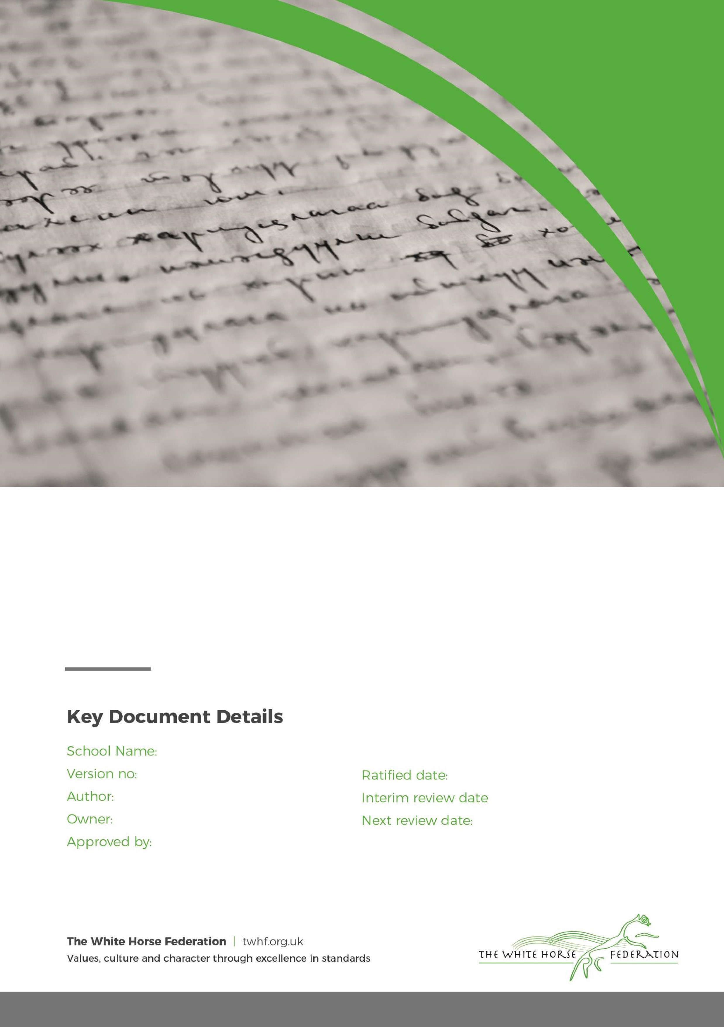

Special Education Needs (SEN)

Information Report

1

Tim James

Tim James

September / 2025

September / 2026

The Manor

Month / Year

Approver

# **Dear Parents and Carers,**

The aim of this information report is to explain how we implement our SEND policy. In other words, we want to show you how SEND support works in our school.

If you want to know more about our arrangements for SEND, read our SEND policy.

You can find it on our website [The Manor CofE School (themanor-school.co.uk)](https://www.themanor-school.co.uk/)

**Note:** If there are any terms we’ve used in this information report that you’re unsure of, you can look them up in the Glossary at the end of the report.

# **1. What types of SEN does the school provide for?**

Our school provides for pupils with the following needs:

|  |  |
| --- | --- |
| **Area of need** | **Condition** |
| **Communication and interaction** | Autism spectrum disorder |
| Speech and language difficulties |
| **Cognition and learning** | Specific learning difficulties, including dyslexia, dyspraxia, dyscalculia |
|
|
| Moderate learning difficulties |
| Severe learning difficulties |
| **Social, emotional and mental health** | Attention deficit hyperactive disorder (ADHD) |
| Attention deficit disorder (ADD) |
| **Sensory and/or physical** | Hearing impairments |
| Visual impairment |
| Multi-sensory impairment |
| Physical impairment |

# **2. Which staff will support my child, and what training have they had?**

Our special educational needs co-ordinator, or SENCO

The SENCO is Gill Brindley, [gillbrindley@twhf.org.uk](mailto:gillbrindley@twhf.org.uk)

Our SENCO has over 15 years experience in this role and holds the National Qualification for SENCOs

The SENCo will:

* Work with the headteacher and SEN governor to determine the strategic development of the SEN policy and provision in the school
* Have day-to-day responsibility for the operation of this SEN policy and the co-ordination of specific provision made to support individual pupils with SEN, including those who have EHC plans
* Provide professional guidance to colleagues and work with staff, parents, and other agencies to ensure that pupils with SEN receive appropriate support and high-quality teaching
* Advise on the graduated approach to providing SEN support
* Advise on the deployment of the school’s delegated budget and other resources to meet pupils’ needs effectively
* Be the point of contact for external agencies, especially the local authority and its support services
* Liaise with potential next providers of education to ensure that the school meets its responsibilities under the Equality Act 2010 with regard to reasonable adjustments and access arrangements
* Ensure the school keeps the records of all pupils with SEN up to date

The SEN governor

The SEN governor will:

* Help to raise awareness of SEN issues at governing board meetings
* Monitor the quality and effectiveness of SEN and disability provision within the school and update the governing board on this
* Work with the headteacher and SENCO to determine the strategic development of the SEN policy and provision in the school

The headteacher

The headteacher will:

* Work with the SENCO and SEN governor to determine the strategic development of the SEN policy and provision within the school
* Have overall responsibility for the provision and progress of learners with SEN and/or a disability

Class teachers

Each class teacher is responsible for:

* The progress and development of every pupil in their class
* Working closely with any teaching assistants or specialist staff to plan and assess the impact of support and interventions and how they can be linked to classroom teaching
* Working with the SENCO to review each pupil’s progress and development and decide on any changes to provision
* Ensuring they follow this SEN policy

Teaching assistants (TAs)

We have a team of TAs, including higher-level teaching assistants (HLTAs) who are trained to deliver SEN provision.

We also have 4 teaching assistants who are trained to deliver ELSA.

External agencies and experts

Sometimes we need extra help to offer our pupils the support that they need. Whenever necessary we will work with external support services to meet the needs of our pupils with SEN and to support their families. These include:

* Speech and language therapists
* Educational psychologists
* Occupational therapists
* GPs or paediatricians
* School nurses
* Primary Mentors
* Child and adolescent mental health services (CAMHS)
* Education welfare officers
* Social services and other LA-provided support services
* Voluntary sector organisations
* Virtual School (for Looked After Children)
* Young Carers
* Social Emotional and Mental Health (SEMH) Support Team

# **. What should I do if I think my child has SEN?**

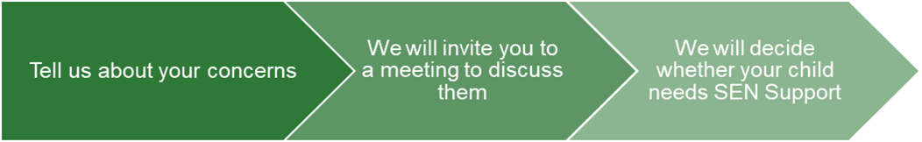

|  |  |  |
| --- | --- | --- |
| If you think your child might have SEN, the first person you should tell is your child’s teacher. An appointment can be made directly with the teacher or via the school office.  They will pass the message on to our SENCO, Gill Brindley, who will be in touch to discuss your concerns.  You can also contact the SENCO directly gillbrindley@twhf.org.uk | We will meet with you to discuss your concerns and try to get a better understanding of what your child’s strengths and difficulties are.  Together we will decide what outcomes to seek for your child and agree on next steps.  We will make a note of what’s been discussed and add this to your child’s record. You will also be given a copy of this. | If we decide that your child needs SEN support, we will formally notify you in writing and your child will be added to the school’s SEND register. |

# 

# **4. How will the school know if my child needs SEN support?**

All our class teachers are aware of SEN and are on the lookout for any pupils who aren’t making the expected level of progress in their schoolwork or socially.

If the teacher notices that a pupil is falling behind, they try to find out if the pupil has any gaps in their learning. If they can find a gap, they will give the pupil extra tuition to try to fill it. Pupils who don’t have SEN usually make progress quickly once the gap in their learning has been filled.

If the pupil is still struggling to make the expected progress, the teacher will talk to the SENCO, and will contact you to discuss the possibility that your child has SEN.

The SENCO will observe the pupil in the classroom and in the playground to see what their strengths and difficulties are. They will have discussions with your child’s teacher/s, to see if there have been any issues with, or changes in, their progress, attainment or behaviour. They will also compare your child's progress and development with their peers and available national data.

The SENCO will ask for your opinion and speak to your child to get their input as well. They may also, where appropriate, ask for the opinion of external experts such as a speech and language therapist, an educational psychologist, or a paediatrician.

Based on all of this information, the SENCO will decide whether your child needs SEN support. You will be told the outcome of the decision in writing.

If your child does need SEN support, their name will be added to the school’s SEN register, and the SENCO will work with you to create a SEN support plan for them.

# **5. How will the school measure my child’s progress?**

We will assess each pupil’s current skills and levels of attainment on entry, which will build on previous settings and Key Stages, where appropriate. Class teachers will make regular assessments of progress for all pupils and identify those whose progress:

* Is significantly slower than that of their peers starting from the same baseline
* Fails to match or better the child’s previous rate of progress
* Fails to close the attainment gap between the child and their peers
* Widens the attainment gap

This may include progress in areas other than attainment, for example, social needs.

Slow progress and low attainment will not automatically mean a pupil is recorded as having SEN.

When deciding whether special educational provision is required, we will start with the desired outcomes, including the expected progress and attainment, and the views and the wishes of the pupil and their parents. We will use this to determine the support that is needed and whether we can provide it by adapting our core offer, or whether something different or additional is needed.

Teachers and Teaching Assistants are trained to personalise the class planning to meet a variety of different needs, and your child’s learning will be directed towards meeting any identified needs through their Provision map, My support Plan or ‘Education and Health Care Plan.’ If it is appropriate, then an individual curriculum will be created for your child

We will follow the ‘graduated approach’ to meeting your child’s SEN needs.

The graduated approach is a 4-part cycle of **assess, plan, do, review**.

**Assess**

**If your child is not making the expected level of progress, we will make an assessment to find out what strengths and difficulties your child has.** **We will ask for you and your child’s input, as well as getting help from external professionals where necessary.**

**Review**

**We will assess how well the support we put in place helped the pupil to meet the outcomes we set. We will use our improved understanding of   
your child’s needs to improve the support we offer.**

**Plan**

**In discussion with you and your child, we will decide what outcomes we are hoping to achieve. We will make a plan of the support we will offer your child to help them meet those outcomes. We will make a record of this and share it with you and all relevant school staff.**

**Do**

**We will put our plan into practice.**

**The class teacher, with the support of the SENCO, will be responsible for working with your child on a daily basis, and making sure the support we put in place is having the impact we intended.**

As a part of the planning stage of the graduated approach, we will set outcomes that we want to see your child achieve.

Whenever we run an intervention with your child, we will assess them before the intervention begins. This is known as a ‘baseline assessment’. We do this so we can see how much impact the intervention has on your child’s progress.

We will track your child’s progress towards the outcomes we set over time and improve our offer as we learn what your child responds to best.

This process will be continual. If the review shows a pupil has made progress, they may no longer need the additional provision made through SEN support. For others, the cycle will continue and the school's targets, strategies and provisions will be revisited and refined.

# **6. How will I be involved in decisions made about my child’s education?**

We will share SEND Pupil Profiles termly and provide annual reports on your child's progress

Your child’s class/form teacher will meet you twice a year to:

* Set clear outcomes for your child’s progress
* Review progress towards those outcomes
* Discuss the support we will put in place to help your child make that progress
* Identify what we will do, what we will ask you to do, and what we will ask your child to do

The SENCO may also attend these meetings to provide extra support.

We know that you’re the expert when it comes to your child’s needs and aspirations. So we want to make sure you have a full understanding of how we’re trying to meet your child’s needs, so that you can provide insight into what you think would work best for your child.

We also want to hear from you as much as possible so that we can build a better picture of how the SEN support we are providing is impacting your child outside of school.

If your child’s needs or aspirations change at any time, please let us know right away so we can keep our provision as relevant as possible.

After any discussion we will make a record of any outcomes, actions and support that have been agreed. This record will be shared with all relevant staff, and you will be given a copy.

If you have concerns that arise between these meetings, please contact your child’s class teacher.

# 

# **7. How will my child be involved in decisions made about their education?**

The level of involvement will depend on your child’s age, and level of competence. We recognise that no 2 children are the same, so we will decide on a case-by-case basis, with your input.

We may seek your child’s views by asking them to:

* Attend meetings to discuss their progress and outcomes
* Prepare a presentation, written statement, video, drawing, etc.
* Discuss their views with a member of staff who can act as a representative during the meeting
* Complete a survey

**8. How will the school adapt its teaching for my child?**

Your child’s teacher is responsible and accountable for the progress and development of all the pupils in their class.

High-quality teaching is our first step in responding to your child’s needs. We will make sure that your child has access to a broad and balanced curriculum in every year they are at our school.

We will adapt how we teach to suit the way the pupil works best. There is no '1 size fits all’ approach to adapting the curriculum, we work on a case-by case basis to make sure the adaptations we make are meaningful to your child.

These adaptations include:

* Adapting our curriculum to make sure all pupils are able to access it, for example, by grouping, 1-to-1 work, adapting the teaching style or content of the lesson, etc.
* Adapting our teaching, for example, giving longer processing times, pre-teaching of key vocabulary, reading instructions aloud, etc.
* Adapting our resources and staffing
* Using recommended aids, such as laptops, coloured overlays, visual timetables, larger font, etc.
* Teaching assistants may support pupils on a 1-to-1 basis
* Teaching assistants may support pupils in small groups

Our School Accessibility Plan can also be accessed via our school website. This document provides further information as to how disabled pupils can participate in the curriculum.

We may also provide the following interventions:

|  |  |  |
| --- | --- | --- |
| **Area of need** | **Condition** | **How we support these pupils** |
| **Communication and interaction** | Autism spectrum disorder | Visual timetables  Social stories  Clear and consistent boundaries  Sensory activities |
| Speech and language difficulties | Speech and language therapy |
| **Cognition and learning** | Specific learning difficulties, including dyslexia, dyspraxia and dyscalculia | Writing slope  Coloured overlays and books |
|
|
| Moderate learning difficulties | Manipulatives |
| Severe learning difficulties | Bespoke curriculum |
| **Social, emotional and mental health** | ADHD, ADD | Quiet workstation  Brain breaks |
| Adverse childhood experiences and/or mental health issues | Nurture groups |
| **Sensory and/or physical** | Hearing impairment | Hearing loops |
| Visual impairment | Carefully designed displays |
| Multi-sensory impairment |  |
| Physical impairment | Accessible toilet and school access |

These interventions are part of our contribution to Wiltshire’s local offer.

# **9. How will the school evaluate whether the support in place is helping my child?**

We will evaluate the effectiveness of provision for your child by:

* Reviewing their progress towards their goals each term
* Reviewing the impact of interventions after 6 to 8 weeks or otherwise if specified for set intervention
* Using pupil questionnaires
* Monitoring by the SENCO
* Using provision maps to measure progress
* Holding an annual review (if they have an education, health and care (EHC) plan)

# **10. How will the school resources be secured for my child?**

It may be that your child’s needs mean we need to secure:

* Extra equipment or facilities
* More teaching assistant hours
* Further training for our staff
* External specialist expertise

If that’s the case, we will consult with external agencies to get recommendations on what will best help your child access their learning.

The school will cover up to £6,000 of any necessary costs. If funding is needed beyond this, we will seek it from our local authority.

# **11. How will the school make sure my child is included in activities alongside pupils who don’t have SEND?**

All of our extra-curricular activities and school visits are available to all our pupils, including our before and after-school clubs.

All pupils are encouraged to go on our school trips, including our residential trip

All pupils are encouraged to take part in whole school activities

No pupil is ever excluded from taking part in these activities because of their SEN or disability and we will make whatever reasonable adjustments are needed to make sure that they can be included.

# **12. How does the school make sure the admissions process is fair for pupils with SEN or a disability?**

The school Admissions policy is available on the school website.

# **13. How does the school support pupils with disabilities?**

The school Accessibility plan is available on the school website.

# **14. How will the school support my child’s mental health and emotional and social development?**

We provide support for pupils to progress in their emotional and social development in the following ways:

* Pupils with SEN are encouraged to be part of the school council and are included in the Year 6 responsibilities
* We provide extra emotional support for listening to the views of pupils with SEN through ELSA and the Primary Mentoring service

We have a ‘zero tolerance’ approach to bullying.

# **15. What support will be available for my child as they transition between classes or settings, or in preparing for adulthood?**

Between years

To help pupils with SEND be prepared for a new school year we:

* Ask both the current teacher and the next year’s teacher to attend a final meeting of the year when the pupil’s SEN is discussed
* Schedule lessons with the incoming teacher towards the end of the summer term

Between schools

When your child is moving on from our school, we will share all relevant SEND and safeguarding documents

The SENCO of the secondary school will come into our school for a meeting with our SENCO. They will discuss the needs of all the children who are receiving SEN support.

Pupils will be prepared for the transition by:

* Practising with a secondary school timetable
* Learning how to get organised independently
* Plugging any gaps in knowledge

# **16. What support is in place for looked-after and previously looked-after children with SEN?**

Gill Brindley, our SENCO will make sure that all teachers understand how a looked-after or previously looked-after pupil’s circumstances and their SEN might interact, and what the implications are for teaching and learning.

Children who are looked-after or previously looked-after will be supported much in the same way as any other child who has SEND. However, looked-after pupils will also have a personal education plan (PEP). We will make sure that the PEP and any SEN support plans or EHC plans are consistent and complement one another.

# **17. What should I do if I have a complaint about my child’s SEN support?**

Complaints about SEN provision in our school should be made to the SENCO in the first instance. They will then be referred to the school’s complaints policy.

If you are not satisfied with the school’s response, you can escalate the complaint. In some circumstances, this right also applies to the pupil themselves.

To see a full explanation of suitable avenues for complaint, see pages 246 and 247 of the [SEN Code of Practice](https://www.gov.uk/government/publications/send-code-of-practice-0-to-25).

If you feel that our school discriminated against your child because of their SEND, you have the right to make a discrimination claim to the first-tier SEND tribunal. To find out how to make such a claim, you should visit: <https://www.gov.uk/complain-about-school/disability-discrimination>

You can make a claim about alleged discrimination regarding:

* Admission
* Exclusion
* Provision of education and associated services
* Making reasonable adjustments, including the provision of auxiliary aids and services

Before going to a SEND tribunal, you can go through processes called disagreement resolution or mediation, where you try to resolve your disagreement before it reaches the tribunal.

# **18. What support is available for me and my family?**

If you have questions about SEND, or are struggling to cope, please get in touch to let us know. We want to support you, your child and your family.

To see what support is available to you locally, have a look at Wiltshire’s offer.

Wiltshire’s information about the local offer on their website:

Our local special educational needs and disabilities information advice and support services (SENDIASS) organisations are:

[Wiltshire SENDIASS - Family Action (family-action.org.uk)](https://family-action.org.uk/services/wiltshire-sendiass/)

[WPCC (wiltshireparentcarercouncil.co.uk)](https://www.wiltshireparentcarercouncil.co.uk/en/Home_Page)

National charities that offer information and support to families of children with SEND are:

* [IPSEA](https://www.ipsea.org.uk/)
* [SEND family support](https://sendfs.co.uk/)
* [NSPCC](https://www.nspcc.org.uk/keeping-children-safe/support-for-parents/)
* [Family Action](https://www.family-action.org.uk/what-we-do/children-families/send/)
* [Special Needs Jungle](https://www.specialneedsjungle.com/)

# **19. Glossary**

* **Access arrangements** – special arrangements to allow pupils with SEND to access assessments or exams
* **Annual review** –an annual meeting to review the provision in a pupil’s EHC plan
* **Area of need** – the 4 areas of need describe different types of needs a pupil with SEND can have. The 4 areas are communication and interaction; cognition and learning; physical and/or sensory; and social, emotional and mental health needs.
* **CAMHS** – child and adolescent mental health services
* **Adapt** – when teachers adapt how they teach in response to a pupil’s needs
* **EHC needs assessment** – the needs assessment is the first step on the way to securing an EHC plan. The local authority will do an assessment to decide whether a child needs an EHC plan.
* **EHC plan** –an education, health and care plan is a legally-binding document that sets out a child’s needs and the provision that will be put in place to meet their needs.
* **First-tier tribunal/SEND tribunal** – a court where you can appeal against the local authority’s decisions about EHC needs assessments or plans and against discrimination by a school or local authority due to SEND
* **Graduated approach** – an approach to providing SEN support in which the school provides support in successive cycles of assessing the pupil’s needs, planning the provision, implementing the plan, and reviewing the impact of the action on the pupil
* **Intervention** – a short-term, targeted approach to teaching a pupil with a specific outcome in mind
* **Local offer** – information provided by the local authority which explains what services and support are on offer for pupils with SEN in the local area
* **Outcome** – target for improvement for pupils with SEND. These targets don't necessarily have to be related to academic attainment
* **Reasonable adjustments** – changes that the school must make to remove or reduce any disadvantages caused by a child’s disability
* **SENCO** – the special educational needs co-ordinator
* **SEN** – special educational needs
* **SEND** – special educational needs and disabilities
* **SEND Code of Practice** – the statutory guidance that schools must follow to support children with SEND
* **SEN information report** – a report that schools must publish on their website, that explains how the school supports pupils with SEN
* **SEN support** – special educational provision which meets the needs of pupils with SEN
* **Transition** – when a pupil moves between years, phases, schools or institutions or life stages