Year group | 5 | 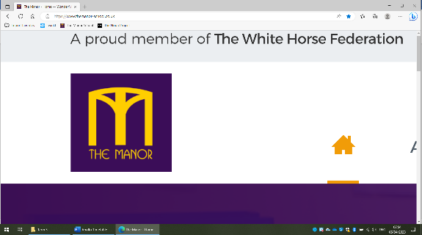  Topic Web |  |  | Term |  | 2
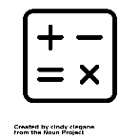  Maths |   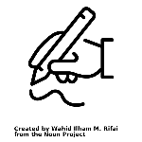  English |  |   RE |   Science |  |   Geography
In maths this term, we will developing our understanding of the four number operations and securing the use of formal written methods to answer questions. | For English this term, we will be using a book called ‘The Promise’ by Nicola Davies. We will be learning how to develop characters through the use of figurative language. We will also write a persuasive letter. |  | Our big questions this term are Was Jesus the Messiah? / How significant is it that Mary was Jesus’ mother? | Our topic for science this term is Living Things including Humans. We will learn about the reproduction system in humans and how the body changes through time. |  | We will delve into South America and where it is in the world before answering the question Do the geographical features of South America make it a good place to live?
  DT | 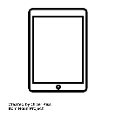  Computing |  |   PSHE |   Music |  |   PE
With Christmas fast approaching, we will be making wreaths and Christmas trees using different woodwork techniques before creating a circuit to add lights for decoration. | For computing, we will continue to learn how to use search engines effectively and how to use a index to inform our searches. |  | Our theme for PSHE this term is Celebrating Differences. We will explore how we are different from one another and how we can celebrate our individuality. | As part of music, we will be busy learning the songs to perform at the Young Voices Concert in January. We will also be learning traditional Christmas hymns in preparation for the Christmas service. |  | This term in PE, we will be learning the skills needed to play a game of dodgeball. This includes difference types of passes and how to work as a team.

