Year group | 5 | 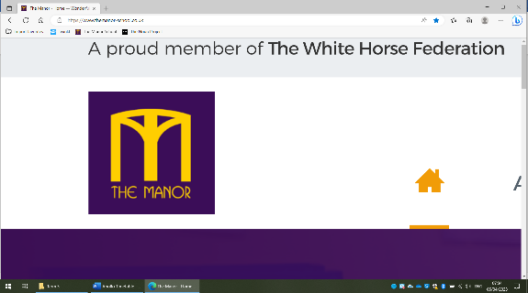  Topic Web |  |  | Term |  | 3
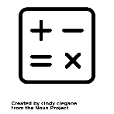  Maths | 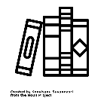  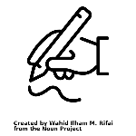  English |  |   RE | 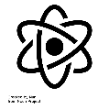  Science |  | 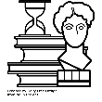  History
In maths this term, we will developing our understanding of multiplication and division using the formal written methods to answer questions and solve problems. | For English this term, we will be using a book called ‘The Man who Walked between the Towers’ by Mordicai Gerstein. We will re-tell the story. We will also use the book ‘Land of Neverbelieve. We will use this to write a non- chronological report. |  | Our big question this term is ‘Are Sikh stories important today?  We will delve into the religion of Sikhism and understand the stories told within the religion | Our topic for science this term is Materials and their Properties. We will learn about how different properties can change state and what causes this. |  | This term, we are travelling back to The Tudor era. We will learn how religions were changed, war was declared and the about the different monarchs who rules during this era.
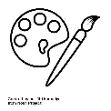  Art | 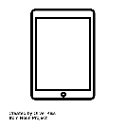  Computing |  | 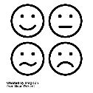  PSHE | 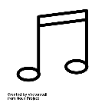  Music |  |   PE
Are unit this term is focused on Street Art. We will explore the different types of artwork found in the towns and who creates it before having a go at creating our own. | Our focus in computing this term is Multimedia- our main aim will be to make and edit a video. |  | Our theme for PSHE this term is Dreams and Goals. We will learn about different aspirations people have and how we can go about achieving our goals in and outside of school. | As part of music, we will be busy learning the songs to perform at the Young Voices Concert in January. |  | This term in PE, we will be learning the skills needed to play a game of netball. This includes difference types of passes and how to work as a team.

