Year group | 5 | 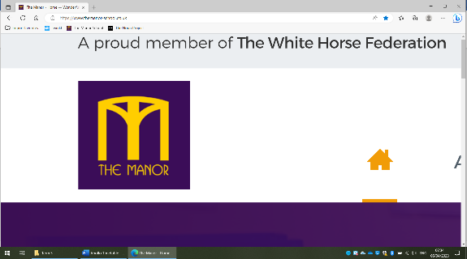  Topic Web |  |  | Term |  | 4
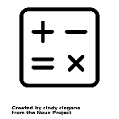  Maths | 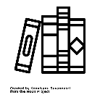  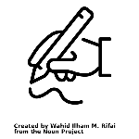  English |  |   RE |   Science |  | 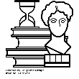  History
In maths this term, we will developing our understanding Roman Numerals, Fraction, Percentages and Decimals and Area and Perimeter of compound shapes. | For English this term, we will be using a book called ‘’Wonder’ by RJ Palacio. We will use this to develop our short story writing skills. We will also so the book and an animation called ‘Freak’ to write a persuasive letter. |  | Our big question this term is ‘What do Christians believe Jesus did to save Human Beings? / What difference does the resurrection make to Christians? | Our topic for science this term is Materials and their Properties. We will learn about how different properties can change state and what causes this.
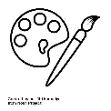  Art | 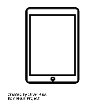  Computing |  |   PSHE |   Music |  |   PE
Are unit this term is focused on Street Art. We will explore the different types of artwork found in the towns and who creates it before having a go at creating our own. | Our focus in computing this term is Multimedia- our main aim will be to make and edit a stop/ go animation. |  | Our theme for PSHE this term is Dreams and Goals. We will learn about different aspirations people have and how we can go about achieving our goals in and outside of school. | As part of music, we will be busy learning the songs ready for the Easter Service. |  | This term in PE, we will be learning the skills needed to play a game of basketball. This includes difference types of passes and how to work as a team.

