 | Term 1 | Term 2 | Term 3 | Term 4 | Term 5 | Term 6
Text | Owl Babies  Little Red Hen  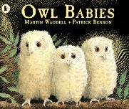  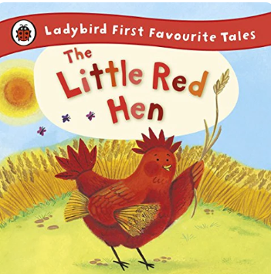 | The Gingerbread Man  Stick Man  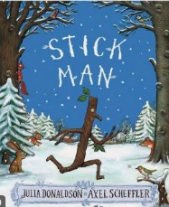  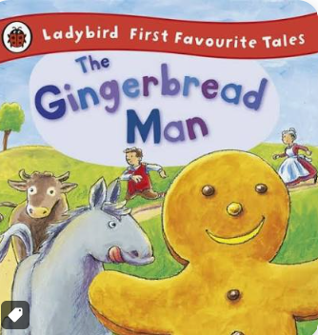 | Lost & Found  Naughty Bus  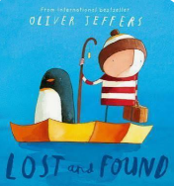  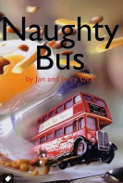 | Littles Red Riding Hood  The Gruffalo  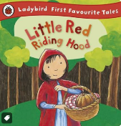  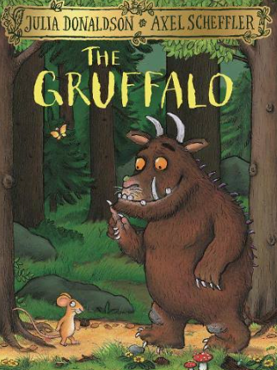 | Jack and the Beanstalk  The Extraordinary Gardener  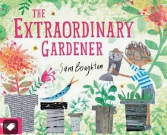  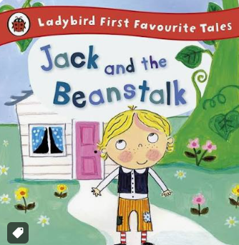 | We’re Going on a Lion Hunt.  Betsy Buglove Saves the Bees  Bee (non-fiction)  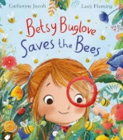  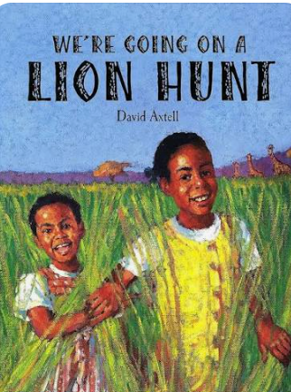
Communication and Language
We believe that strong communication and language skills are the foundation of all learning. Children's spoken language development underpins all seven areas of learning and development and is nurtured through meaningful interactions and rich learning experiences.
All children will be immersed in a language-rich environment where they have extensive opportunities to engage in high-quality conversations with both adults and their peers throughout the day. Positive, responsive interactions support children in developing their communication skills, confidence, vocabulary and understanding of language.
Children's back-and-forth exchanges from an early age provide the foundations for language development, thinking and learning. We promote communication through play, adult-led experiences and everyday interactions.
Children will have regular exposure to a wide range of high-quality texts, stories, non-fiction books, rhymes, poems and songs. Adults read frequently to children, encouraging active participation, discussion and comprehension while introducing and revisiting new vocabulary in meaningful contexts.
Our learning environment fosters a love of reading and language, encouraging children to explore a variety of texts independently and through play. Children are supported to learn and recite poems, rhymes and songs by heart, helping to develop their vocabulary, memory, confidence and enjoyment of language

Nursery Rhymes | *Twinkle Twinkle  *I’m a Little Teapot | *Baa Baa Black Sheep  *I hear Thunder | *Incy Wincy Spider  * Hickory Dickory Dock | *Mary had a Little Lamb  *Hot Cross Buns | *Jack and Jill  *Hey Diddle Diddle | *The Grand Old Duke of York  *Humpty Dumpty
Additional songs and rhymes | Five Little Speckled Frogs  Head, Shoulders, Knees and Toes  1, 2, 3, 4, 5 Once I caught a Fish Alive | 5 Little Ducks  10 Sparkling Fireworks  Dingle Dangle Scarecrow | Mary, Mary Quite Contrary  Little Miss Muffet  Sing a Song of Sixpence | I can sing a Rainbow  10 Green Bottles | 10 Fat Sausages  Teddy Bears’ Picnic  Nelly the Elephant | Down in the Jungle  The Animals went in Two by Two  Oh, I do like to be beside the seaside!
Expressive Art
Children will learn to sing and perform a range of songs and rhymes. In addition, to daily experiences and opportunities offered the children will learn songs and rhymes from 'The Poetry Basket' throughout the year.
Poems | Treasury of Nursery Rhyme Books | Furry Squirrel (Spring poetry basket)  Shoes  Pointy hat  5 little pumpkins  Leaves are falling  Falling apples  The Fox (Summer poetry basket) | I can build a snowman  Let’s put on our mittens  Popcorn  Carrot nose  Who has seen the wind?  A little house | Spring Wind  Mrs Bluebird  Hungry Birdies  Stepping stones  Pancakes by Christina Rossetti  A basket of apples (Autumn Poetry basket) | A little seed (spring poetry basket)  5 little peas  If I were so very small  Thunderstorm  Pitter patter | Mice (Autumn poetry basket)  A little shell  Under a stone  I have a little frog  Monkey babies  Sliced bread
EAD | We are Artists | Kandinsky | Jackson Pollock | Van Gough | Monet | Local Artist
Creative Art
Children will experience and develop a range of creative, artistic skills. The children will have daily, continuous access to a wide range of open ended, ambiguous resources allowing the opportunity to explore, experiment and develop their own creativity. They will have the opportunity to create collaboratively sharing Ideas and resources as well on solo work. Throughout the year the children will have the opportunity to return to and build on their previous learning, refining ideas and developing their ability to represent them. In addition specific skills and/or experiences will be planned.
Phonics  Little Wandle letters and sounds | Phase 2  Week 1 s a t p  Week 2 i n m d  Week 3 g o c k  Week 4 ck e u r  Week 5 h b f l | Phase 2  Week 1 ff ll ss j  Week 2 v w x y  Week 3 z zz qu words with s /s/ added at the end (hats sits) ch  Week 4 sh th ng nk  Week 5 words with s /s/ added at the end (hats sits) • words ending s /z/ (his) and with s /z/ added at the end (bags) | Phase 3  Week 1 ai ee igh oa  Week 2 oo oo ar or  Week 3 ur ow oi ear  Week 4 air er words with double letters: dd mm tt bb rr gg pp ff  Week 5 longer words | Phase 3  Week 1 review  Week 2 review Phase 3: er air words with double letters longer words  Week 3 words with two or more digraphs  Week 4 longer words words ending in –ing compound words  Week 5 longer words words with s in the middle /z/ s words ending –s words with –es at end /z/ | Phase 4  Week 1 short vowels  Week 2 short vowels  Week 3 short vowels longer words  Week 4 longer words compound words  Week 5 root words ending in: –ing, –ed /t/, –ed /id/ /ed/ –est | Phase 4  Week 1 long vowel sounds  Week 2 long vowel sounds  Week 3 Phase 4 words ending –s /s/ Phase 4 words ending –s /z/ Phase 4 words ending –es longer words  Week 4 root word ending in:–ing, –ed /t/, –ed /id/ /ed/, –ed /d/  Week 5 Phase 4 words ending in:–s /s/, –s /z/, –es longer words
Writing Focus | Orally retell a story  Write initial sounds | Orally retell the story of The Gingerbread Man using story map  Write words / label connected to The Gingerbread Man story  Write a list | Orally retell the story a using story map  Write a sentence | Orally retell the story a using story map  Write a description | Orally retell the story a using story map  Recount the story | Orally retell the story a using story map  Recount and  Innovate the story
Fine Motor Skills
We understand that effective handwriting begins with strong physical development. Before children can write fluently, they need to develop core strength, stability, coordination and fine motor control.
To support this, we use the Kinetic Letters handwriting programme, which is based on the understanding that handwriting is a physical skill. The programme focuses first on developing children's core strength, posture and gross motor skills, providing the strong foundations needed for successful writing. Through movement-based activities, children learn how to position their bodies correctly and develop the strength and control required for writing.
As children become physically stronger, they are supported to develop the fine motor skills necessary for accurate pencil control and letter formation. Kinetic Letters promotes correct pencil grip, letter orientation and fluency, helping children to become confident and successful writers.
To further support fine motor development, children regularly engage in activities such as pegboards, playdough, threading games, tweezers, construction activities and mark-making opportunities. These experiences help to strengthen hand muscles, improve hand-eye coordination and develop the dexterity needed for writing and other everyday tasks.
Through high-quality teaching, purposeful play and the Kinetic Letters approach, children are supported to achieve the Fine Motor Skills ELG and develop the confidence, stamina and independence needed for lifelong writing success
Maths | We follow the White Horse Federation Maths Curriculum
Understanding the world | UTW Past and Present  My Story So Far: Then and Now | UTW Past and Present  Celebrations Then and Now  UTW The Natural world  Nature Detectives | UTW The Natural world  Habitats Near and Far | UTW: People, Cultures and communities  Our Diverse Britain | UTW: People Cultures and Communities  Our Wonderful World | UTW The Natural world  Changes All Around Us  UTW Past and Present  Real or Make Believe?
Musical Development
Children will develop skills in listening attentively, moving to and talking about music, express their feelings and responses. We will experience singing in a group or on their own, increasingly matching the pitch and following the melody. Children will watch and talk about dance and performance art, express their feelings and responses. Children will explore and engage in music making and dance, performing solo or in groups. In addition to the daily experiences and opportunities offered in EYFS the children will have specific musical development sessions using Music Express.
RE Year A | Creation 1  Why is the word ‘God’ so important to Christians? | INCARNATION 1  Why do  Christians perform  nativity plays at Christmas? | SALVATION 2  How can we help others when they need it? | SALVATION 1  Why do  Christians put a cross in an  Easter garden? | Judaism  Mitzvot / tzedakah  Why is learning to do good deeds so important to Jewish people? | CREATION 2  How can we care for our wonderful world?
RE Year B | Christianity  Parables / gospel  What did Jesus teach about God in his parables? | INCARNATION 2  What makes every single person  unique and precious? | Christianity  Prayer / worship  Why do Christians pray to God and worship him? | Christianity  Resurrection / joy  What are the best symbols of Jesus’ death & resurrection at Easter? | Judaism  Tefillah/ blessings  Why do Jewish families say so many prayers and blessings | Christianity  Baptism / church  Why is belonging to God and the church family important to Christians?
PSHE  Jigsaw scheme | Being me in my world | Celebrating differences | Dreams and Goals | Healthy me | Relationships | Changing me
Personal, Social and Emotional Development
We support children to achieve the PSED Early Learning Goals by creating a nurturing, inclusive and supportive environment where every child feels safe, valued and respected. Through positive relationships with adults and peers, children learn to manage their feelings and behaviour, develop resilience and independence, and build confidence in their own abilities. Daily routines, collaborative play opportunities and targeted activities help children to form positive friendships, understand the perspectives of others and work cooperatively. We encourage children to make choices, take responsibility for their learning and persevere when faced with challenges, supporting them to become confident, capable and emotionally secure learners.

Festivals and Cultural Celebrations | Harvest​  Diwali ​  Black History Month​  National Poetry Week | Bonfire Night​  Remembrance day​  Christmas | Pancake Day​  Chinese New Year​  Valentine’s day | Mother’s Day​  Easter​  Eid |  | Father’s Day
Welly Walks | Our local area | Lacock Abby | Our local area | Lacock Abby | Our local area | Our local area
PSHEE (Jigsaw) | Being me in my world | Celebrating differences | Dreams and Goals | Healthy Me | Relationships | Changing Me
PE | First PE | Gymnastics | Dance | Multiskills | Swimming | Swimming
Gross Motor
children develop their gross motor skills through high-quality PE lessons using the Primary PE Planning scheme. Through a range of engaging units, including gymnastics, dance and multiskills, children build strength, coordination, balance and agility while developing confidence in movement.
Children are provided with regular opportunities to practise fundamental movement skills such as running, jumping, hopping, skipping, balancing and climbing. In gymnastics, they develop body control, balance and spatial awareness. Through dance, children learn to move rhythmically and expressively while improving coordination and control. Multiskills activities support the development of agility, balance and coordination through a variety of fun and challenging games

Cultural Captial | The Egg theatre Bath |  |  |  | Netherstreet Farm | Bournemouth Beach

