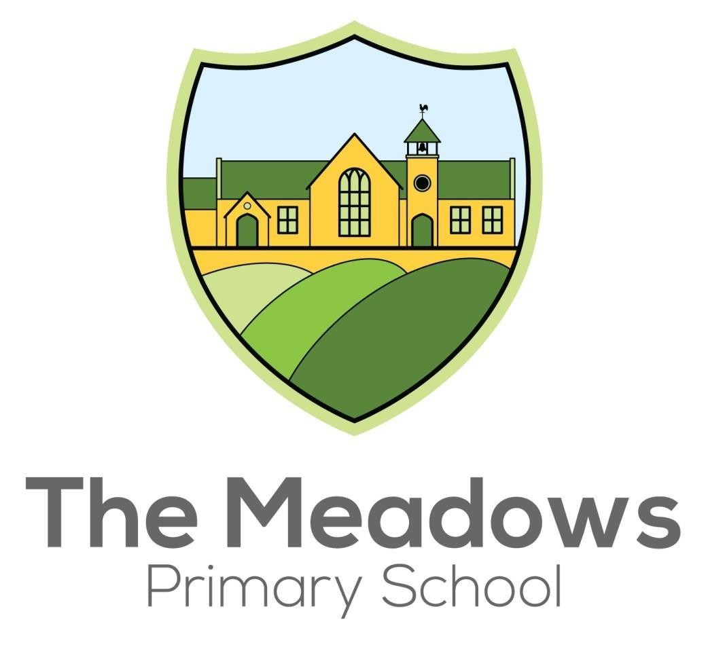
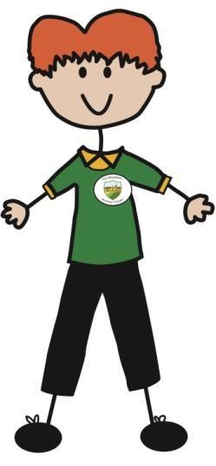
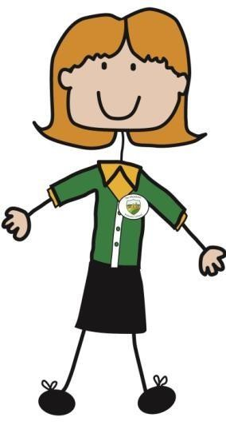

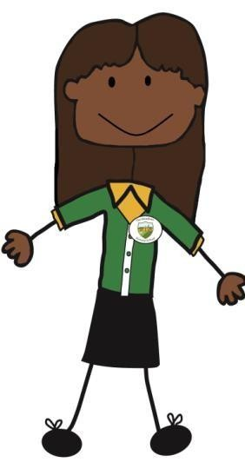
Assessment Policy

Introduction
In September 2014, the Government introduced a new National Curriculum, with a great deal of fresh content and ambitious expectations of learning. It is designed to provide children with the essential knowledge, skills and understanding that they require as citizens of Great Britain.

Moreover, the curriculum has not provided statutory requirements expected in each year group. Instead, it has provided two standards: knowledge to be acquired by the end of Key Stage 1 and knowledge to be acquired by the end of Key Stage Two. Partially, this is due to the idea that learning is accumulative and requires time. Also, that children do not all learn at the same pace, and that some require longer than others before they are secure with certain skills and concepts.

The manner in which schools assess learning has also changed dramatically. Levels have been removed and will not be replaced. Partially this is due to a shift in perception about levels:
- That levels have encouraged schools to race children through the curriculum, moving on too quickly to ideas in the next ‘level’ . As a result, children have developed a shallow understanding of the concepts and skills taught.
- Children are levelled according to the ‘best fit’ – thus children may not have completely understood key concepts, or may have even missed some out.
- Levels given on test papers are taken from an average and might not truly reflect a child’s capabilities.
- Best international practice does not use levels. Rather focus is placed upon learning less concepts in a greater depth.
As a result, although the content has been stipulated by the Government and Statutory Assessments will continue to be prescribed, schools are free to assess the skills acquired in each subject, at each stage of learning, in whatever manner they deem appropriate.

The Meadows Selected Method Of Assessment
At The Meadows, we have chosen to follow the Chris Quigley Essentials Curriculum which sets out essential coverage, learning objectives and standards which are required for all subjects.
Furthermore, it provides progress measures for all subjects including personal development. One of the primary reasons why we have chosen to adopt this curriculum is because it emphasises the
importance of developing the depth of children’s learning.

In essence, this means providing children with increased cognitive challenge, allowing them to apply the skills which they have learnt independently in a range of contexts rather than moving them onto the next skill needlessly when they have not truly mastered it. Such thinking is encapsulated in the scenario below:
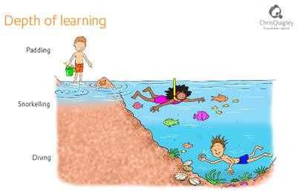

We have designed our system to reflect the changes from the DfE. From Year 1 to Year 6 pupils’ performance will be described in terms of achievement by age related Milestones. This will incorporate the Chris Quigley ‘BAD’ system we have adopted;

- Basic: understanding of basic facts and ideas relating to a concept – can tackle questions, sometimes with support.
- Advancing: more independent application, can explain, use or summarise understanding
- Deep: have a full understanding and can apply independently in different contexts/ problems solve/ etc.

Subjects that are assessed are: English (Reading and Writing) Maths, Science, D&T, PE, Art and Design, History, Geography, MFL (KS2), PSHE, Personal Development, RE and Computing.

This is similar to the Early Years system of Emerging, Expected and Exceeding. It will ensure the focus is on the depth of learning rather than rapid progression through a system.

At The Meadows, we want to challenge our children to become independent, well-rounded individuals who take ownership of their learning and become deep thinkers. We do not want them to have to swim across the water above, rather we want them to be diving for pearls of wisdom and learning through discovery – a key skill expected from children who achieve high levels in their GCSEs at High School.
Moreover, we want our children to be able to apply their knowledge and skill set in a range of contexts within school and real life.

Core Principles of Assessment
Good assessment practice in our school will:
- enable our children to demonstrate what they know, understand and can do in their work;
- help our children recognise the standards to aim for, and to understand what they need to do next to improve their work;
- make children aware of the role they play in the development of their own learning so they feel motivated and supported;
- enable the active involvement of pupils in their own learning by providing effective feedback which closes the gap between present performance and future standards required
- raise standards of attainment and behaviour, and improve pupil attitudes and response
- allow teachers to plan work that accurately reflects the needs of each child;
- base judgements of children’s attainment on a body of evidence from teachers ongoing marking, target setting and testing;
- enable the teacher to adjust teaching to take account of assessment information and to focus on how pupils learn
- track pupil performance and in particular identify those pupils at risk of underachievement
- provide regular information for parents that enables them to support their child’s learning;
- provide the Headteacher, Senior Leadership Team (SLT), the Academy Council and the Academy Trust with information that allows them to make judgements about the effectiveness of the school.

How We Assess
In September 2015, we introduced depths of learning in order to assess children’s learning. We assess their progress in each subject, including personal development, by reviewing the depth of their understanding.
All learning is be grouped into three milestones. Throughout Y1 and Y2, children are assessed on the concepts contained in Milestone 1. During Y3 and Y4, children are assessed on the concepts contained in Milestone 2. Finally, in Y5 and Y6 children are assessed on Milestone 3. N.B. Children in Reception will continue to be assessed on the Early Learning Goals.

During each term, we continuously assess the depth of children’s understanding within that milestone – whether it is basic, advancing or deep. Each milestone has 6 assessment points: Basic 1, Basic 2, Advancing 1, Advancing 2, Deep 1, Deep 2.
These points are not a mere label about a child: basic is not less able than deep. Rather, they allow us to determine each child’s level of understanding of a concept in the curriculum.

All children begin each milestone at the ‘basic’ level. Here they are acquiring new skills and are dependent upon the support of adults in order to learn new concepts. A child at the ‘basic’ level will

be able to: name, describe, follow instructions, use, match, recognise, label and recall concepts and skills essential in a specific milestone.
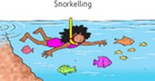
After children are able to demonstrate this ability on multiple occasions, they move to the ‘advancing’ stage. They are more independent learners, capable of making some degree of decision whilst applying some of their skills with guidance. Typically they are able to: explain, classify, infer meaning, make predictions, interpret summarise and apply their skills to solve problems.
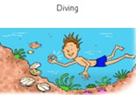
Finally some children may reach the ‘deep’ level of thinking. This involves a high level of cognitive challenge, where children are expected to apply their skills in a range of complex contexts without the guidance of adults. At this stage, children are able to: solve non-routine problems, appraise, explain concepts, hypothesise, investigate, design and prove.

At deep level 2, Children will have ’mastered’ all skills and concepts taught.
It is important to note, however, that only some children will reach this level of understanding during the course of their learning journey.

Children with Special Needs
Some pupils need to focus on the very small steps that will help them along the way in their learning journey. For these children we use “Pebbles”. It is a curriculum for pupils who are not ready to work on the milestones according to their age related expectations. They have significant gaps in their knowledge and skills, compared to other pupils in the same year group. Pupils overlearn the key things they need, in order to enable them to access the Milestones as specified in the Essentials Curriculum.

Tracking pupils in the Pebbles system differs to Essentials tracking. Rather than tracking cognitive understanding it assesses their fluency according to the amount of support required. Progress is tracked as “Requires heavy support, “Becoming fluent” and “Fluent”.

Measuring Good Progress
All children will be expected to make good progress from their starting point. Depending upon a
child’s starting point at the end of the Early Years Curriculum in the Reception class, they will each have their own line of good progress. If a child leaves Reception at the ‘emerging’ stage, and they make good progress they will leave Milestone 1 (at the end of Y2) at ‘basic 2’ which means working toward national expectation. However at the end of Milestone 2 and 3, they will be expected to
leave at ‘advancing 1’, slightly below national expectation.

EYFS |   Milestone |   Milestone |   Milestone
Emerging | Basic 2 | Advancing 1 | Advancing 1

Alternatively, if a child left Reception at the ‘expected’ stage, they should leave Milestone 1, 2 and 3 at ‘advancing 2’ which means that they are working at national expectation.

EYFS | Milestone | Milestone | Milestone
Expected | Advancing 2 | Advancing 2 | Advancing 2

However, if a child left Reception at the ‘exceeding’ stage, they should leave Milestone 1, 2 and 3 at either ‘deep 1’ or ‘deep 2’.

EYFS | Milestone | Milestone | Milestone
Exceeding | Deep 1/2 | Deep 1/2 | Deep 1/2

Informing Parents
We have a range of strategies that keep parents and carers fully informed of their child’s achievement and progress. We encourage parents and carers to contact the school if they have any concerns about any aspect of their child’s education. If teachers have concerns, regardless of their attainment, they will discuss this with parents as soon as possible.

Each term parents are sent a report regarding their child’s progress, in Writing, Reading, and Mathematics. It contains a child’s depth of progress as well as the targets that they need to work on during the course of the following term. All judgements are generated through the result of

summative assessment (regular tests taken at the end of a unit of work) and well as formative assessment, done at the point of learning.
Additionally parents are provided with their child’s standardised test score in Reading and Mathematics.
At the end of the summer term parents receive a full report which details their child’s achievements, strengths and weaknesses in each area of the curriculum, including personal development. Results of national statutory tests (End of key stage SATS and phonics screening) are also reported in this way.

Each term we offer parents and carers the opportunity to meet with their child’s teacher and share examples of children’s work, together with a discussion regarding the children’s learning behaviours and attitudes.

Standardised Tests
Standardised tests are based on key areas of the curriculum and test the knowledge that each child has acquired against the criteria of a subject’s programme of study. Furthermore they:
- Provide quantifiable evidence of a children progress.
- Allow us to compare a child against their peers of the same age both locally, nationally and internationally.
- Allow us to take into consideration a child’s actual age when measuring progress.
- Help us to measure small increments of progress.
Each term we provide parents and carers with a ‘scaled score’, which compares a child to national norms.

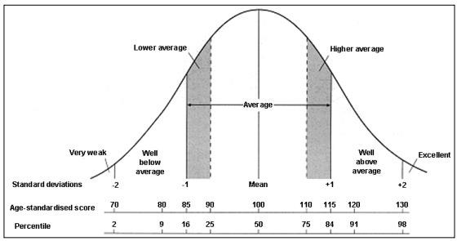

Assessment in Reception

In Reception, teacher assessment is conducted within the first few weeks, so we can assess the children’s starting points in order to chart their progress during the course of the year as well as
their progress throughout their time at The Meadows. The assessment will take the form of a range of practical tasks as well as observations of the children. This evidence will then be used by the teacher to form a judgement.

Ongoing assessment takes place continuously, conducted by both the class teacher and the teaching assistant. “Wow” learning moments are recorded in a variety of ways including photographs.
Together with assessment notes made during adult led activities, guided learning and continuous provision, these form a picture of a child’s level of achievement and from this we are best able to inform each child’s next steps for learning and plan appropriately. Where necessary, alterations to the provision or teaching are made to ensure maximum progress and attainment for all pupils.

At the end of the summer term, a written summary of a pupil’s attainment against the early learning goals (ELGs) is provided. This explains to parents whether the pupil is:
- meeting expected levels of development
- exceeding expected levels or
- not yet reaching expected levels (‘emerging’)

Planning For Assessment
Assessment should be an integral and recognisable part of every teacher’s planning and linked to National Curriculum expectations. To support our teaching we use the National Curriculum and Chris Quigley’s Essentials Curriculum. We plan our lessons with clear learning objectives based on the
milestone indicators. We strive to ensure that all tasks set are appropriate to each child’s ability. Activities with varying degrees of independence are planned and facilitated, to provide differing levels of cognitive challenge. Our lesson plans make clear the expected differentiated outcomes for each lesson. Teachers always share the lesson’s learning objective with the children as the lesson begins. They also indicate the way in which the activity is linked to the learning objective, and the success criteria against which the work will be judged. Children are encouraged to self-evaluate their work at the end of sessions and next steps are indicated on their work. (See Feedback and Marking Policy)
Teachers ask well-phrased questions and analyse pupils’ responses to find out what they know, understand and can do, and to reveal any misconceptions. We identify those individual children who do not achieve the expected progress during a lesson, and we use this information when planning for the next lesson.

Inclusion and Assessment for Learning
Our school aims to be an inclusive school. We actively seek to remove the barriers to learning and participation that can hinder or exclude individual pupils, or groups of pupils. We achieve educational inclusion by continually reviewing what we do, by monitoring data, and through asking

ourselves questions about the performance of these individuals and groups of pupils. In this way we make judgements about how successful we are being at promoting racial and gender equality, and including pupils with disabilities or special educational needs. SEND pupils will follow the same structure as other pupils but staff must keep evidence to indicate progress against their individualised targets on their Support Plans and provision maps. Staff will liaise with the SENCO. We have a comprehensive tracking system to record the progress of SEN pupils.

Equality Impact Assessment
Under the Equality Act 2010 we have a duty not to discriminate against people on the basis of their age, disability, gender, gender identity, pregnancy or maternity, race, religion or belief and sexual orientation.

This policy has been equality impact assessed and we believe that it is in line with the Equality Act 2010 as it is fair, it does not prioritize or disadvantage any pupil and it helps to promote equality at this school.

Standardisation/Moderation
The process of moderation is an essential part of the assessment system. Teachers are involved in the moderation process to ensure agreement and accuracy in the following ways:
- With colleagues in school
- With colleagues from other schools through cross school moderations networks
- Through statutory moderation by the LA.

Monitoring and Review
Our Assessment Leader is responsible for monitoring the implementation of this policy. The leader will use the data provided through teachers’ assessments to provide management information and statistics for the Headteacher, SLT and the Academy Council, and to meet the schools obligation to provide information to the LA and make statutory returns as required. This policy will be reviewed in two years, or earlier if necessary.

Reviewed | October 2025
Document Owner | N. Parry
Approved By | G. Taylor
Review Period | 3 years


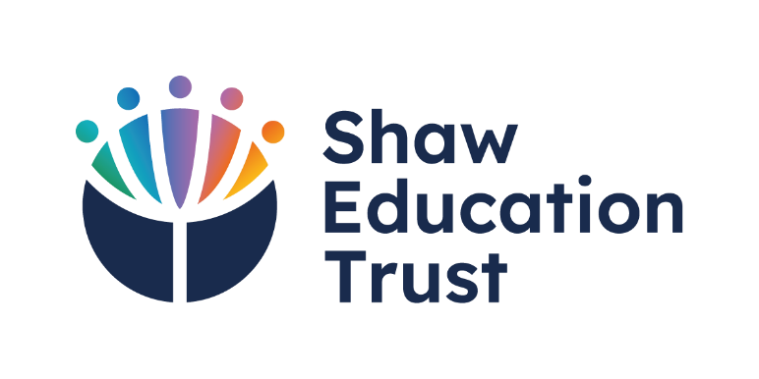
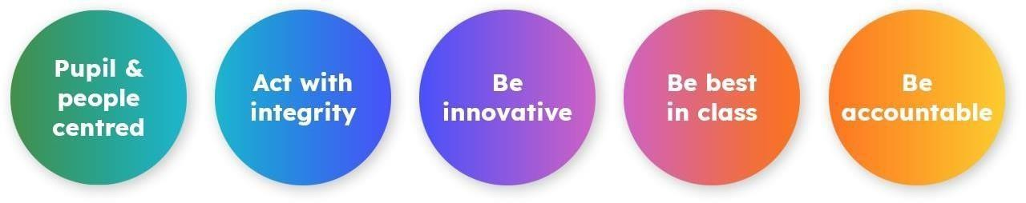

Shaw Education Trust Head Office, Kidsgrove Secondary School, Gloucester Road,  Kidsgrove,  ST7 4DL | Twitter LinkedIn Call  Email Visit | @ShawEduTrust @ShawEducationTrust 01782 948259  info@shaw-education.org.uk  shaw-education.org.uk

15

