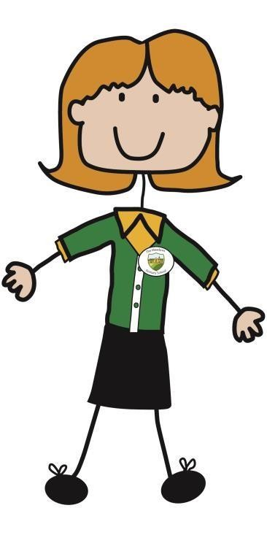

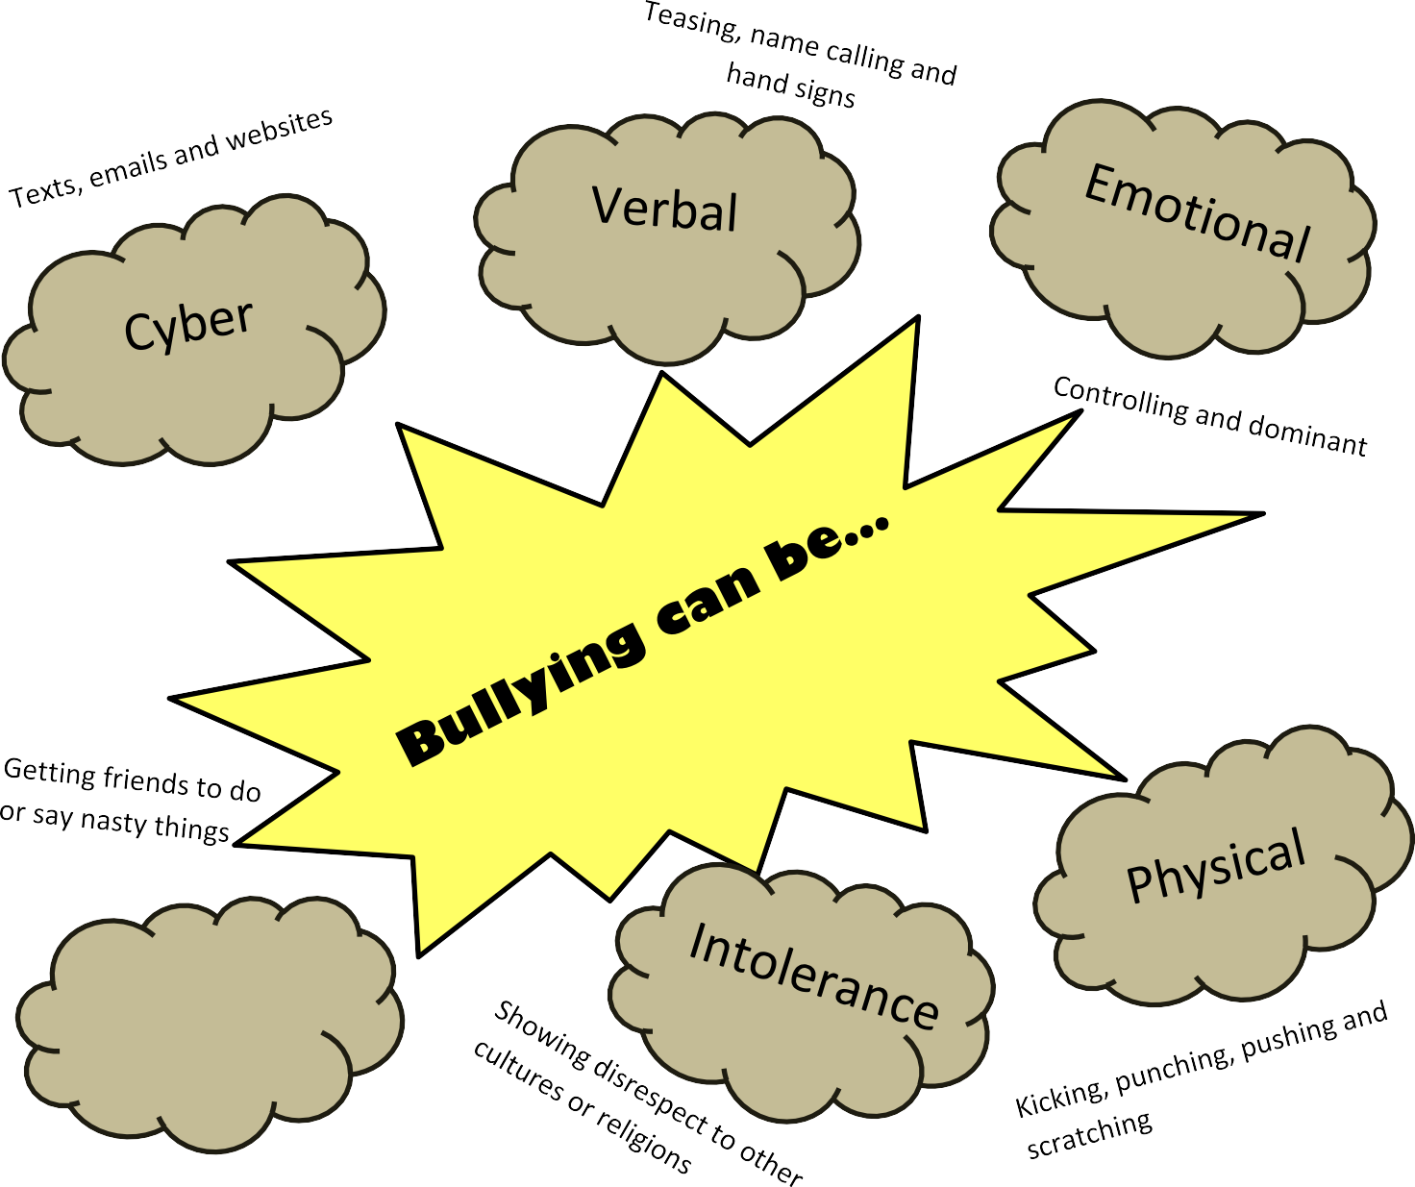
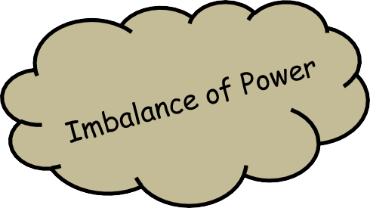

At The Meadows Primary School, we use the following acronym:
STOP IT: negative behaviour(s) which occurs Several Times On Purpose, which creates an Imbalance of power and is Targeted.

Through a 3rd person



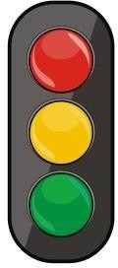

SEVERAL TIMES ON PURPOSE

We take bullying seriously and we find a way to make it
STOP. We want you to feel safe and happy in school.







Use eye contact and tell them to go away. Ignore them.
Walk away
Act as though you don’t care what they say
or do.
Remember, it is NOT YOUR fault. Tell an adult!

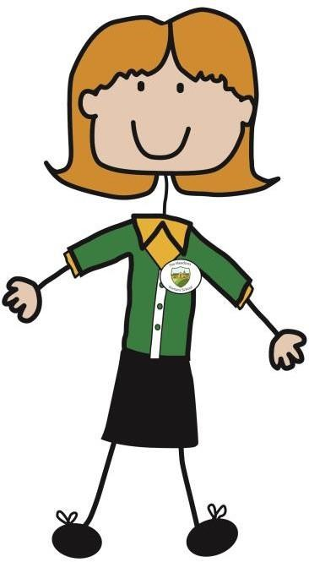

Don’t walk away and ignore the bullying.

Let the bully know what is happening.

Tell the bully to S.T.O.P. if it is safe to do so.

Don’t stay silent or the bullying will keep
happening.





- We will work together to STOP bullying.
- We want our school to make everyone feel safe and happy.
- To deal with bullying in our school we will help everyone to get on well together, to respect and understand each other and to believe that everyone has a right to be who they are.

