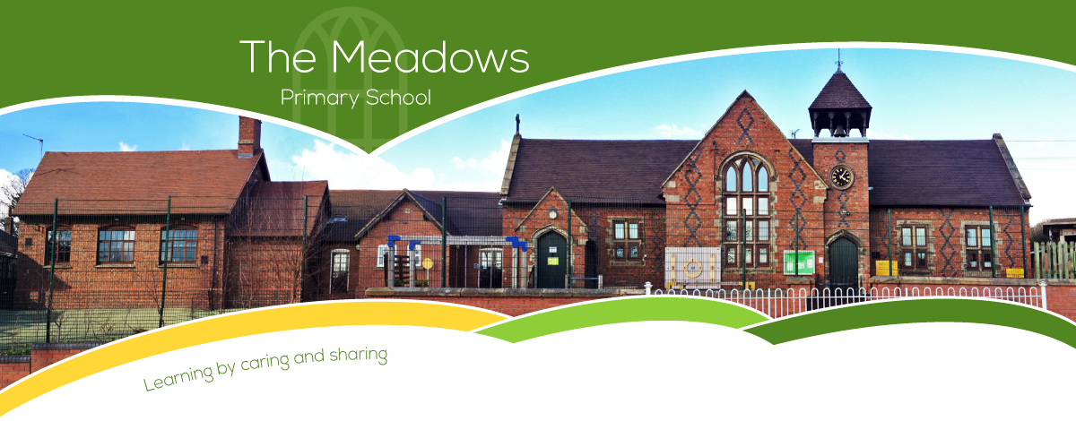

|  |  |  |  |  |  |  |
| --- | --- | --- | --- | --- | --- | --- |
| **Class 4 – Even Year Planning** | | | | | | |
| **Subject** | **Autumn Term** | | **Spring Term** | | **Summer Term** | |
| **Literacy** | * Star of Fear, Star of Hope by Jo Hoestlandt * Can we save the tiger? by Martin Jenkins | | * Island by Jason Chin alongside Jemmy Button by Alix Barzelay * The Selfish Giant by Oscar Wilde | | * Plastic Planet: How Plastic Came to Rule the World by Georgia Amson-Bradshaw * Sky Chasers by Emma Carroll | |
| **Maths** | * Number and place value * + - ÷ x methods * Properties of shape * Position and direction | * Fractions * Decimals * Mass * Time | * Number and place value * + - ÷ x methods * Properties of shape * Fractions * Length | * Decimals * Statistics * Percentages (FDP) * Perimeter and area | * Number and place value * + - ÷ x methods * Properties of shape * Money * Fractions | * Volume and capacity * Percentages (FDP) * Position and direction * Statistics |
| **Science** | * Body health * Circulatory system | | * Biology - Adaptation: Everything changes * Physics – Light up Your World | | * Chemistry – Investigating Materials (All Change) * Danger! Low Voltage | |
| **Computing** | * Year 5 - Online Safety * Programming music | | * Exploring AI * Inventing a product | | * Data handing 2: Big data * Intro to Python | |
| **History** | * The Maya * Medieval African Kingdoms | | * Shock Cities (a theme through time) – Part 1 * Shock Cities (a theme through time) – Part 2 | | * Britain in the era of the Second World War * Local history: WW2 impact in Staffordshire | |
| **Geography** | * Energy and climate change * Ethiopia | | * Changing Birmingham * Jamacia | | * Local area enquiry - Part 1 * Local area enquiry - Part 2 | |
| **Art/DT** | * Automata toys (Y6) * Make my voice heard | | * Come dine with me (Y6) * Making memories (Y6) | | * Steady Hand Game (Y6) * Architecture | |
| **Music** | * Film music * Composition notation | | * Musical theatre * Theme and variations | | * Composing and performing a Leavers' song * Songs of World War 2 | |
| **PSHE** | * VIPS * Think Positive | | * Growing up * Respecting rights | | * Tween safe * One World | |
| **PE** | * Hockey * Netball * Gymnastics | | * Cricket * Tag rugby * Gymnastics/Dance | | * Outdoor Adventure * Athletics * Dance | |
| **RE** | * Dharmic religions * Abrahamic religions | | * Art and action: three Christian lives * Stories which point to truth | | * Holy spaces and places * Reason and Revelation | |
| **Spanish** | * Phonics 1&2 (C) * I’m Learning Spanish (E) * Animals (E) | | * I Can (E) * Fruits (E) | | * Presenting Myself (I) * At the Café (I) | |