Class 4 Spring – Even Year

Subject | Learning Hook | Context | Prior Learning
History | Investigate and interpret the past  Build an overview of world history  Understand chronology  Communicate historically | 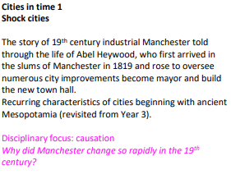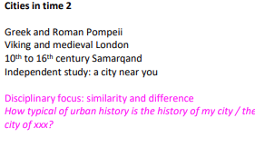 | Understanding of chronology – Ancient Egypt, The Victorians, The Romans, The Vikings, The Stone age
Science | Investigate Materials  Investigate Light and Seeing  Work scientifically | Biology - Adaptation: Everything changes  This unit introduces the children to the key concepts of evolution and inheritance by building upon previous topics, including animal characteristics and fossils. The children will learn about inherited traits and apply their knowledge to various animals and plants, before being introduced to the work of Mary Anning and Charles Darwin. Through the presentations and tasks, the children will learn about the fascinating history of the human race and discover links between extinct animals and those which are still living today  Chemistry – Investigating Materials (All Change)  This unit ‘Changes of materials’ takes children through six lessons where they learn how to: describe how to recover a substance from a solution; demonstrate that dissolving, mixing and changes of state are reversible changes; and finally, they learn how to explain that some changes result in the formation of new materials and that this kind of change is not usually reversible, including changes associated with burning and the action of acid on bicarbonate of soda. | Amazing bodies (Y3/4)  Taking care (KS1)
Geography | Investigate patterns  Communicate geographically  Investigate places | 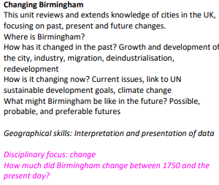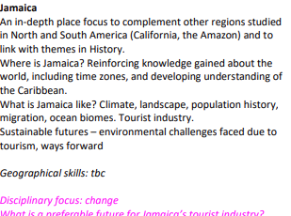 | Settlements (Stone Age, Romans and Anglo-Saxons)  Local area study  Map Skills  The Americas (Y5/6)  Around the World (Y3/4)
Design and Technology | Master practical skills  Design, make, evaluate and improve  Take inspiration from design throughout history | Come dine with me (Y6)  - Find a suitable recipe for their course.  - Record the relevant ingredients and equipment needed.  - Follow a recipe, including using the correct quantities of each ingredient.  - Write a recipe, explaining the process taken.  - Explain where certain key foods come from before they appear on the supermarket shelf. | Master practical skills (Y1,2,3,4, 5)  Design, make, evaluate and improve (Y1,2,3,4, 5)  Take inspiration from design throughout history (Y1,2,3,4, 5)
Art and Design | Develop ideas  Master techniques  Take inspiration from the greats | Making memories (Y6)  - Discuss the work of artists that appreciate different artistic styles.  - Create a sculpture to express themselves in a literal or symbolic way.  - Reflect verbally or in writing about creative decisions.  - Suggest ways to represent memories through imagery, shapes and colours.  - Draw a composition of shapes developed from initial ideas to form a plan for a sculpture.  - Competently use scissors to cut shapes accurately.  - Talk about artists’ work and explain what they might use in their own work.  - Produce a clear sketchbook idea for a sculpture, including written notes and drawings to show their methods and materials needed.  - Successfully translate plans to a 3D sculpture.  - Work mostly independently, experimenting and trying new things.  - Identify and make improvements to their work.  - Produce a completed sculpture demonstrating experimentation, originality and technical competence.  - Competently reflect on successes and personal development. | Describe the work of notable artists,  artisans and designers (EYFS, Y1, Y2, Y3, Y4, Y5)
Religious Education | Understand beliefs and teachings  Understand practices and lifestyles  Understand how beliefs are conveyed  Reflect  Understand values | 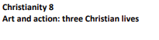  Awaiting resources  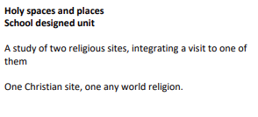 | Understand beliefs and teachings (Y1,2,3,4, 5)  Understand practices and lifestyles (Y1,2,3,4, 5)  Understand how beliefs are conveyed (Y1,2,3,4, 5)  Reflect (Y1,2,3,4, 5)  Understand values(Y1,2,3,4, 5)
Languages | Read fluently  Write imaginatively  Speak confidently | - I Can (E)  - Fruits (E) | Spanish Phonics (Y3/4/5)  Presenting myself (Y3/4/5)
Physical Education | Develop practical skills in order to participate, compete and lead a healthy lifestyle | - Cricket  - Tag rugby  Gymnastics/Dance | Gymnastics (Y3/4)  Net and Wall (Y3/4)  Invasion Games (Y3/4)
Computing | Code  Collect  Communicate  Connect | Exploring AI  - Explain what AI is and its basic functions.  - Identify real-life applications of AI that are commonly used in everyday life.  - Identify how AI understands and processes text and image prompts.  - Generate and refine prompts to achieve the best possible response from AI.  - Identify how AI generates code and how it can be useful in web design.  - Identify how AI can be a useful starting point for a project.  - Explain the key ethical considerations of AI.  - Debate the potential of AI replacing human roles, presenting well-structured arguments.  Data handling 1: Big Data  - Understand why barcodes and QR codes were created.  - Create (and scan) their own QR code using a QR code generator website.  - Explain how infrared can be used to transmit a Boolean type signal.  - Explain how RFID works, recall a use of RFID chips, and type formulas into spreadsheets.  - Take real-time data and enter it effectively into a spreadsheet.  - Presenting the data collected as an answer to a question.  - Recognising the value of analysing real-time data.  - Analyse and evaluate transport data and consider how this provides a useful service to commuters. | Code (Y1,2,3,4, 5)  Collect (Y1,2,3,4, 5)  Communicate (Y1,2,3,4, 5)  Connect (Y1,2,3,4, 5)
Maths | Know and Use Numbers  Add and subtract  Multiply and divide  Use fractions | - Decimals  - Percentages  - Algebra  - Perimeter, area, volume  - Imperial and metric  - Ratio and proportion | Know and Use Numbers (Y3/4/5)  Add and subtract (Y3/4/5)  Multiply and divide (Y3/4/5)  Use fractions (Y3/4/5)
English | Understand texts  Transcribe  Compose  Analyse  Present | - Fiction: Narrative - The Firework Maker’s Daughter by Phillip Pullman  - Poetry – Thinker's Rap  - Non-fiction: Ancient Greece  - Narrative – Rose Blanche by Ian McEwan | Understand texts (Y1,2,3,4)  Transcribe (Y1,2,3,4)  Compose (Y1,2,3,4)  Analyse (Y1,2,3,4)  Present (Y1,2,3,4)
PSHE |  | Growing up  This topic builds on children’s knowledge of how we grow  and change, both physically and emotionally, and the types  of relationships that people have. Children will learn about  sexual relationships and sexually transmitted diseases. They  will also learn about positive body images and stereotypes.  Respecting rights  This unit is based on the concept that we can all make choices to live as rights-respecting citizens. It is inspired by human rights being shared by all people – no matter who they are or where they are from – and that these rights are there to protect all people, enabling them to live happy, safe and healthy lives. This unit helps children to understand that no one can take away their rights. It also aims to help children explore the ideas of equality and discrimination and the consequences of both. In this unit, children learn about how they can make choices and take actions that respect the rights of others. They will also learn about human rights activists and how they work to make the world a better place. | Mental wellbeing(Y1,2,3,4,5)  Respectful relationships (Y1,2,3,4,5)
Music | Perform  Compose  Transcribe  Describe music | South and West African Music  - Sing using the correct pronunciation and with increasing confidence.  - Play a chord with two notes, remaining in time.  - Maintain their part in a performance with accuracy.  - Play the more complicated rhythms in time and with rests.  - Create an eight beat break and play this in the correct place.  Dynamics, pitch and texture (Theme: Coast - Fingal’s Cave by Mendelssohn)  - Engage in discussion about the sounds of an orchestral piece.  - Have a selection of varied vocabulary in response to what they hear.  - Change dynamics and pitch, differentiating between the two.  - Take the role of conductor or follow a conductor.  - Change texture within their group improvisation and talk about its effect.  - Create a graphic score to represent sounds.  - Follow the conductor to show changes in pitch, dynamics and texture. | Pitched Instrument Lessons (Y3/4)

