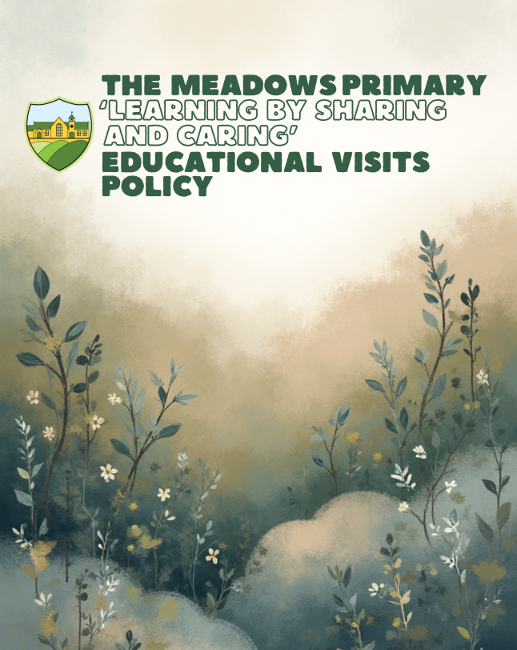Rationale
Education in its broadest sense is not just about delivering a curriculum. It is about giving children the chance to extend their life skills. It is about developing their confidence. It is about fostering their resilience and sense of responsibility. It is about enjoyment, engagement and excitement; of venturing out into the real world, with all its capacity for uncertainty, surprise, stimulation and delight.
Our school values the learning experience that takes place outside the classroom. Well-planned and executed educational visits provide our pupils with valuable experiences, which enhance their learning at school. Providing a variety of ‘real-life’ opportunities for our children enables them to achieve a fuller understanding of the world around them through direct experience.
Educational visits and learning outside the classroom are an essential element of good primary practice. The school makes every effort to ensure that educational visits and learning outside the classroom activities are available and accessible to all children, irrespective of special educational or medical needs, ethnic origin, gender or religion.

Purposes
Our educational visits can provide stimulus and support to work being covered as part of the school curriculum. It may be that a visit provides an effective stimulus at the start of a unit of work; alternatively, teachers may decide to use an educational visit at any time during a project to enhance and support the curriculum. Wherever or whatever the venue, teachers ensure that the educational benefits to the children are maximised.

Guidelines
The organisation of an educational visit is crucial to its success. With rigorous organisation and control, a visit should provide a rich learning experience for the pupils. The following guidelines support the planning and implementation of educational visits organised at Meadows Primary School.

Responsibilities

Headteacher
The Headteacher at Meadows Primary School will endeavour to ensure that:
- there is a suitable Educational Visits Policy in place;
- they have appointed a suitable Educational Visit Coordinator;
- there is a thorough planning procedure in place and that all staff follow it;
- contingency planning is in place;
- there is adequate and relevant insurance cover.

Educational Visit Coordinator (EVC)
The EVC will ensure that visit planning, risk assessment, staffing, medical planning and EVOLVE documentation meet school requirements, and that all necessary actions are completed before the visit begins.

Visit Leader
The visit leader is responsible for the safe conduct and supervision of the visit, briefing staff and volunteers, completing risk assessments with the EVC, and ensuring first aid, medication and contact information are taken.

Other adults involved in a visit
All adults must do their best to ensure the health and safety of everyone in the group, follow the visit leader’s instructions, adhere to the EVOLVE risk assessment and support control and discipline.

Responsibilities of pupils
Pupils must not take unnecessary risks, follow adult instructions, behave sensibly and responsibly and report any hazards to staff. Pupils whose behaviour is a danger to themselves or others may be prevented from attending a visit.

Parents/Carers
Parents/carers must provide emergency contact details, complete consent and medical information, provide relevant health details, and supply any medication with clear written instructions.

Procedures for Planning Off-site Visits
The EVC, in conjunction with the Health & Safety Coordinator, has prepared extensive documentation for the planning procedure for all educational visits. A timeline of best practice must be followed by group leaders.
Once a trip has been agreed in principle and the venue and any necessary transport has been provisionally booked, the group leader must complete a risk assessment and submit it to the EVC within the stated deadlines. The EVC will then submit documentation to the Headteacher for approval before uploading onto EVOLVE.
Letters should be sent to parents as soon as possible requesting consent and any applicable financial contributions. Prior to the visit taking place, medical and dietary information must be completed by parents and is held centrally in the school office.
Once the visit has taken place, an evaluation should be completed and returned to the EVC within one week.

Deadlines for Documentation
For one-day non-adventurous activities, all documentation must be submitted to the EVC for approval at least four weeks before the visit takes place. For UK and overseas residential visits, documentation must be submitted at least eight weeks before the visit.
These deadlines allow time to check staffing ratios, risk assessments, itineraries, registers and medical records. Visit leaders may be contacted via EVOLVE/email if further information is required prior to approval.

Risk Assessment
A risk assessment must be completed for every educational visit using the EVOLVE Risk Assessment format. The Meadows Primary School generic risk assessment (stored on OneDrive) should be used as a baseline and adapted for each specific visit. The assessment must specify the required adult-to-child ratios.
Risk assessments must consider:
- the type of activity and the level at which it is being undertaken;
- the location;
- the competence, experience and qualifications of supervisory staff;
- the group members’ age, competence, fitness and temperament;
- pupils with special educational or medical needs;
- the quality and suitability of available equipment;
- seasonal conditions, weather and timing.
Supervisors should continually reassess risks throughout the visit and take appropriate action if pupils are in danger.

Pre-visit exploratory checks
Where possible, the visit leader should undertake an exploratory visit to confirm suitability, assess potential risks and ensure familiarity with the site. If this is not feasible, the leader must contact the venue to obtain assurances and copies of their risk assessments.

First Aid and Medication

First Aid provision
First aid provision must be considered when assessing visit risks. For adventurous activities, overnight stays or visits abroad, it is expected that at least one trained first aider accompanies the group. The visit leader should have a working knowledge of first aid.
Minimum first aid provision includes:
- a suitably stocked first aid kit/backpack;
- a person appointed to be in charge of first aid arrangements;
- basic first aid items carried by staff where appropriate (e.g. plasters, wipes, gloves, paper towels, ice pack).

Medication procedures
Accurate records must be kept regarding medication and accidents using the Medication and Accidents folder kept in the medical room. Medication must be stored securely. Two members of staff must be present when medication is administered and both must sign the administration record.

Supervision and Ratios
The group leader must ensure sufficient supervision for any off-site visit. Supervision levels must be determined through the risk assessment, taking account of pupil age and needs, activity risks, journey, location and staff experience.

Recommended ratios
As a general guideline, Meadows Primary School uses the following ratios as a baseline:
- Nursery–Reception (ages 3–5): 1 adult to 4 children
- Years 1–2 (ages 5–8): 1 adult to 8 children
- Years 3–6 (ages 8–11): 1 adult to 10 children
These ratios may be increased where additional risks are present. Volunteers must have appropriate DBS clearance and understand their roles. Staff should avoid one-to-one situations with pupils wherever possible.
Pupils should be allocated into smaller groups assigned to each adult. Regular headcounts must take place and rendezvous points should be established.
All pupils must wear school wristbands during visits, showing the school name and telephone number.

Transport of Pupils

Coach travel
Meadows Primary School uses coaches hired from accredited companies. Coaches have seat belts and staff ensure that these are fastened at all times.

Public transport
Pupils using public transport should be made aware of basic safety rules, including:
- arrive on time and wait away from the road or platform edge;
- do not rush towards the transport when it arrives;
- stay seated and wear a seatbelt where provided;
- keep bags clear of aisles;
- never distract the driver;
- use the Green Cross Code when crossing roads;
- tell a member of staff if you feel unwell.

Local walking visits
For walking trips, pupils should wear high-visibility jackets. Staff should be positioned at the front and back of the group, and extra care taken when crossing roads.

Pupils with Special Educational and Medical Needs
The Headteacher will not exclude pupils with special educational or medical needs from school visits. Every effort should be made to accommodate pupils while maintaining safety. Planning must consider supervision ratios and any additional safety measures needed.

Communicating with Parents / Guardians and Parental Consent
Parents need to be aware that teachers on the visit act in their place – ‘in loco parentis’ – and will exercise the same care that a prudent parent would. The following information will be communicated to parents / guardians prior to a visit (where appropriate):
- dates of the visit;
- times of departure and return;
- mode(s) of travel including the name of any travel company;
- details of accommodation with security and supervisory arrangements on site (residential visits);
- names of leader, staff and accompanying adults;
- benefits of the visit – educational and social;
- an overview of activities planned;
- insurance taken out for the group as a whole (luggage, accident, cancellation, medical cover as applicable);
- clothing and equipment required;
- money to be taken (if relevant);
- information required from parents, e.g. medical and/or dietary, and what they will be asked to consent to.
Meadows Primary School will seek consent for:
- local visits involving all children;
- day trips outside the local area;
- adventure activities;
- visits abroad;
- other residential visits.
If parents withhold consent absolutely, the pupil should not be taken on the visit, but the curricular aims should be delivered in other ways wherever possible. Where consent is conditional, the Headteacher will decide whether the child may attend. Consent should be completed via ParentMail.
Parents are expected to inform the school of collection arrangements at the end of day or residential visits; this will be included in the consent process.
Special arrangements may be necessary for parents for whom English is an additional language.

10. Residential Visits
The school's current residential programme is:
• Year 3 – 2 day residential to Delamere Forest
• Year 4 – 3 day residential to Chasewater
• Year 5 and 6 – Standon Bowers (Every two years)
Medical, dietary and contact forms must be taken on the visit and a copy left with a senior leader.
Forms for pupils who received medication or had accidents must be stored; others retained four weeks then shredded.

Hostels and Hotels
Accommodation arrangements must ensure:
• staff rooms are adjacent to pupil rooms where possible;
• areas are secure and access controlled;
• males/females have separate sleeping areas;
• all pupils know fire procedures and layout;
• safety features (locks, lighting, balconies) are checked;
• facilities are adequate for SEND needs.

Coastal Visits
Coastal environments present specific hazards. Leaders must consider tides, sandbanks, signage, base points, terrain and cliff safety. Pupils must stay on paths; cycling on cliff paths is discouraged.

Swimming and Paddling
Swimming in natural waters is not permitted on Meadows visits.
Paddling is only allowed in supervised, recognised safe areas with a minimum ratio of 1:4. One teacher must remain onshore for supervision.

Farm Visits
Farms hold machinery and infection risks. Leaders must check farm management standards, hygiene, and suitability. Pupils must not:
• touch faces after feeding animals;
• eat without washing hands;
• sample animal foodstuffs;
• drink from farm taps.

Risk of Violence (Terrorism)
The EVC and Headteacher must check national and Trust guidance before visits. Unless official advice warns against travel, trips proceed. Parents may withdraw pupils but may lose payments if the school has already paid suppliers.
In the event of an incident, staff follow emergency services, venue instructions and the school’s Critical Incident Policy.

Ongoing (Dynamic) Risk Assessment
Leaders must continually assess risks during the visit and document any significant unplanned risk decisions afterward. Residential visits should include daily briefings and morning safety updates for pupils.

Weather Checklist
Leaders must:
• check local forecasts;
• ensure appropriate clothing;
• consider hazards such as flash floods, high winds and unstable ground;
• obtain local hazard advice (tides, rivers, terrain, crossing points).

Communication with School
Leaders must take the school trip mobile and contact school on arrival and departure. If delayed, school must be notified immediately so parents can be informed.

Alternative Planning
Visits must include contingency plans. Leaders must reassess risks before changing locations. On arrival at an unplanned site, leaders must assess hazards before pupils disembark.

Behaviour Problems
Behaviour expectations must be shared in advance. Leaders must not lower standards off‑site. If an adult must supervise an individual for an extended period, group supervision must be redistributed.

Illness During Visits
Staff must monitor unwell pupils, check care plans and contact school/parents if symptoms worsen. Pupils with vomiting/diarrhoea must be collected from residentials and remain home 48 hours after symptoms stop.

Accidents and Injuries
All accidents must be recorded on school forms and any venue forms. The Health & Safety Coordinator must be informed and incidents reported to Staffordshire where required.

Emergency Procedures
Serious incidents require immediate communication with the designated emergency contact. Staff must follow the school’s Critical Incident Policy. Priorities: save life, minimise injury and safeguard pupils.

